
Paper 5.5b HSC 27.04.2026
Equality Impact Assessment Form (EqIA)
As a public sector organisation, GSA has a legal duty under the Equality Act 2010 to assess the impact all of its new or revised policies, practices, procedures or projects may have on protected groups (as defined by the Act).
The purpose of this assessment is to use relevant evidence and critical thinking to identify any impact (positive, negative or neutral) the policy, practice, procedure or project that is being assessed may have on the people it affects or is intended for.
The EqIA is a tool which helps mainstream equality into everything GSA does. It requires us to consider how we can mitigate or eliminate negative impact and, in turn, advance positive outcomes. Therefore, it must be undertaken during the development / review of the policy, practice, procedure or project it refers to and not after it has been finalised. Ideally, EqIAs should be a team effort of relevant parties to ensure a variety of perspectives have been consulted. All finalised EqIAs must be signed off by an executive lead and either the Head of Student Support and Development or GSA’s Equality Officer, however, support from the Equality Officer is available at any stage of completion.
Further guidance on how to complete an EqIA can be found on GSA’s website and the Equality and Diversity section on the staff intranet. If you have any additional questions, please contact equality@gsa.ac.uk.
Name of Equality Impact Assessment  (E.g. Area of decision making/title of policy, procedure, programme or relevant practice) | Suspicious package Guidance. (Health and Safety)
New or reviewed | New
Owner/Review Lead and role | Ian Hackford Head of Health and Safety and Security Intelligence
Department or School | Health and Safety
Date of assessment | 14/04/2026

- Purpose of policy / practice / procedure / project being assessed – brief description
Threats to the GSA may present themselves as a package or bag that may look out of place or in some way suspicious.
Every member of the GSA community, students, staff and visitors may come across or be in receipt of a suspicious package. This means that we all have a role to play in dealing with this potential security threat.
Some people may be more likely to be in receipt of/or notice suspicious packages because of their role or profile.
The guidance document provides advice on how to respond to a suspicious package and how to minimise the risk to yourself and those around you.

- Evidence used when undertaking this assessment – this can comprise of internal and external reports, survey data, etc
The policy and guidance were written after a review of relevant Legislation and sector guidance

Protect UK and National Counter Terrorism Security office. Mail handling
Protect UK and National Counter Terrorism Security office Unattended and suspicious items
University of Bristol Suspect mail / suspicious packages

All Health and Safety Policy is written with the provisions and requirements of the Equalities Act 2010 in mind and with the aim of making the GSA a fair and accessible institution for all.

3. Type of impact by protected characteristic – please provide details of the potential impact (could be more than just one type); make reference to relevant evidence (from the list you provided above) where applicable
Age | Positive impact |  |  | Negative impact |  | Neutral impact
Age |  |  |  |  |  | Neutral
Disability | Positive impact |  |  | Negative impact |  | Neutral impact
Disability |  |  |  | . |  | Neutral
Gender reassignment (covers Trans identities) | Positive impact |  |  | Negative impact |  | Neutral impact
Gender reassignment (covers Trans identities) |  |  |  |  |  | Neutral
Marriage and Civil Partnership | Positive impact |  |  | Negative impact |  | Neutral impact
Marriage and Civil Partnership |  |  |  |  |  | Neutral
Pregnancy and Maternity | Positive impact |  |  | Negative impact |  | Neutral impact
Pregnancy and Maternity |  |  |  |  |  | Neutral
Race | Positive impact |  |  | Negative impact |  | Neutral impact
Race |  |  |  |  |  | Neutral
Religion or Belief | Positive impact |  |  | Negative impact |  | Neutral impact
Religion or Belief |  |  |  |  |  | Neutral
Sex | Positive impact |  |  | Negative impact |  | Neutral impact
Sex |  |  |  |  |  | Neutral
Sexual orientation | Positive impact |  |  | Negative impact |  | Neutral impact
Sexual orientation |  |  |  |  |  | Neutral
Impact on other groups (e.g. Care Experienced; Carers; Military Veterans; Low Socioeconomic Status (SES); Asylum Seekers; British Sign Language Users, etc) | Positive impact |  |  | Negative impact |  | Neutral impact
 |  |  |  |  |  | Neutral
4. How has the identified negative impact been mitigated? – please provide details of undertaken actions broken down by protected characteristic
No negative impacts

5. Any outstanding mitigation (where applicable) – please provide a concise action plan with action owner and a timescale for completion
Action |  | Equality Impact | Person Responsible |  | Time frame
None
6. How does the outcome of this assessment and the actions undertaken support GSA’s 2021 - 2025 Equality Outcomes
This Guidance will support all persons working, studying or visiting the GSA and help them to participate in GSA activities in a healthy and safe environment regardless of any protected characteristics.

7. How does the outcome of this assessment and the actions undertaken support the three main duties GSA has under the Equality Act 2010 Equality Act 2010 to:
- eliminate discrimination, harassment and victimisation;
- advance equality of opportunity;
- foster good relations between people who share a relevant protected characteristic and those who do not?
This Guidance will support the health safety and welfare all persons working, studying or visiting the GSA and help them to participate in GSA activities in a safe and secure environment regardless of any protected characteristics.
We will continue to evaluate our physical and digital environment, aiming to optimise accessibility and inclusivity by acknowledging and providing for the needs of our students, staff and stakeholders

8. Where/when will action progress and outcome be reported and reviewed?
This Guidance will be reviewed according to the H&S policy and guidance review plan and reported to the Health and Safety Committee. These documents may be reviewed sooner if circumstances or legislation change.

Next review date – please consider any outstanding actions outlined above; the review period must be in line with the policy/service review and/or at intervals of no more than three years | May 2029

Signed off by Owner/Review Lead (name and role) Ian Hackford Head of Health and Safety and Security Intelligence | 17/04/2026 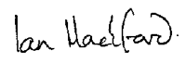
Signed off by Executive Lead (name and role) Eleanor Magennis Director of Estates and Infrastructure | 19/04/2026 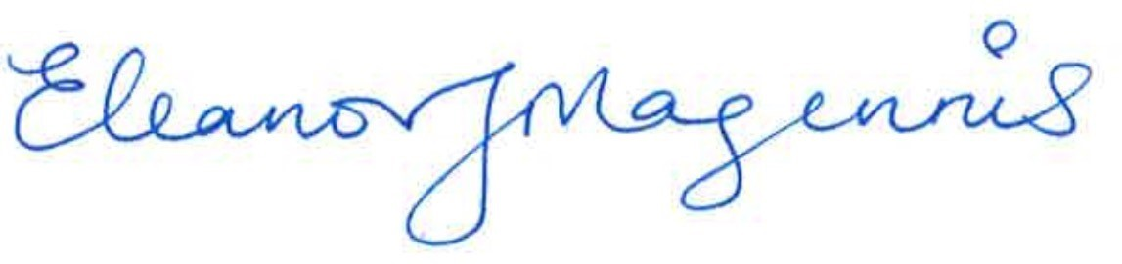
Signed off by Equality Lead Ceit Mackintosh, Equality Officer | 06/05/2026
Signed off by Education Committee | NA

