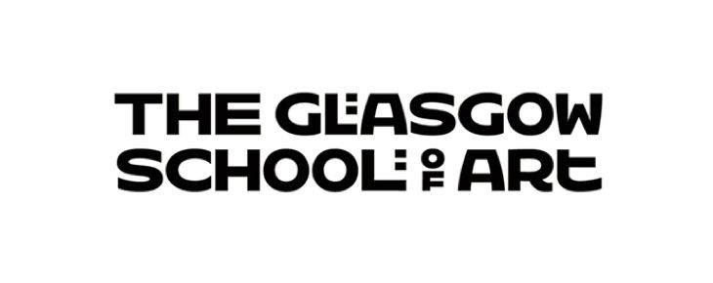
Paper 5.4b HSC 27.05.2026
Equality Impact Assessment Form (EqIA)
As a public sector organisation, GSA has a legal duty under the Equality Act 2010 to assess the impact all of its new or revised policies, practices, procedures or projects may have on protected groups (as defined by the Act).
The purpose of this assessment is to use relevant evidence and critical thinking to identify any impact (positive, negative or neutral) the policy, practice, procedure or project that is being assessed may have on the people it affects or is intended for.
The EqIA is a tool which helps mainstream equality into everything GSA does. It requires us to consider how we can mitigate or eliminate negative impact and, in turn, advance positive outcomes. Therefore, it must be undertaken during the development / review of the policy, practice, procedure or project it refers to and not after it has been finalised. Ideally, EqIAs should be a team effort of relevant parties to ensure a variety of perspectives have been consulted. All finalised EqIAs must be signed off by an executive lead and either the Head of Student Support and Development or GSA’s Equality Officer, however, support from the Equality Officer is available at any stage of completion.
Further guidance on how to complete an EqIA can be found on GSA’s website and the Equality and Diversity section on the staff intranet. If you have any additional questions, please contact equality@gsa.ac.uk.
Name of Equality Impact Assessment  (E.g. Area of decision making/title of policy, procedure, programme or relevant practice) | Suspicious Persons. (Health and Safety)
New or reviewed | New
Owner/Review Lead and role | Ian Hackford Head of Health and Safety and Security Intelligence
Department or School | Health and Safety
Date of assessment | 13/04/2026

- Purpose of policy / practice / procedure / project being assessed – brief description
The purpose of this Guidance document is to provide information and support for students and staff on what to do if they think that someone is acting suspiciously on or around GSA property or offsite activities.
It is recognised in the document that suspicious behaviour is somewhat subjective. This document also provides students and staff with examples of what might constitute suspicious behaviour requiring further action.

It is important that students and staff do not put themselves at increased risk while investigating suspicious behaviours. This document offers some practical tips to everyone when approaching a person who is acting suspiciously.

- Evidence used when undertaking this assessment – this can comprise of internal and external reports, survey data, etc
The policy and guidance were written after a review of relevant Legislation and sector guidance

Action Counters Terrorism. Protect UK Suspicious activity
University of Bristol, Security Services, Challenging strangers.
University of the Arts, London. Suspicious Activity

All Health and Safety Policy is written with the provisions and requirements of the Equalities Act 2010 in mind and with the aim of making the GSA a fair and accessible institution for all.

3. Type of impact by protected characteristic – please provide details of the potential impact (could be more than just one type); make reference to relevant evidence (from the list you provided above) where applicable
Age | Positive impact |  |  | Negative impact |  | Neutral impact
Age |  |  |  | Older persons might be seen as suspicious on the GSA campus where the majority of student are in there 20s.  The guidance document offsets this by providing advice on what might constitute suspicious behaviour at the GSA. The document also emphasises the need for a polite and friendly approach as the majority of cases of suspicious behaviours are likely to have an innocent explanation
Disability | Positive impact |  |  | Negative impact |  | Neutral impact
Disability |  |  |  | Some people with mental health conditions, learning disabilities, autism, speech or communications differences may behave in a manner that might attract attention and may appear uncomfortable or evasive when questioned. The guidance document provides advice on what might constitute suspicious behaviour and emphasises the need for a polite and friendly approach as the majority of cases of suspicious behaviour are likely to have an innocent explanation. |  | Neutral
Gender reassignment (covers Trans identities) | Positive impact |  |  | Negative impact |  | Neutral impact
Gender reassignment (covers Trans identities) |  |  |  |  |  | Neutral
Marriage and Civil Partnership | Positive impact |  |  | Negative impact |  | Neutral impact
Marriage and Civil Partnership |  |  |  |  |  | Neutral
Pregnancy and Maternity | Positive impact |  |  | Negative impact |  | Neutral impact
Pregnancy and Maternity |  |  |  |  |  | Neutral
Race | Positive impact |  |  | Negative impact |  | Neutral impact
Race |  |  |  | Black ethnic groups and those that may appear to be from overseas may be at risk of racial bias and discrimination. It is important that the guidance is followed when approaching anyone. The guidance document provides advice on what might constitute suspicious behaviour and emphasises the need for a polite and friendly approach as the majority of cases of suspicious behaviour are likely to have an innocent explanation. Staff, especially, public facing staff, should ensure that they have undertaken the GSA equality and diversity training as well as unconscious bias and keep this up to date.  If you feel uncomfortable or the situation begins to escalate contact the GSA security when safe to do so. Security are trained to respond to these situations.
Religion or Belief | Positive impact |  |  | Negative impact |  | Neutral impact
Religion or Belief |  |  |  | There is reference in the document to use of face coverings to conceal an intruders identity as being suspicious. This has potential to unfairly stigmatise people that might cover their faces for religious reasons, such as niqabs, hijabs or scarves. Wording has been provided in the document making it more clear what is regarded as a suspicious face covering such as wearing a balaclava or woollen scarf on a hot day or a crash helmet worn in doors.
Sex | Positive impact |  |  | Negative impact |  | Neutral impact
Sex |  |  |  |  |  | Neutral
Sexual orientation | Positive impact |  |  | Negative impact |  | Neutral impact
Sexual orientation |  |  |  |  |  | Neutral
Impact on other groups (e.g. Care Experienced; Carers; Military Veterans; Low Socioeconomic Status (SES); Asylum Seekers; British Sign Language Users, etc) | Positive impact |  |  | Negative impact |  | Neutral impact
 |  |  |  |  |  | Neutral
4. How has the identified negative impact been mitigated? – please provide details of undertaken actions broken down by protected characteristic
Age: Older persons might be seen as suspicious on the GSA campus where the majority of student are in there 20s.
The document offsets this by providing guidance on what might constitute suspicious behaviour at the GSA. The document also emphasises the need for a polite and friendly approach as the majority of cases of suspicious behaviours are likely to have an innocent explanation.

Race.
Black ethnic groups and those that may appear to be from overseas may be at risk of racial bias and discrimination. It is important that the guidance is followed when approaching anyone. The guidance document provides advice on what might constitute suspicious behaviour and emphasises the need for a polite and friendly approach as the majority of cases of suspicious behaviour are likely to have an innocent explanation. Staff, especially, public facing staff, should ensure that they have undertaken the GSA equality and diversity training as well as unconscious bias, and keep this up to date.
If you feel uncomfortable or the situation begins to escalate contact the GSA security when safe to do so. Security are trained to respond to these situations.

Religion or belief. There is reference in the document to use of face coverings to conceal an intruder’s identity as being a suspicious act. This has potential to unfairly stigmatise people that may cover their faces for religious reasons. Wording has been provided in the document making it clearer what is regarded as a suspicious face covering such as wearing a balaclava or woollen scarf on a hot day or a crash helmet worn in doors. Training is provided to staff on Equality and Diversity as well as unconscious bias. This is particularly important for those staff that are public facing. The Guidance should be followed in particular it must be remembered that behaviour often has innocent explanations and when challenging suspicious behaviour, it must be remembered that you must be polite and supportive. There is also an emphasis on personal safety and comfort, if you feel that the situation is escalating contact the GSA Security who are trained in responding to these situations.

Disability: Some people with mental health conditions learning disabilities, autism, speech or communications differences may behave in a manner that might attract attention and may appear uncomfortable or evasive when questioned. The guidance document provides advice on what might constitute suspicious behaviour and emphasises the need for a polite and friendly approach as the majority of cases of suspicious behaviour are likely to have an innocent explanation.. Training is also provided to staff on Equality and Diversity as well as unconscious bias.

The Security Team, receptionists and janitors will report incidents of suspicious persons through Awaken and to their team leaders. These will be anonymised and reported to the Health and Safety Committee.

5. Any outstanding mitigation (where applicable) – please provide a concise action plan with action owner and a timescale for completion
Action |  | Equality Impact | Person Responsible |  | Time frame
None
6. How does the outcome of this assessment and the actions undertaken support GSA’s 2021 - 2025 Equality Outcomes
This guidance will support all persons working, studying or visiting the GSA and help them to participate in GSA activities in a secure environment regardless of any protected characteristics.

7. How does the outcome of this assessment and the actions undertaken support the three main duties GSA has under the Equality Act 2010 Equality Act 2010 to:
- eliminate discrimination, harassment and victimisation;
- advance equality of opportunity;
- foster good relations between people who share a relevant protected characteristic and those who do not?
This guidance will support all persons working, studying or visiting the GSA and help them to participate in GSA activities regardless of any protected characteristics.
We will continue to evaluate our physical and digital environment, aiming to optimise accessibility and inclusivity by acknowledging and providing for the needs of our students, staff and stakeholders

8. Where/when will action progress and outcome be reported and reviewed?
This guidance will be reviewed according to the H&S policy and guidance review plan. It may be reviewed sooner if circumstances or legislation change.

Next review date – please consider any outstanding actions outlined above; the review period must be in line with the policy/service review and/or at intervals of no more than three years | February 2029

Signed off by Owner/Review Lead (name and role) Ian Hackford Head of Health and Safety and Security Intelligence | 13/04/2026 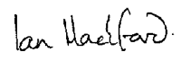
Signed off by Executive Lead (name and role) Eleanor Magennis Director of Estates and Infrastructure | 19/04/26 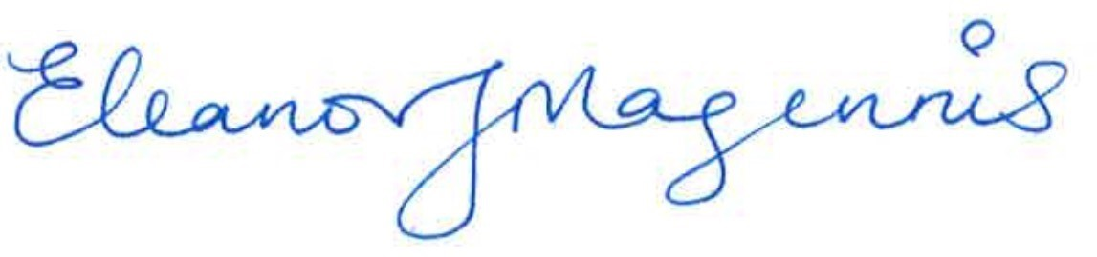
Signed off by Equality Lead Ceit Mackintosh, Equality Officer | 17/04/2026

