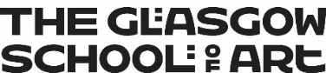
Mainstreaming Equality and National Equality Outcomes Report 2026
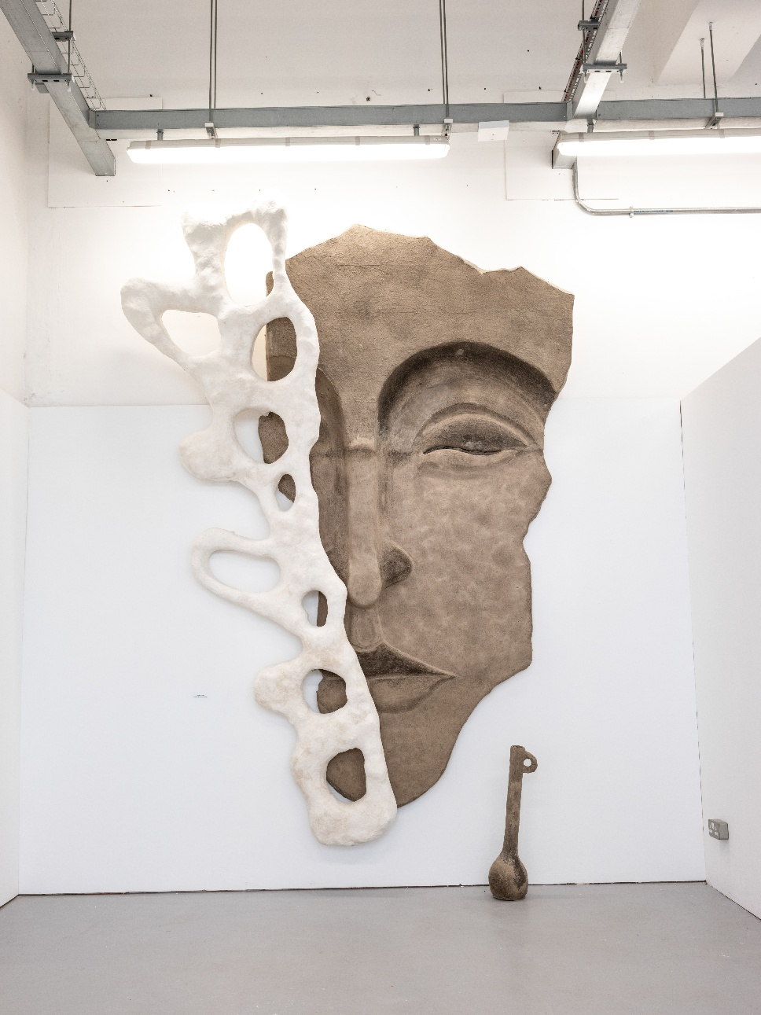
Image: Maha Al Yousefi, Openings in the Sanctuary of the Face – Oriental Voices (Sculpture & Environmental Art, 2025)

Foreword
I am proud to present the Glasgow School of Art’s National Equality Outcomes (NEOs) and Mainstreaming Equality Report 2025.

At GSA, we are committed to fostering an inclusive and equitable environment where diversity is celebrated, and everyone has the opportunity to thrive. This report reflects the progress we have made in eliminating discrimination, advancing equality of opportunity, and fostering good relations across our GSA community. Over the past year, we have taken significant strides in embedding Equality, Diversity, and Inclusion (EDI) across our Institution, expanding both the breadth and impact of our efforts.

Guided by the Glasgow School of Art Strategic Plan 2022-2027, our Institution is committed to creating inclusive working and learning environments and celebrating the diversity of our staff and students, recognising the strengths this brings. Our Equality, Diversity and Inclusion Committee (EDIC) plays an important role in driving this work forward, helping to integrate EDI into our policies and practices and supporting progress towards the NEOs. In addition, we will work with IFF Research to actively participate in the SFC/EHRC evaluation of the impact of the National Equality Outcomes (NEOs) in the further and higher education sectors in Scotland.

We also welcome the new Equality and Human Rights Mainstreaming Toolkit and its six key drivers—strengthening leadership, developing accountability and transparency, ensuring an effective regulatory and policy environment, utilising evidence and experience, enhancing capability and culture, and improving capacity—which will continue to guide and inform our approach as we embed equality and human rights more deeply across the institution.

I am particularly proud of the development of our second Student Mental Health Agreement, reinforcing our dedication to supporting student wellbeing. While our staff and student surveys highlight ongoing concerns around mental health - aligning with the Scottish higher education sector - we recognise the urgency of these issues and are taking meaningful action to address them.

In the past year, we expanded our Digital Inclusion Scheme, developed an ethical Endowment Investment Policy, and broadened our staff and student EDI training. Our intersectional approach ensures that the lived experiences of our community remain central to our work, fostering a culture where every individual feels valued and empowered to reach their full potential.

Our People Strategy, launched in 2022, sets a clear roadmap building a diverse, engaged, and agile workforce equipped to deliver our strategic goals. We are committed to fair work practices and increasing workforce diversity, with clear actions and timelines in place. Additionally, we are enhancing our institutional oversight of key student data to inform policies that support fair access and address inequalities, as outlined in the GSA Education Strategy.

Looking ahead, we remain steadfast in our commitment to embedding EDI across all aspects of the GSA. By listening, learning, and working collaboratively with our community and beyond, we will continue to drive meaningful change and build an institution where everyone can flourish.

Professor Penny Macbeth
Director & Principal of the Glasgow School of Art

Table of Contents

Table 1: Acronyms and denotations 7

Student Profile Data 2024/2025 10

National Equality Outcomes (NEOs) 15
Age 15
Disability 18
Gender Reassignment 23
Race 23
Religion or Belief 31
Sex 32
Sexual Orientation 37

Eliminate discrimination, harassment, victimisation 40
16 Days of Activism Against Gender Based Violence 40
Ask Angela 42
Digital Accessibility 43
Dignity and Respect at Work Workshops 43
Equality, Diversity, and Inclusion Committee (EDIC) 43
#erasethegreycampaign 44
Exhibitions Equality Impact Checklist 45
Inclusive Learning, Teaching and Assessment Working Group 46
Mental Health First Aid & Mental Health Awareness Training 46
Report and Support 46
Staff eLearning 54
Student eLearning 55
Widening Participation 55
You are Safe with Me LGBTQ+ Badges 56

Advance equality of opportunity 57
Access Grants 57
Bereavement Support Group 58
Cognitive Behavioural Therapy (CBT) Sessions 58
Collections and Reflections Workshops 58
Digital Inclusion Scheme 59
Discretionary Funds 60
Dr Bike 62
Emergency Food Vouchers 62
Interactive Library Map 63
Junk Journaling Sessions 63
Learning and Teaching Conference – Keynote and Panel on Inclusive Education 64
Mature Student Learning Experience Project 64
Mature Student Network 64
Maryhill Integration Network – Oasis Women’s Group 65
Men’s Mental Health Month 65
Mindfulness with Lego 66
Neurodiversity-Affirming Practice Workshop 66
Personal Safety Training 67
Reasonable Adjustment Policy 67
Souper Tuesdays and Thursdays 67
See Me – Empower Change Training 67
Speaking Your Mind 68
Student Experience Survey 2025 68
Student Mental Health Agreement 2025 - 2027 68
Student Support Drop in Sessions 69
Supporting Inclusive Wellbeing Toolkit 69
World Mental Health Day 70

Foster good relations 72
Agency and Imagination Blow in the Winds of the Liberal State Exhibition 72
Black History Month 2025 73
Book Club 74
Critical Studies in Sound for Moving Image 75
The Dance Short Film 76
Decolonising Research Workshop 76
Design for Care Project – BA (Hons) Interior Design 76
Empire Retold: Other Voices from the British Empire Exhibition 77
Equality Newsletters 77
Garnethill Synagogue Tour 79
GSA Degree Show 2025 79
GSA Student Association Societies 80
Inclusive Library Collections 81
Lunar New Year Card 81
Modest, Inclusive, Sustainable and Circular Considerations – Postgraduate Fashion 81
Mother Curator Exhibition 82
The Maud Sulter Annual Lecture with Pratibha Parmar 82
Migrant Garnethill Exhibition 83
Neurodiversity Forum 84
Race, Rights and Sovereignty Series: 84
School EDI Leads 85
Student Consultants (Equality, Diversity, and Inclusion) 85
Visual Language Glossary 86
Who’s Listening? Short Film 86
Why We Ride – Film Screening and Panel Discussion 87

Table 1: Acronyms and denotations
Acronym | Full title
EDI | Equality, Diversity, and Inclusion
EDIC | Equality, Diversity, and Inclusion Committee
EqIA | Equality Impact Assessment
GBV | Gender Based Violence
GSA | Glasgow School of Art
GSASA | Glasgow School of Art Student Association
HoS | Head of School
MSA | Mackintosh School of Architecture
NEO | National Equality Outcome
PL | Programme Lead
pp | Percentage points
RAR | Reasonable Adjustments Report
SLG | Senior Leadership Group
SIT | School of Innovation and Technology
SoD | School of Design
SoFA | School of Fine Art
WP | Widening Participation

Introduction
The Glasgow School of Art (GSA) is a small, specialist institution with approximately 3,020 students and 671 staff members (excluding visiting workers). Renowned for its high-level, studio-based education in the visual creative arts, GSA delivers programmes from pre-undergraduate through to doctoral study across four academic Schools: the Mackintosh School of Architecture, the School of Design, the School of Fine Art, and the School of Innovation and Technology.

GSA is committed to mainstreaming equality, diversity, and inclusion (EDI) across all areas of its work. In doing so, we take cognisance of intersectionality, recognising that protected characteristics do not exist in isolation but interact with wider structural factors such as socio-economic status and the ongoing cost-of-living crisis. These intersections can compound disadvantage and influence access, participation, and outcomes, and our approach seeks to address these complexities holistically.

This report outlines the progress GSA has made in embedding equality throughout its functions and details ongoing actions aligned with the three core aims of the Public Sector Equality Duty under the Equality Act 2010:

- Eliminate discrimination, harassment, victimisation, and other prohibited conduct
- Advance equality of opportunity between people who share a protected characteristic and those who do not
- Foster good relations between people who share a protected characteristic and those who do not

The Mainstreaming Equality and National Equality Outcomes Report provides an opportunity to showcase GSA’s practice and commitment to inclusive education. Please note that this report does not repeat information contained in the 2024 report, which can be accessed here:
https://gsadocuments.net/category/equality-and-diversity/.

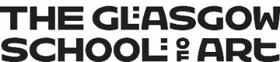
Student Profile Data
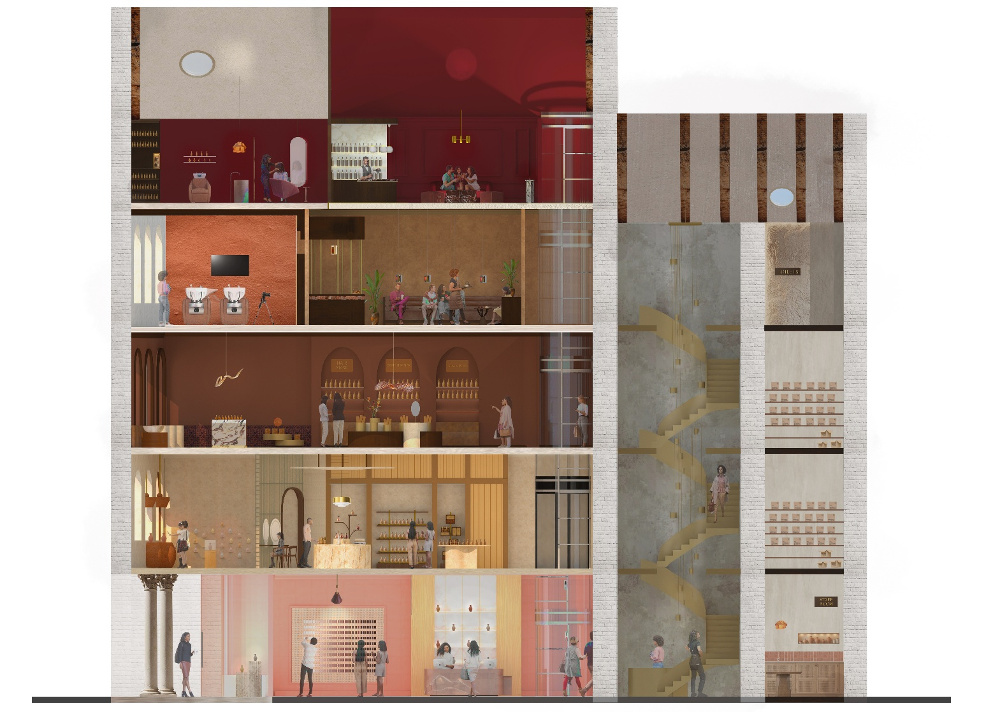
Image: Jessie Orville, Layers (Interior Design, 2025)

Student Profile Data 2024/2025
This report presents an overview of GSA’s student body profile by protected characteristics. We recognise that these categories may not fully reflect how individuals identify; however, they follow the terminology and classification required by HESA for sector reporting. GSA remains committed to respecting self-identification and fostering an inclusive environment where all students feel seen and valued beyond statistical classifications.

To preserve anonymity throughout the report numbers under 10 have been presented as ‘*’. Data on pregnancy and maternity is not included in this report to protect the identity of the individuals.

Key findings
Since the 2023/2024 report:

- Overall student numbers grew by 178 (from 2842 to 3020).
- Students with a known disability increased by 2.8%
- Overseas students grew by 3.6%. Both Scotland and the EU’s share fell by 2.7% and 1%, respectively.
- The number of Asian students rose by 4% and Black students by 0.5%.
- Jewish students increased by 0.8%. “Prefer not to say” increased from 7.5% in 2022/23 to 9.2% in 2023/24 to 10.7% in 2024/25. “No religion” remains the majority at 65.8%.
- Female share increased to 69.4%; Male decreased to 26.8%; Other rose to 2.0%; Unknown to 1.8%.
- For sexual orientation, there was an increase of 1.5% in students opting “prefer not to say.”
- There has been a slight decrease in the number of trans students (0.1%). However, there has also been a slight decrease of 0.1% in the percentage of students selecting “prefer not to say” when asked if they are trans.

Table 1: Student Population by Age
Age Group | 2022/23 | 2023/24 | 2024/25
Under 25 | 2164 (76.2%) | 2101 (74.7%) | 2296 (76.0%)
Over 25 | 678 (23.8%) | 713 (25.3%) | 724 (23.9%)
Total | 2842 | 2814 | 3020

Table 2: Student Population by Disability Status
Disability Status | 2022/23 | 2023/24 | 2024/25
Known Disability | 591 (20.8%) | 800 (28.4%) | 942 (31.2%)
No Known Disability | 2170 (76.4%) | 1847 (65.7%) | 1851 (61.3%)
Prefer not to say | 69 (2.4%) | 161 (5.7%) | 193 (6.4%)
Unknown | 12 (0.4%) | 6 (0.2%) | 34 (1.2%)
Grand Total | 2842 | 2814 | 3020

Table 3: Student Population by Domicile
Domicile | 2022/23 | 2023/24 | 2024/25
Scotland | 1315 (46.3%) | 1286 (45.7%) | 1298 (43.0%)
RUK | 508 (17.9%) | 521 (18.5%) | 566 (18.7%)
EU | 201 (7.1%) | 157 (5.6%) | 140 (4.6%)
Overseas | 790 (27.8%) | 833 (29.6%) | 1002 (33.2%)
Unknown | 28 (1.0%) | 17 (0.6%) | 14 (0.5%)
Grand Total | 2842 | 2814 | 3020

Table 4: Student Population by Ethnicity
Ethnicity | 2022/23 | 2023/24 | 2024/25
Arab | 21 (0.7%) | 25 (0.9%) | 23 (0.8%)
Asian | 678 (23.9%) | 739 (26.3%) | 914 (30.3%)
Black | 26 (0.9%) | 28 (1.0%) | 44 (1.5%)
Mixed | 119 (4.2%) | 148 (5.3%) | 149 (4.9%)
Unknown | 211 (7.4%) | 55 (2.0%) | 79 (2.6%)
Prefer not to say | 50 (1.8%) | 69 (2.5%) | 66 (2.2%)
White | 1737 (61.1%) | 1750 (62.2%) | 1745 (57.8%)
Grand Total | 2842 | 2814 | 3020

Table 5: Student Population by Religion and Belief
Religious belief | 2022/23 | 2023/24 | 2024/25
Any other religion or belief | 109 (3.8%) | 130 (4.6%) | 151 (5%)
Buddhist | 45 (1.6%) | 41 (1.5%) | 50 (1.7%)
Christian – Church of Scotland | 59 (2.1%) | 50 (1.8%) | 49 (1.6%)
Christian – Roman Catholic | 189 (6.6%) | 177 (6.3%) | 181 (6%)
Christian – other denomination | 136 (4.8%) | 136 (4.8%) | 130 (4.3%)
Hindu | 44 (1.5%) | 40 (1.4%) | 42 (1.4%)
Jewish | 10 (0.4%) | 17 (0.6%) | 24 (0.8%)
Muslim | 63 (2.2%) | 70 (2.5%) | 62 (2.1%)
No Religion | 1940 (68.3%) | 1871 (66.5%) | 1987 (65.8%)
Prefer not to say | 213 (7.5%) | 260 (9.2%) | 324 (10.7%)
Sikh | * | * | *
Unknown | 32 (1.1%) | 19 (0.7%) | 16 (0.5%)
Total | 2842 | 2814 | 3020

Table 6: Student Population by Sex
Sex | 2022/23 | 2023/24 | 2024/25
Female | 1889 (66.5%) | 1909 (67.9%) | 2096 (69.40%)
Male | 897 (31.6%) | 815 (29%) | 809 (26.79%)
Other | 37 (1.3%) | 54 (1.9%) | 61 (2.02%)
Unknown | 19 (0.7%) | 36 (1.3%) | 54 (1.79%)
Total | 2842 | 2814 | 3020

Table 7: Student Population by Sexual Orientation
Sexual Orientation | 2022/23 | 2023/24 | 2024/25
Bisexual | 413 (14.5%) | 438 (15.6%) | 462 (15.3%)
Gay or lesbian | 162 (5.7%) | 178 (6.3%) | 169 (5.6%)
Heterosexual or straight | 1602 (56.4%) | 1514 (53.7%) | 1617 (53.5%)
Other sexual orientation | 78 (2.7%) | 91 (3.2%) | 91 (3.0%)
Prefer not to say | 511 (18%) | 574 (20.4%) | 661 (21.9%)
Not available | 75 (2.6%) | 19 (0.7%) | 20 (0.7%)
Total | 2842 | 2814 | 3020

Table 8: Student Population by Transgender or Transgender History
Gender Identity | 2022/23 | 2023/24 | 2024/25
Yes | 37 (1.3%) | 47 (1.7%) | 48 (1.6%)
No | 2186 (77%) | 2527 (89.7%) | 2759 (91.4%)
Prefer not to say | 135 (4.7%) | 174 (6.2%) | 183 (6.1%)
Unknown | 484 (17%) | 66 (2.3%) | 30 (1%)
Total | 2842 | 2814 | 3020


National Equality Outcomes Progress Report

Image: Ruolan Wang, Choreography of 2D to 3D (Textile Design, 2025)

National Equality Outcomes (NEOs)

This section highlights the GSA’s progress towards achieving the National Equality Outcomes (NEOs). To avoid repetition, comprehensive details on the activities supporting this progress are linked to the relevant sections in the Mainstreaming Equality Report above.

Full details of how the GSA is addressing persistent inequalities can be found within The GSA’s National Equality Outcome Strategy and National Equality Outcome Implementation Plan is available on both the staff and student intranets and the Document Store which can be accessed externally.

To preserve anonymity throughout the report, numbers under 10 have been presented as ‘*’.

Age

The retention outcomes for university students aged 25 and over will improve.

Retention outcomes for students aged 25 and over show a mixed pattern depending on which measure is used. The strict continuation rate, which counts only students, who remain enrolled at the end of the academic year, fell from 50.7% in 2022/23 to 42.8% in 2024/25.

However, this decline does not reflect a reduction in student success. When using the broader combined continuation rate (positive outcome rate) which includes students who either continue or leave with credit or a qualification, outcomes for mature students have improved significantly. The positive outcome rate rose from 93.8% to 98.6% and non-retained- withdrawals fell sharply from 6.2% to 1.4% over the same period.

This indicates that while fewer mature students remain enrolled at end of year (strict continuation), more are successfully completing their studies, achieving awards, or leaving with credit, resulting in fewer unsuccessful withdrawals overall.

Table 9: Student withdrawal by age
Year | 25+ Continue | 25+ Positive | 25+ Non-retained | Overall Continue | Overall Positive | Overall Non-retained | Gap: 25+ vs Overall | Gap: 25+ vs Overall | Gap: 25+ vs Overall
2022/23 | 50.7% | 93.8% | 6.2% | 60.4% | 95.6% | 4.4% | -9.7pp | -1.8pp | 1.8pp
2023/24 | 44.0% | 96.1% | 3.9% | 56.8% | 97.7% | 2.3% | -12.8pp | -1.6pp | 1.6pp
2024/25 | 42.8% | 98.6% | 1.4% | 55.5% | 98.7% | 1.3% | -12.7pp | -0.1pp | 0.1pp

Initiatives to address this NEO include:
- A growing range of programmes offer both synchronous and asynchronous learning options, providing greater flexibility for learners
- Digital Accessibility
- Digital Inclusion Scheme
- Dignity and Respect at Work Workshops
- Discretionary Funds
- Dr Bike
- Emergency food vouchers
- Junk Journaling sessions
- Mature student journey workshop at Learning and Teaching Conference
- Mature Student Network established

Disability

The success and retention rates of college and university students who declare a mental health condition will improve.

Retention of students declaring a mental health condition has markedly improved and is on par with the overall GSA cohort. More students declaring a mental health condition are leaving with an award and a higher share are achieving First-class honours. Taken together, outcomes show improving success and attainment alongside reduced in year continuation for this cohort.

Table 10: Students declaring a mental health condition – retention
Year | Non-retained | Overall GSA Non-Retained
2022/23 | 7.2% | 4.4%
2023/24 | 2.6% | 2.3%
2024/25 | 1.0% | 1.3%

Table 11: Students declaring a mental health condition – attainment
Year | Declared Mental Health Condition Good Honours | No Mental Health Condition Good Honours | Gap (pp)
2022/23 | 71.4% | 74.7% | +3.3
2023/24 | 82.6% | 70.0% | −12.6
2024/25 | 77.6% | 73.9% | −3.7

Initiatives to support this NEO:
- A growing range of programmes offer both synchronous and asynchronous learning options, providing greater flexibility for learners
- Bereavement Support Group
- Book Club
- Collections and Reflections Workshop
- Digital Accessibility
- Discretionary Funds
- Junk Journaling Sessions
- Mental Health First Aid Training
- Reasonable Adjustments Policy
- See Me – Empower Change Training
- Staff eLearning
- Student eLearning
- Student Mental Health Agreement 2025 – 2027
- World Mental Health Day events

Disabled students report feeling satisfied with the overall support and reasonable adjustments received, including from teaching staff, while on their course

Disabled students continue to report overall satisfaction with the support and reasonable adjustments provided during their studies, including those implemented by teaching staff. Data from the 2025 Student Support Survey (116 respondents, 4% response rate) shows that satisfaction with reasonable adjustments from Student Support remains strong, though there has been an increase in “Neither” responses, often from students who did not require support. This will be addressed in future surveys.

Satisfaction with adjustments implemented by teaching staff has improved, with overall satisfaction rising from 62% in 2023 to 68% in 2025. While the inclusion of a “Neither” option may have influenced results, this will be reviewed moving forward. Some Schools are embedding inclusive design principles as best practice; for example, the School of Design ensures that learning activities, resources, assessments, and digital media are accessible, incorporating features such as captions, alternative text, and screen reader compatibility.

Through the NEO Strategy, GSA is committed to raising satisfaction levels with reasonable adjustments provided by Student Support from 81% to 90% by 2029 and improving satisfaction with adjustments from teaching staff from 62% to 80% by 2029. This work includes reviewing reasonable adjustments, assessment strategies, competency standards, and inclusive teaching and assessment practices, alongside embedding the principles of the Advance HE Disabled Student Commitment.

Initiatives to address this NEO include:

- Digital Accessibility
- Inclusive Learning, Teaching and Assessment Working Group
- Reasonable Adjustments Policy
- Student Experience Survey
- Student Support Drop in Sessions

Table 12: Student satisfaction with reasonable adjustments from Student Support
 | Very Satisfied | Satisfied | Neither | Dissatisfied
2023 | 65% | 15% | 3% | 18%
2024 | 50% | 30.8 | 7.7% | 11%
2025 | 50% | 19.2% | 26.9% | 3.8%

Table 13: Student satisfaction with reasonable adjustments from academic staff
 | Very Satisfied | Satisfied | Neither | Dissatisfied
2023 | 34.6% | 17.9% | 16.7% | 7.7%
2024 | 30.8% | 30.8% | 23.1% | 15.4%
2025 | 46.1% | 21.2% | 21.2% | 11.5%

Disabled staff and students report feeling safe in the tertiary system

Disaggregated data is not currently available for staff, but this will be addressed in the upcoming Staff and Student EDI Survey. However, in the Staff Survey 2024, 72% of the overall staff cohort agreed with the statement, “I can be myself at work”. In the 2025 Student Experience Survey (SES) 87% of disabled students reported feeling safe to be themselves compared to 92% of the whole GSA cohort. Guided by the NEO Strategy and NEO Implementation Plan, the GSA will strive to ensure all disabled students feel safe, with the long term ambition of achieving 100% positive safety perception by 2029. This target will be reassessed after baseline data is collected in 2026. For staff, the GSA has pledged to increase agreement with the statement “I can be myself at work” from 72% to 85%.

Initiatives to support this NEO:
- Book Club
- CBT Session (staff and students)
- Collections and Reflections Workshops
- Digital Accessibility
- Dignity and Respect at Work Workshops
- Exhibitions Equality Impact Checklist
- Interactive Library Map
- Junk Journaling Sessions
- Men’s Mental Health Month
- Mental Health First Aid Training
- Mindfulness with Lego
- Neurodiversity Affirming Practice Workshops
- Neurodiversity Forum
- Reasonable Adjustments Policy
- Report and Support
- School EDI Leads
- Staff eLearning
- Student eLearning
- Student Experience Survey
- Student Mental Health Agreement 2025 – 2027
- Sunflower Society
- World Mental Health Day

Where representation is not proportionate to the relevant population, increase the representation of disabled staff in the workforce and on college Boards and university Courts

According to the 2022 Scottish Census, 21.4% of the Scottish population identifies as having a disability. At the GSA, disability disclosure among students has been increasing year on year: 21.5% in 2022/23, 28% in 2023/24, and 31.2% in 2024/25. This demonstrates a positive upward trend in disclosure and representation. Among staff who have provided sensitive information, 26% have declared a disability. When considering the full staff headcount (including those who have not disclosed), the overall proportion is 15.4%. The GSA has committed to maintaining, and where possible, improving this level of representation throughout the GSA National Equality Outcome Strategy 2025–2029.

However, disability representation within governance remains a challenge. For this reporting period, no Board of Governors members disclosed a disability, a decrease from 4% in the previous period. Through the NEO Strategy, GSA has set a target to increase disability representation on the Board of Governors to 20% by 2029.

Sensitive data for Governor members is captured through the same approach for staff. A form is distributed to Governors ahead of each academic session and returned to HR. The data captured from the form is anonymised and shared with the Governance teams for the annual Board of Governors statement on equality, diversity and inclusion.

To achieve these goals, GSA will embed disability representation in governance and recruitment processes, provide inclusive recruitment training for Board panels, and engage with disability employment networks. We will also promote safe disclosure through clear policies, targeted communications, and awareness campaigns.

Gender Reassignment

Trans staff and students report feeling safe to be themselves in the tertiary system

The 2025 Student Experience Survey (SES) shows that 90% of students who identify as trans feel safe to be themselves at GSA, compared to 92% of the overall student cohort. While this is a positive result, it highlights a small but meaningful gap in perceived safety for trans individuals within the tertiary environment.

Currently, disaggregated data for trans staff is not collected through the Staff Survey. However, the 2024 Staff Survey indicated that 72% of the overall GSA staff cohort agreed with the statement “I can be myself on campus.

Initiatives to support this NEO:
- Dignity and Respect at Work Workshops
- Inclusive Library Collections
- Student Consultant (EDI)
- Report and Support
- Sexual Reform Society
- Staff eLearning
- Student Experience Survey 2025
- You are Safe with Me LGBTQ+ Badges

The GSA’s NEO Strategy commits to increasing student safety perception from 89% to 100% by 2029, monitored through the SES. Additionally, GSA aims to raise trans staff agreement with the statement “I can be myself on campus” from 72% to 85%, tracked via the Staff and Student EDI Survey.

Race

Staff and students feel supported and safe and are confident that complaints of harassment or bias on the grounds of race will be dealt with appropriately because complaints procedures are fit for purpose and offer effective redress.

GSA is committed to ensuring that staff and students feel supported, safe, and confident that complaints of harassment or bias on racial grounds are handled appropriately through robust and effective procedures. While current data is limited, a Staff and Student EDI Survey will launch in 2026 to address this National Equality Outcome. In the meantime, GSA maintains well-publicised reporting pathways for anyone experiencing or wishing to report violence, harassment, or abuse.
The 2025 Student Experience Survey indicates that 94% of respondents from racialised groups feel safe to be themselves at GSA, compared to 92% of the overall student cohort. However, a focus group facilitated by a Student Consultant (EDI) highlighted concerns around awareness and trust in formal reporting systems, perceived informality in responses, and barriers such as anonymity, language, and cultural differences.

To address these concerns and achieve progress toward this outcome, GSA will implement recommendations from the 2025 complaints and disciplinary review to strengthen communication, processes, and visibility. We will disaggregate SES data and introduce an institutional EDI survey to monitor perceptions of safety and confidence in reporting, while continuing to facilitate student focus groups to build trust in reporting mechanisms. A Race Equality Action Plan will be co-created based on survey and focus group findings. In addition, GSA will promote and monitor completion of anti-racism training for students and staff, embed training in leadership roles, invest in advanced anti-racism training, and ensure that 90% of staff complete complaints handling training. Additionally, the NEO Strategy and Implementation Plan commits us to increasing the proportion of staff and students from racialised groups reporting that they feel safe to be themselves at the GSA.

Institutions should also have regard to attainment levels by racial group and ensure that their curriculum is diverse and anti-racist

This analysis defines a good degree as First or Upper Second (1st/2:1). For each year, we report both the good degree attainment rate (%) for each racial group and the attainment gap, calculated as the difference between the White attainment rate and the rate for each group (expressed in percentage points). This means the “variance” shown in the table is always in comparison to the White population, which serves as the reference group.

Across the period, the White good degree rate remains high and stable (78% → 81%). Asian students show consistently lower attainment, with the resulting gap widening over time (19 pp in 2022/23, 26 pp in 2023/24, 31 pp in 2024/25). Mixed students briefly exceed the White rate in 2023/24 (gap −5 pp), before returning to a small positive gap (3 pp) in 2024/25. The Black, Arab, and Not known groups display substantial year to year volatility due to very small cohort sizes; therefore, large swings in gaps should be interpreted with caution.

Overall, the persistent gap for Asian students remains the most stable equity concern and indicates a need for targeted investigation into curriculum design, learning environment, and assessment practices.
Table 14: Attainment gap vs White (percentage points) - White minus group
Ethnic group | 2022/23 | 2023/24 | 2024/25
White | 0.0 pp | 0.0 pp | 0.0 pp
Asian | 18.8 pp | 25.4 pp | 30.6 pp
Black | 77.9 pp | -23.6 pp | 80.6 pp
Mixed | 17.9 pp | -5.4 pp | 3.3 pp
Arab | -22.1 pp | 76.4 pp | -19.4 pp
Not known | 27.9 pp | -23.6 pp | -19.4 pp
Prefer not to say | -3.9 pp | -3.6 pp | 11.4 pp

Initiatives to support this NEO:
- Agency and Imagination Blow in the Winds of the Liberal State Exhibition
- Black History Month
- Critical Studies in Sound for Moving Image
- Decolonising Research Workshop
- Equality Newsletters
- Exhibitions Equality Impact Checklist
- Empire Retold: other voices from the British Empire Exhibition
- Inclusive Library Collections
- Learning and Teaching Conference
- Lunar New Year Card
- Maryhill Integration Network – Oasis Women’s Group
- The Maud Sulter Annual Exhibition with Pratibha Parmar
- Migrant Garnethill Exhibition
- Race, Rights and Sovereignty Series
- School EDI Leads
- Staff eLearning
- Student Consultants
- Student Experience Survey 2025
- Visual Language Glossary
- Why We Ride – Film Screening and Panel Discussion
- Growth of pre-sessional English provision

Through the GSA’s National Equality Outcome Strategy, Heads of School are responsible for tracking attainment by racial group via the Programme Monitoring Annual Review (PMAR) and addressing gaps of ≥3% through QEAPs with targeted action to reduce any gaps identified.

Where representation is not proportionate to the relevant population, increase the racial diversity of Court members and address any racial diversity issues in college Boards.

GSA recognises that where representation is not proportionate to the relevant population, proactive steps must be taken to increase racial diversity on its governing bodies. Current data shows that the Board of Governors lacks racial diversity when compared to both the GSA student population and the 2022 Scotland Census, where 12.9% of people identified as being from an ethnic minority background. In Glasgow, the figure is 17.3%. Currently, 8.9% of GSA staff belonging to a racialised group.

Table 15: Board of Governors by Ethnicity (2024/25):
Ethnicity | Whole Board | Independent Governors
White or white other | 90.48% | 92.86%
Mixed or multiple ethnic groups | 4.76% | 7.14%
Prefer not to say | 0.00% | 0.00%
Not known | 0.00% | 0.00%
Total | 95.24% | 100.00%

By contrast, GSA’s student profile demonstrates significantly greater diversity, with Asian students representing 30.3%, Black students 1.5%, and Mixed ethnicity students 4.9% in 2024/25. Further details can be seen in the table below.

Table 16: Student Profile by Ethnicity
Ethnicity | 2022/23 | 2023/24 | 2024/25
Arab | 21 (0.7%) | 25 (0.9%) | 23 (0.8%)
Asian | 678 (23.9%) | 739 (26.3%) | 914 (30.3%)
Black | 26 (0.9%) | 28 (1.0%) | 44 (1.5%)
Mixed | 119 (4.2%) | 148 (5.3%) | 149 (4.9%)
Unknown | 211 (7.4%) | 55 (2.0%) | 79 (2.6%)
Prefer not to say | 50 (1.8%) | 69 (2.5%) | 66 (2.2%)
White | 1737 (61.1%) | 1750 (62.2%) | 1745 (57.8%)
Grand Total | 2842 | 2814 | 3020

This disparity is concerning and underscores the need for targeted action. In line with GSA’s National Equality Outcome Strategy, we have committed to increasing racial diversity on the Board of Governors from 8% in 2023/24 to at least 15% by 2029. Achieving this will require sustained efforts, including:

- Deliver inclusive recruitment training for Board appointment panels; unconscious bias
- Strengthening engagement with race related employment networks when advertising Board roles in alignment with the GSA Recruitment Charter
- Encourage applications from racialised candidates where underrepresentation exists

These actions aim to ensure that governance structures reflect the diversity of our student body and wider society, fostering inclusive decision-making and leadership.

Where representation is not proportionate to the relevant population, increase the racial diversity of teaching and non-teaching staff to align with student representation in the sector.

According to Advance HE’s 2024 Statistical Report, 11.4% of students in Scotland identified as being from an ethnic minority background in 2022/23. At GSA, representation is significantly higher, with Asian students comprising 30.3% of the student population in 2024/25, alongside Black students (1.5%) and Mixed ethnicity students (4.9%).

Staff representation, while improving, remains lower than student diversity. In 2024/25, 7.6% of academic staff and 10.2% of professional services staff identified as belonging to a racialised group, giving an overall average of 8.9%—up from 6% in 2023/24. This compares to 5.5% across Scotland’s higher education workforce. It is important to note that the GSA staff figures are based on a 59% staff disclosure rate.

Table 17: Academic Staff Profile by Ethnicity 2024/25
Ethnicity | Percentage
African | 0.85%
Any other Asian Background | 0.85%
Any other Mixed or Multiple Ethnic Background | 3.39%
Any other White Background | 15.25%
British | 11.86%
English | 9.32%
Indian | 1.69%
Irish | 6.78%
Northern Irish | 0.85%
Prefer not to say | 2.54%
Scottish | 45.76%
White and/or Black Caribbean | 0.85%
Grand Total | 100.00%

Table 18: Professional Services Staff Profile by Ethnicity 2024/2025
Ethnicity | Percentage
African | 0.70%
Any other Arab Background | 0.35%
Any other Asian Background | 1.05%
Any other Mixed or Multiple Ethnic Background | 1.75%
Any other White Background | 10.18%
British | 15.44%
Caribbean | 0.35%
Chinese | 3.16%
English | 8.07%
Indian | 1.05%
Irish | 3.16%
Northern Irish | 1.05%
Not Known | 0.35%
Pakistani | 0.70%
Prefer not to say | 1.40%
Scottish | 49.82%
Welsh | 0.35%
White and Asian | 1.05%
Grand Total | 100.00%

Table 19: Student Profile by Ethnicity
Ethnicity | 2022/23 | 2023/24 | 2024/25
Arab | 21 (0.7%) | 25 (0.9%) | 23 (0.8%)
Asian | 678 (23.9%) | 739 (26.3%) | 914 (30.3%)
Black | 26 (0.9%) | 28 (1.0%) | 44 (1.5%)
Mixed | 119 (4.2%) | 148 (5.3%) | 149 (4.9%)
Unknown | 211 (7.4%) | 55 (2.0%) | 79 (2.6%)
Prefer not to say | 50 (1.8%) | 69 (2.5%) | 66 (2.2%)
White | 1737 (61.1%) | 1750 (62.2%) | 1745 (57.8%)
Grand Total | 2842 | 2814 | 3020

This disparity highlights the need for targeted action to ensure our workforce better reflects the diversity of our learning community. In line with GSA’s National Equality Outcome Strategy, we have committed to increasing racialised staff representation from 6% to at least 8% by 2029. To achieve this, GSA is embedding inclusive recruitment practices by advertising vacancies through diverse networks and aligning with the GSA Recruitment Charter, reviewing job descriptions for inclusive language, and providing guidance for recruitment panels. Recruitment panels are required to complete training on anti-racist and inclusive practices, with completion tracked for modules such as Let’s Talk About Race, Unconscious Bias, and Inclusive Recruitment. Alongside these measures, GSA continues to promote resources and initiatives that celebrate diversity and advance racial equity across the institution.

Religion or Belief

Students and staff report that they have confidence in institutional report and support mechanisms because they are fit for purpose.

Although current data is not yet available, GSA has well-publicised reporting pathways for anyone experiencing or wishing to report violence, harassment, or abuse. To strengthen understanding and accountability, a Staff and Student EDI Survey will launch in 2026 and will include a question specifically addressing this National Equality Outcome. Once a baseline is established through the survey, GSA aims to achieve at least 80% confidence in reporting and support mechanisms among staff and students by 2029.

Alongside this, GSA will conduct student focus groups on religion-related experiences and develop actions based on findings. We are committed to providing suitable multi-faith spaces and catering options across all campuses, celebrating key religious events, and partnering with external belief networks to raise awareness and understanding.

Initiatives to support this NEO:

- Dignity and Respect at Work Workshops
- Equality Newsletters
- Report and Support
- Student Experience Survey

Sex

Staff and students know how to access support about violence, harassment and abuse, report their experience, and feel properly supported in doing so because the services are fit for purpose.

While current data is not yet available, GSA has well-publicised reporting pathways for anyone experiencing or wishing to report such incidents. In addition, a Staff and Student EDI Survey will launch in 2026 and will include a question specifically addressing this National Equality Outcome.

To achieve progress by 2029, GSA will map and promote all existing prevention and response initiatives, raise awareness through targeted campaigns, and train first-line responders in trauma-informed practices. All staff and students will continue to have access to a clearly signposted Report + Support system. Our goals include ensuring that at least 80% of staff and students know how to access support, 75% of reporters feel properly supported, and 80% express confidence in the effectiveness of services, as measured through the EDI survey.

Initiatives to support this NEO:

- 16 Days of Activism Against Gender Based Violence
- Ask Angela
- Equality Newsletters
- #erasethegrey Campaign
- Report and Support

Institutions can evidence approaches that prevent and respond to violence, harassment, and abuse.

GSA’s Complaints team did not receive any reports of sexual misconduct in the 2024/25 academic year. However, four incidents were reported via Report and Support. Selections of incident categories within Report and Support have decreased year on year, which may indicate prevention impacts. Full details can be seen in the table below.

Table 20: Report and Support data on GBV related incidents
Year | Assault | Domestic Abuse | GBV | Sexual Harassment | Sexual Violence | Stalking
2022/23 | 3 | 2 | 9 | 4 | 4 | N/A
2023/24 | 1 | 0 | 1 | 0 | 1 | N/A
2024/25 | N/A | N/A | 2 | 1 | N/A | 1
NB - Multiple options could be selected in a single report

Initiatives to support this NEO:
- 16 Days of Activism Against Gender Based Violence Equality Newsletter
- Ask Angela
- Dignity and Respect at Work Workshops
- Equality, Diversity and Inclusion Committee & Gender Based Violence Working Group
- Erase the Grey Campaign
- Inclusive Library Collections
- Personal Safety Workshops
- Report and Support
- Staff eLearning
- Student eLearning
- Student Experience Survey 2025

Men (staff and students) know how to access mental health support (recognising intersectionality within that group).

The GSA does not currently collect the data required to ascertain levels of awareness of mental health support from male staff. However, steps are being taken to measure this through a Staff and Student EDI survey in 2026. Additionally, through their newsletter, HR promotes the Employee Assistance Programme and MYNDUP, a digital wellbeing platform.

Recognising intersectionality amongst male students, the 2025 SES indicates that most male students are aware of how to access Student Support services. Data shows the following:

- Overall awareness: 84% of men reported knowing how to access Student Support services, compared to 86% of the overall GSA cohort.
- Ethnic background: Awareness was slightly higher among men from Racialised Groups (85%) than among men from White ethnic groups (83%).
- Sexual orientation: 89% of men identifying as gay, bisexual, or another sexual orientation reported awareness of support services.
- Mental health and disability: Among men who disclosed a mental health condition, awareness was very high at 96%. Similarly, 90% of male students with a disability reported knowing how to access support.
- Age: Mature male students (25+) demonstrated greater awareness (92%) compared to younger male students under 25 (82%)

Table 21: Who is accessing Mental Health services?
 | Male | Female | Other | White | Racialised Group | Unknown | Disability | No known disability
20/21 | 19% | 81% | - | 72% | 24% | 4% | 50% | 50%
21/22 | 26% | 74% | - | 73% | 23% | 4% | 45% | 46%
22/23 | 23% | 77% | - | 14% | 15% | 44% | 57.4% | 42.6%
23/24 | 20% | 79% | 1% | 35% | 26% | 43% | 68% | 31%
24/25 | 15% | 74% | 4% | 60% | 32% | 8% | 74% | 26%

The table above indicates that less males are accessing mental health support than the overall GSA population.

Initiatives to support this NEO:
- Men’s Mental Health Month
- Mental Health First Aid Training
- See Me – Empower Change Training
- Staff eLearning
- Student eLearning
- Supporting Inclusive Wellbeing Toolkit
- Student Support, TSD and Sustainability are in the process of establishing a ‘Men’s Shed’ to support male students. This initiative aims to create a welcoming, informal space for connection, with the hope of fostering a stronger sense of inclusion and support for this cohort within the community.

Institutions will have regard to significant imbalances by sex on courses and take action to address it.

GSA has made progress in recognising and responding to sex disparities across programmes. Data shows persistent imbalances: Design and Fine Art remain predominantly female, while programmes such as BDes Sound for Moving Image (SFMI) in the School of Innovation and Technology and Product Design Engineering in the School of Design are male majority. SFMI reflects global trends in audio and sound industries, yet proactive measures have been embedded, including inclusive curriculum content, visibility of diverse role models, and staff training. Outreach and recruitment strategies emphasise creative conceptualisation over technology to attract marginalised sexes.

Challenges remain in achieving balanced representation, particularly in disciplines with entrenched industry norms. While initiatives such as targeted recruitment, monitoring conversion rates, and curriculum interventions are in place, systemic factors beyond GSA, such as cultural stereotypes and industry bias, continue to influence applicant demographics. Sustained action and sector-wide collaboration are required to address these structural barriers.

Table 22: 2024/25 Sex by School
School | Male | Female | Other & prefer not to say
Architecture | 41.5% | 57.1% | 1.5%
Design | 16.9% | 80.5% | 2.6%
Fine Art | 20.5% | 72.6% | 6.9%
Innovation and Technology | 36.3% | 60.4% | 3.4%
GSA Total | 26.8% | 69.4% | 3.8%

Table 23: 2023/24 Sex by School
School | Male | Female | Other & prefer not to say
Architecture | 43.5% | 55% | 1.5%
Design | 20% | 78% | 2%
Fine Art | 22% | 72% | 6%
Innovation and Technology | 38% | 59% | 3%
Continuing Education | 15% | 85% | 0%
GSA Total | 29% | 68% | 3%

The GSA NEO Strategy sets a clear commitment to increasing male enrolment from 29% to 40% by 2029 and reducing sex disparities in at least three programmes with the most significant imbalances. To achieve this, targeted outreach and recruitment initiatives will focus on courses where representation gaps are most pronounced, ensuring a more equitable and inclusive student population

Sexual Orientation

Lesbian, Gay and Bisexual staff and students report that they feel safe being ‘out’ at university and college.

This data is not currently collected for staff. However, this will be addressed in the Staff and Student EDI Survey in 2026 and will be reported on in the next Mainstreaming Equality and NEO Report.

While the SES does not directly ask about being ‘out,’ it provides insight into feelings of safety and authenticity. In the 2025 SES, 89% of respondents identifying as Lesbian, Gay, Bisexual, or another sexual orientation reported feeling safe to be themselves at GSA, compared to 92% of all respondents.

Current Initiatives supporting this NEO:
- Dignity and Respect at Work Workshops
- Inclusive Library Collections
- Report and Support
- Sexual Reform Society
- Staff eLearning
- Student Experience Survey 2025
- “You Are Safe with Me” LGBTQ+ Badges

Mainstreaming Equality Report

Image: Tarika Kinney, Progeny (Fashion Design, 2025)

Eliminate discrimination, harassment, victimisation, and any other conduct that is prohibited under the Equality Act 2010

This section includes: 16 Days of Activism Against Gender Based Violence, Ask Angela, Digital Accessibility, Dignity and Respect at Work Workshops, Equality, Diversity, and Inclusion Committee (EDIC), Erase the Grey Campaign, Exhibitions Equality Impact Checklist, Inclusive Learning, Teaching and Assessment Group, Mental Health First Aid Training, Report and Support, Staff eLearning, Student eLearning, Widening Participation, You are Safe with Me Badges

16 Days of Activism Against Gender Based Violence
As part of the global 16 Days of Activism Against Gender-Based Violence, the Students’ Association delivered a coordinated programme of awareness‑raising and community‑building activities. The campaign began with a collaboration between the Students’ Association and the Stitch and Bitch Society, who hosted a Fight for the Night banner‑making and placard‑making workshop. The completed artworks were later displayed in the exhibition space in the Students’ Association building, showcasing student creativity and solidarity. The Students’ Association also worked in partnership with other Glasgow universities to participate in the Fight for the Night March, using the banners and placards created during the workshop.

Additionally, the Students’ Association and BADFEM co-hosted Solidari‑Tea, a feminist reading and discussion event designed to create space for reflection, dialogue, and collective support. Further activity included a collaboration with Glasgow Girls Club to screen the short film Where We Stop, followed by a facilitated discussion on themes of gender‑based violence.

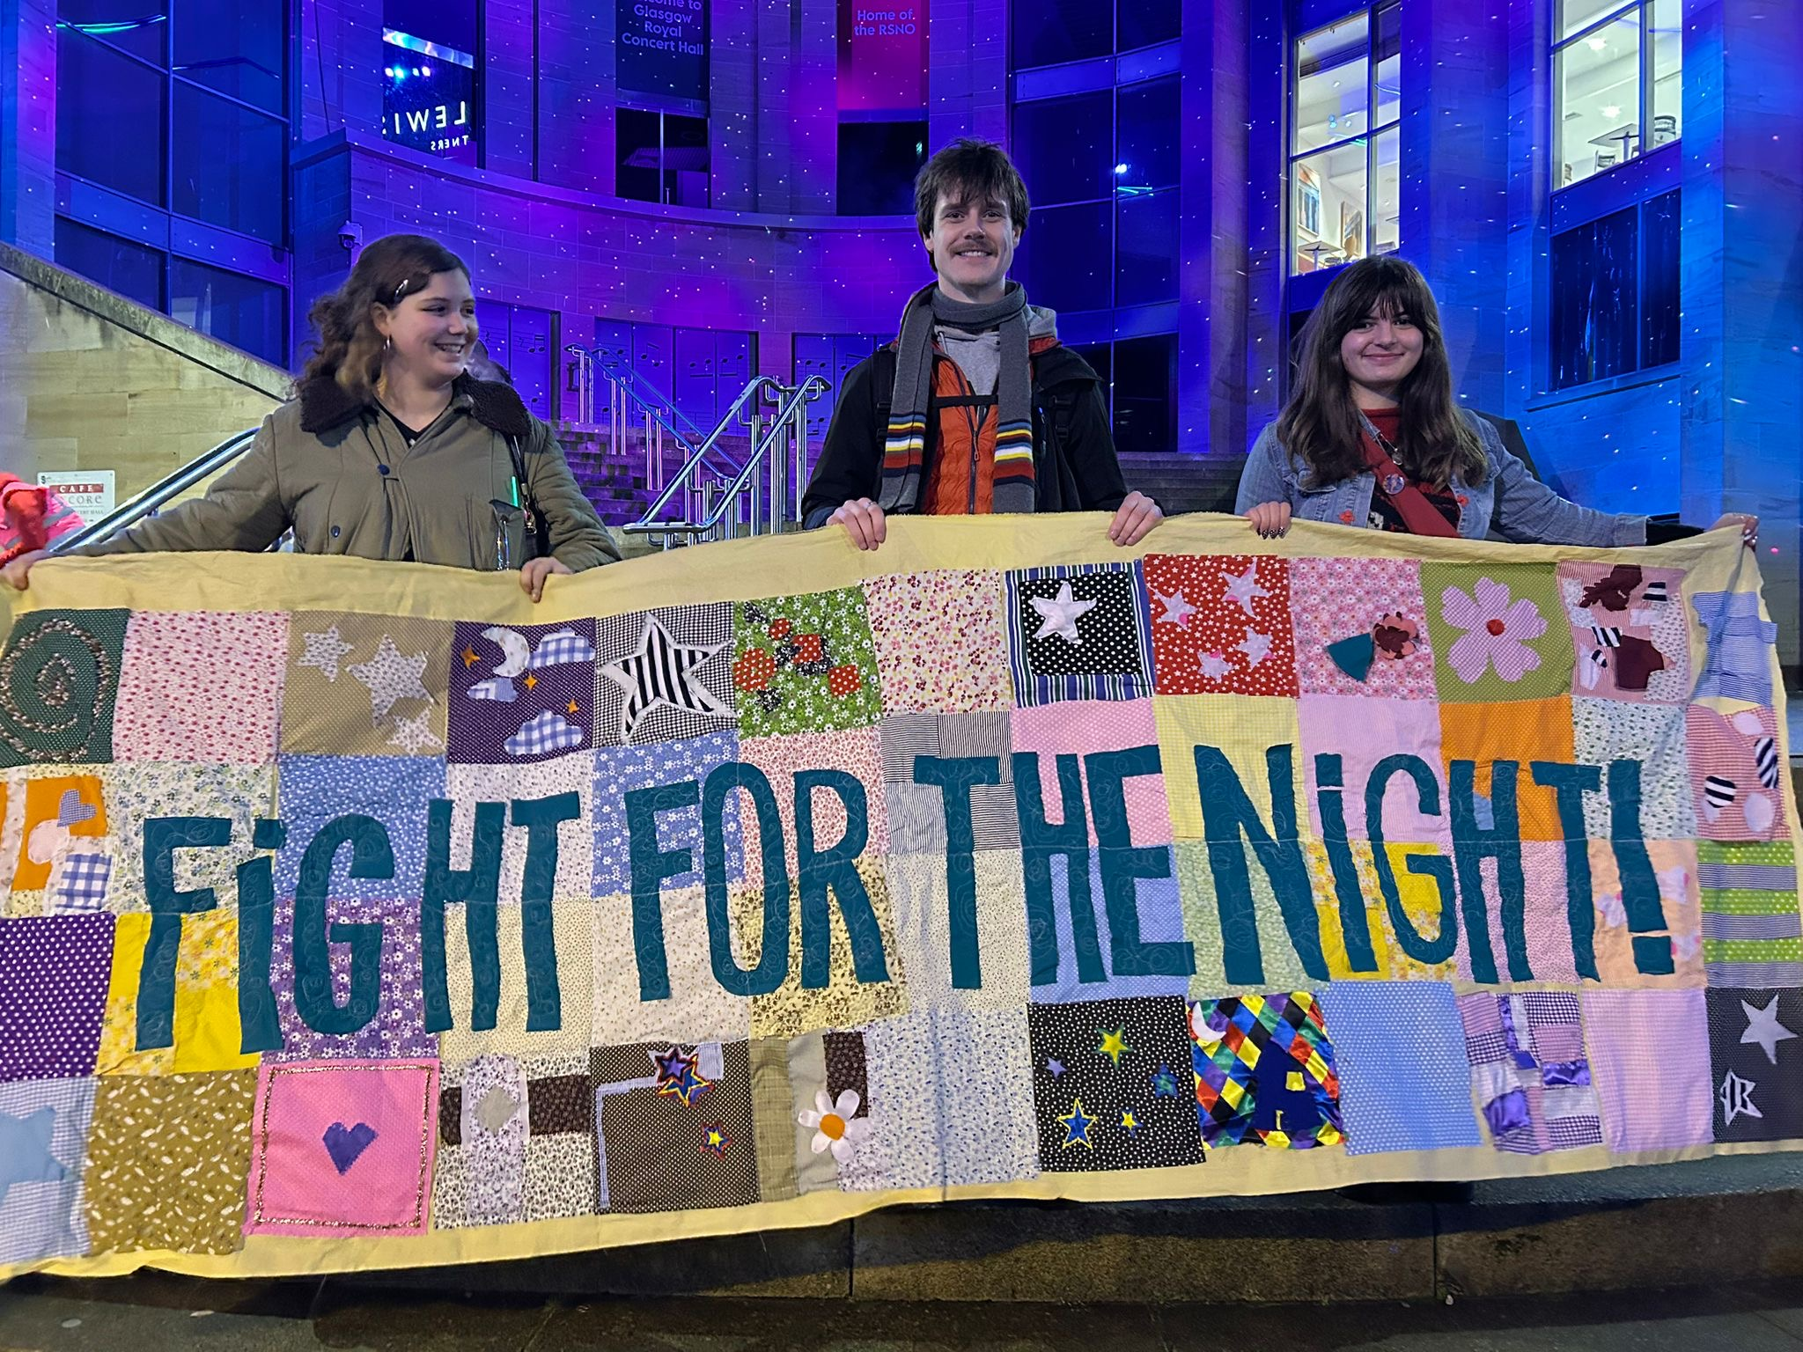
Image 1: GSA Sabbaticals & President of Stitch and Bitch holding the Fight for the Night banner on Buchannan steps

Ask Angela
The GSA Students’ Association has introduced the Ask Angela initiative at its campus bar, The Vic, as part of ongoing efforts to enhance student safety and wellbeing. Staff have received dedicated training to respond appropriately when the code phrase “Ask Angela” is used, ensuring discreet and effective support for anyone feeling unsafe. To raise awareness, posters explaining the initiative have been distributed throughout the building.

Digital Accessibility
The Library and Learning Technology team have continued their work in providing support in improving digital accessibility including:

- Accessibility Workshops: Creating Accessible Documents and Canvas courses.
- Demos and sessions on using Ally (accessibility tool in Canvas) to staff
- Attended Staff and Student Consultative Committees (SSCC) to raise awareness of the tool to students and staff.

Library staff have started remediation work in Canvas, using Ally to add alternative text to images. With Ally the goal is to achieve an 80% accessibility score across all Canvas courses.

Dignity and Respect at Work Workshops
Participative workshops were delivered to staff, covering key areas such as raising awareness of the GSA’s Report and Support tool, the legal principles and legislation underpinning dignity at work, recognising disrespectful behaviours, and addressing bullying and harassment via internal process, policy, and procedure. Practical tips and techniques were shared to help individuals and teams promote and uphold dignity and respect in their daily interactions. 8 workshops have been delivered to 40 attendees since the last reporting period.

Equality, Diversity, and Inclusion Committee (EDIC)
Chaired by the Secretary and Registrar, EDIC brings together representatives from across GSA and reports directly to the Senior Leadership Group, ensuring that equality, diversity, and inclusion remain embedded in institutional decision-making.

The Committee continues to meet three times a year, addressing key strategic and operational priorities. Recent areas of focus include:

- Approval of the National Equality Outcomes Strategy and Implementation Plan
- Review and discussion of disaggregated Student Experience Survey data
- Approval of questions for the Staff and Student EDI survey
- Establishment of a Gender-Based Violence Working Group
- Consideration of the Supreme Court ruling on the definition of “woman”
- Updates from the Menospace Network
- Updates on GSASA’s Trans Healthcare Week and other trans inclusion initiatives
- Feedback on the Wellbeing Spaces map from Estates

For transparency, all agendas and minutes are available to staff and students via the intranet.

#erasethegreycampaign
As part of the 16 Days of Activism Against Gender-Based Violence in 2025, GSA actively participated in the Erase the Grey initiative by distributing campaign posters across the Glasgow campus. Originally developed by Glasgow Caledonian University, the #erasethegrey campaign aims to challenge misconceptions about gender-based violence, raise awareness of its many forms, and signpost individuals to available support services.

Staff can access downloadable poster templates and an accompanying awareness video via the campaign resources: #erasethegrey | There are no grey areas when it comes to gender-based violence - YouTube

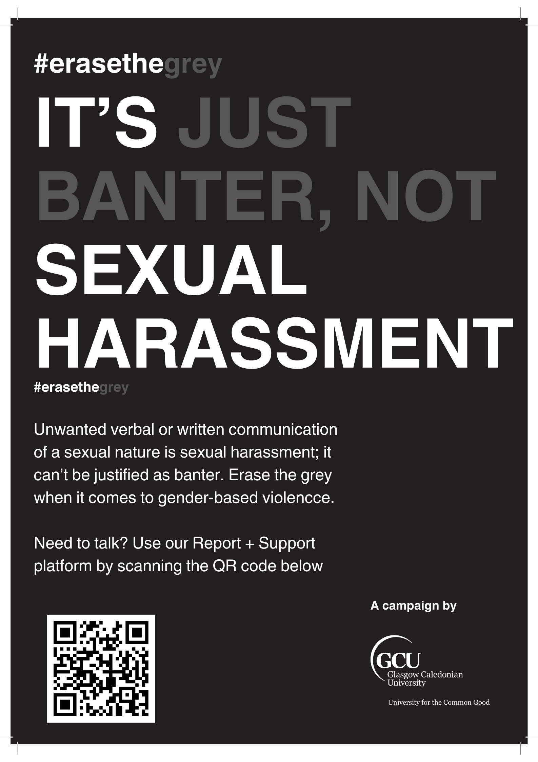
Image 2: an #erasethegrey campaign poster

Exhibitions Equality Impact Checklist
GSA Exhibitions delivers a dynamic year-round public programme that connects research, teaching, student experience, and the heritage of The Glasgow School of Art, while collaborating with UK and international artists, designers, and architects. In 2025, GSA Exhibitions has continued to use the Equality Impact Checklist they developed to ensure exhibitions, events, and interpretation content are accessible and considerate of diverse audiences. The checklist guides staff and students to assess content for inclusivity, representation, accessibility, and potential sensitivities, and to implement mitigations where necessary.

Inclusive Learning, Teaching and Assessment Working Group
Following sector-wide recommendations arising from the Bristol vs Abrahart ruling, an analysis identified the need to strengthen institutional practice and understanding around disability disclosure. The GSA’s Inclusive Learning, Teaching and Assessment Working Group is reviewing institutional risk appetite, reporting processes, awareness of reasonable adjustments, policy amendments, and approaches to achieving inclusive design and practice across learning, teaching, and assessment in alignment with the GSA’s Education Strategy 2023–2027. As part of this work, the Reasonable Adjustment Policy was revised and approved by Academic Council in November 2025

Mental Health First Aid & Mental Health Awareness Training
23 members of staff attended Mental Health First Aid training in April and September 2025. A Mental Health Awareness session was held in January 2025 with 18 people participating.

Report and Support
Following its renewal in early 2025, GSA continues to actively promote the Report and Support tool, powered by Culture Shift. This online platform is available to all staff, students, and visitors to report incidents of bullying, harassment, abuse, assault, or discrimination, either anonymously or with contact details for follow-up support. The tool also provides access to both internal and external support resources.

In November 2025, GSA participated in Culture Shift’s Community of Practice event at City of Glasgow College, creating opportunities to network and share best practice in tackling harassment and discrimination.

Feedback has indicated that some students were unaware of the full range of issues that could be reported. In response, GSA developed and distributed posters across campus and shared detailed guidance in the Equality Newsletter. The tool continues to be promoted through staff and student intranets, landing pages, the Student Handbook, and induction materials.

Between 1 September 2024 and 31 August 2025, 36 reports were submitted via the platform, 25 of which were from students.
Table 24: Report and Support Incident Types

Harassment (11) and discrimination (8) are the most frequently reported incidents, followed by “Other” (7) and racism (7). Please note that multiple options could be selected in a single report.
Table 25: Report and Support Anonymous and Named Reports

Of the 25 reports made by students between 1st September 2024 to 31st August 2025, 15 were made anonymously and 10 were named.

Table 26: Reasons for Reporting Anonymously

The leading reason respondents chose to report anonymously was concern that the individual involved might discover they had been reported (8). This was closely followed by feelings of being in a position of lesser authority (7) and worries that reporting could negatively affect their future career or academic prospects (7).

Table 27: Outcomes of Reports

Most cases resulted in informal action (15), with only a small proportion escalating to formal processes (3).

Student Support will work in partnership with People and Culture to develop a combined student and staff report, identifying any concerns or trends with informed action when required. This will be reviewed by the Equality Diversity and Inclusion Committee (EDIC) on an annual basis. Trust in reporting mechanisms will be ascertained via the proposed institutional equality survey.

Staff eLearning
To support the creation of inclusive and supportive working and learning environments, all staff are required to complete the following mandatory online training every three years:

- Equality and Diversity in the Workplace
- Complaints Handling
- Identifying and Responding to Student Mental Health Problems
- Safeguarding

Beyond these mandatory modules, GSA provides a comprehensive suite of Equality, Diversity, and Inclusion (EDI) learning opportunities. Courses include:

- Being an Active Bystander
- Bullying and Harassment for Managers
- Bullying and Harassment for Staff
- Care Experience & Corporate Parenting
- Dignity and Respect at Work
- Disability Awareness
- Diversity in Learning & Teaching
- Freedom of Speech
- Gender-Based Violence
- Guidance for Managers on Having Wellbeing Conversations
- Inclusive Leadership
- Inclusive Manager’s Toolkit
- Inclusive Recruitment
- Insiders and Outsiders – How Micro-Behaviours Affect the Workplace
- Let’s Talk About Race in the Workplace
- Menopause at Work
- Neurodiversity at Work
- Overcoming Unconscious Bias
- Supporting Transgender Staff and Students

Key modules essential to driving the GSA’s progress toward the NEOs are actively promoted, with completion rates closely monitored to ensure engagement and success.

Student eLearning
eLearning courses, offered on a voluntary basis, are actively promoted through Equality Newsletters, induction programs, during Independent Study Week and during Creative Skills Work weeks programme to maximise accessibility and engagement. The available modules are:

- Bystander Intervention: Know how to help safely
- Gender-Based Violence
- Mental Health Training
- Sexual Consent
- Understanding Wellbeing

Widening Participation
In the 2024/25 period, total new registrations increased by 9% compared with the previous year, reflecting overall growth in engagement. The proportion of care-experienced students remained static at 4%, and registrations from SIMD20 learners fell by 5 percentage points. Similarly, there was a drop in registrations from refugees (from 4% to 2%).

Positively, both the number and proportion of students identifying as Black or a Person of Colour increased during this period (from 21% to 23%), indicating progress in diversifying the student body. Additional outreach efforts focused on schools local to GSA with high concentrations of priority-group pupils - particularly SIMD20 learners and young people of colour. Twenty-three schools were identified and provided with enhanced communications to encourage participation. The table below highlights where these targeted interventions have been effective and where further improvement is required.

Table 28: Widening Participation Users
 | 2023/24 | % Total | 2024/25 | % Total
Total new registrations | 374 | 100% | 408 | 100%
Care experienced | 14 | 4% | 17 | 4%
SIMD20 | 194 | 52% | 193 | 47%
SIMD40 | 98 | 26% | 117 | 29%
Carer | 43 | 11% | 51 | 12%
Estranged | 8 | 2% | 8 | 2%
Refugee | 15 | 4% | 8 | 2%
Black or Person of Colour | 78 | 21% | 95 | 23%

You are Safe with Me LGBTQ+ Badges
In 2025, Academic Development and Student Support introduced badges bearing the message “You are safe with me,” displayed in the colours of the LGBTQ+ flag. These badges are available to all students and staff who wish to actively show their allyship and create a visible sign of support. By wearing a badge, individuals help foster an environment where LGBTQ+ people feel respected, valued, and free to be themselves.

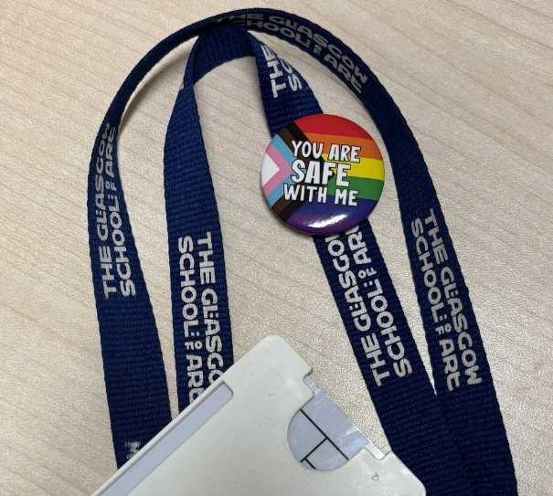
Image 3: “You are safe with me” badge on staff lanyard

Advance equality of opportunity between persons who share a relevant protected characteristic and persons who do not share it

In this section: Access Grants, Bereavement Support Group, Board of Governors Diversity Monitoring, CBT Session, Collections and Reflections Workshops, Digital Inclusion Scheme, Discretionary Funds, Dr Bike, Emergency Food Vouchers, Junk Journaling Sessions, Interactive Library Map, Learning and Teaching Conference, Mature Student Learning Experience, Mature Student Network, Maryhill Integration Network – Oasis Women’s Group, Men’s Mental Health Month, Mindfulness with Lego, Neurodiversity Affirming Practice Workshop, Neurodiversity Network, Personal Safety Workshops, Souper Tuesdays and Thursdays, Reasonable Adjustments Policy, See Me Scotland Training, Student Experience Survey, Student Mental Health Agreement 2025 – 2027, Student Support Drop in Sessions, Supporting Inclusive Wellbeing Toolkit, World Mental Health Day

Access Grants
The GSA Access Grant scheme is available to all students enrolled on a GSA programme of higher education. The scheme is funded through a combination of donations and central tuition fee income. Information about the grants is widely promoted to ensure equitable access, including via the Student Intranet, internal newsletters, Boards and Committees, and campus posters.

GSA Access Grants are awarded on the basis of financial need and are normally paid in two instalments across the remainder of the academic year. The scheme is designed to support students who experience limited access to statutory or alternative sources of student funding. This includes, for example, overseas students who may not be eligible for public funding. The Access Grant scheme also provides an important funding route for new students whose offer of study was made after the GSA Scholarships application deadline (31 May 2024).

Applications are assessed annually by an Awarding Committee, which reviews all eligible submissions. In line with the School’s equality objectives, the Committee is instructed to prioritise students who are considered vulnerable or who face additional financial barriers to participation.

In the 2024/25 academic year, 57 eligible applications were received. This resulted in 14 new Access Grant awards, with individual awards ranging from £1,000 to £4,000. In addition, three continuing students received a further payment in 2024/25 from Access Grant awards originally made in a previous academic year.

Table 29: Access Grant Awards
Year | Total annual amount awarded | Number of students supported
2024/25 | £17,500 | 17
2023/24 | £24,000 | 24
2022/23 | £23,500 | 21

Bereavement Support Group
A Bereavement Support Group was introduced by the Student Counselling Team in October 2025 to provide a safe, peer-led space for students navigating grief. The group aims to reduce isolation and foster understanding of the complexities of bereavement, regardless of when the loss occurred. Facilitated by two counsellors, the group meets every two weeks for eight sessions across the academic term, offering participants a consistent and confidential environment to share experiences and provide mutual support. To date, 26 students have registered to take part.

Cognitive Behavioural Therapy (CBT) Sessions
The pilot CBT student placement within the Counselling and Mental Health team has enabled CBT based, psychoeducational programmes to be introduced, exploring anxiety and managing change. In recognition of mental health awareness week, a 3-part workshop was delivered with 11 staff members attending focusing on stress, anxiety and coping with change.

Collections and Reflections Workshops
Collections and Reflections is delivered in collaboration with the Archives and Collections team and the Mental Health and Wellbeing team. These workshops provide students with an opportunity to engage mindfully with selected materials from GSA Archives & Collections, incorporating journaling, reflection, and creative activities designed to support mental health and wellbeing. The session aimed to create a calm, reflective space that encouraged creativity while promoting positive wellbeing.

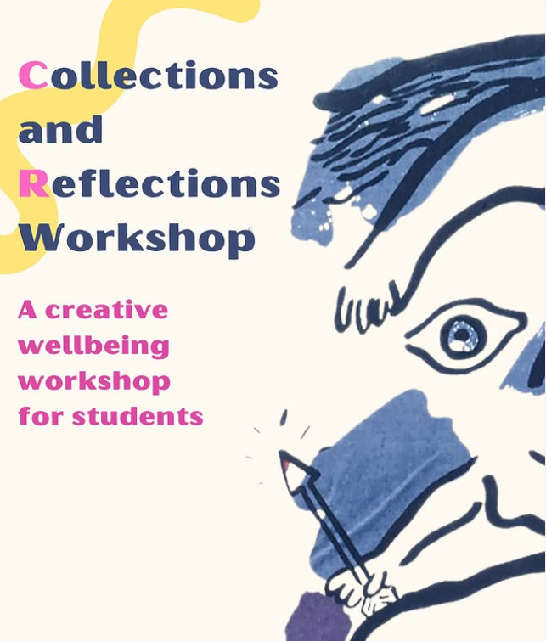
Image 4: Collections and Reflections Workshop promotional poster

Digital Inclusion Scheme
Established in 2020, the Digital Inclusion Scheme aims to remove barriers to learning arising from financial hardship and digital exclusion. The scheme provides long-term laptop loans to full time and part time undergraduate and postgraduate students who do not have access to appropriate IT equipment, ensuring equitable access to essential digital resources for study. Supporting the GSAs commitment to equality of opportunity, priority is given to those with the greatest need, including students with a household income of £34, 000 or less, care experienced students and students under 25 who are estranged from their parents.
Since its inception, the scheme has supported 655 students in accessing digital provision. The table below illustrates annual uptake across related support initiatives:
To maintain the scheme’s sustainability and meet evolving student needs, an additional £50,000 investment has been made to procure 15 high-specification laptops and 38 standard laptops, bringing the total available to 150 devices. This continued investment reflects the GSAs commitment to ensuring that all students have the tools required to succeed in their studies.

Table 30: Digital Inclusion Scheme
Academic Year | Digital Inclusion | Short Term Loan | Student Support | Total
2020/21 | 71 | 113 | 4 | 188
2021/22 | 124 | 208 | 18 | 350
2022/23 | 146 | 304 | 33 | 483
2023/24 | 154 | 381 | 38 | 573
2024/25 | 159 | 454 | 42 | 655

Discretionary Funds
Available to Scottish and RUK students, Discretionary Funds play a vital role in promoting equality of access and participation by reducing financial barriers for students who might otherwise struggle to continue their studies. By supporting living costs, childcare expenses, and disability-related needs, these funds help ensure that students from these backgrounds can engage fully with their education. This targeted financial assistance contributes to a more inclusive learning environment, enabling students to focus on their academic success rather than financial hardship.

Table 31: Overview of funding allocations
Year | No. of students | Total value of awards | UG living costs | PG living costs | UG disability diagnosis | PG disability diagnosis | Childcare costs
20/21 | 44* | £145,090 | 91 | 22 | 36 | 7 | 7
21/22 | 198* | £135,742 | 117 | 23 | 50 | 4 | 4
22/23 | 163* | £136,668 | 120 | 16 | 27 | 1 | 3
23/24 | 125* | £96,533 | 107 | 18 | 18 | 2 | 4
24/25 | 116* | £108,072 | 79 | 22 | 11 | 0 | 4
* Some students received discretionary funds and disability diagnosis or childcare costs but were not counted twice

Dr Bike
Monthly Dr Bike sessions continue to provide refreshments and free bicycle repairs for staff and students, encouraging active travel, reducing financial barriers, and supporting wellbeing.


Image 5: A Dr Bike Promotional Poster

Emergency Food Vouchers
The Student Welfare Service continue to work with the Development Office to maintain funding for emergency food vouchers scheme with £2,000 in place for session 25/26.

Table 32: Emergency Food Vouchers
Emergency Food Vouchers | Students | Total
2022/23 | 15 | £825
2023/24 | 27 | £1,800
2024/25 | 22 | £1,600

Interactive Library Map
In 2025, the Library team developed a new interactive map to help users navigate the space. The map aims to make it easier for people to find what they are looking for, but also to allow people to view the space and layout before visiting the building. This may help to ease any feelings of anxiety students may have around accessing new spaces.

Junk Journaling Sessions
Monthly junk journaling sessions are organised by the Mental Health and Wellbeing Team to encourage creativity and self-expression as part of wellbeing support. The sessions offer participants the opportunity to design their own journals using provided materials, with the option to bring personal items for inclusion. This initiative aimed to foster connection, reduce stress, and promote positive mental health in an informal, welcoming environment.

Learning and Teaching Conference – Keynote and Panel on Inclusive Education
Reflecting the Scottish sector priority of supporting diverse learner journeys, the 2025 Learning and Teaching Conference focused on the theme Diverse Learner Journeys: Supporting Students to Succeed, encouraging discussion on how institutions can better support student diversity from entry to graduation and beyond.

The conference opened with a keynote by Professor Khadija Mohammed (University of the West of Scotland), a leading advocate for anti‑racism and racial equity in education. Drawing on lived experience, she explored identity, systemic inequality, and inclusive curriculum design, calling for strategic leadership to embed equity and global awareness in educational practice.

This was followed by a panel discussion, Supporting Diverse Learner Journeys at GSA, featuring Professor Khadija Mohammed, Alicia Bickerstaff (Student President, GSA Students’ Association), and Professor Jimmy Stephen Cran (Head of Fashion and Textiles, GSA). The panel considered how GSA can more effectively respond to student diversity and co‑create inclusive learning environments.

Mature Student Learning Experience Project
The Mature Student Learning Experience Project was presented at the Learning and Teaching Conference in June 2025. Led by a Widening Participation and Articulation Manager and a Student Consultant, it explored mature undergraduate students’ transitions into and through GSA, focusing on support needs, adaptation, and strengths. A key output was a Journey Map highlighting the balance between academic study and personal responsibilities. Participant feedback informed the final resource, which will support future planning and aligns with national equality outcomes addressing inequalities affecting students aged 25+.

Key outcomes included new approaches to engaging mature students through Student Support’s Mature Student Network and the development of a tips and hints guide for new entrants. The guide draws on mature students’ lived experiences of transitioning to art school while managing additional commitments.

Mature Student Network
A Mature Student Network was established by the Mental Health team in 2025 to provide a supportive community for students who have entered higher education later in life, are making a career change, or have returned to study after a break. The network offers a space to connect with like-minded peers and foster a sense of belonging during their time at GSA. Monthly lunch gatherings and social events outside of the GSA create opportunities for informal networking and mutual support. To date, up to 45 students have participated in these activities.

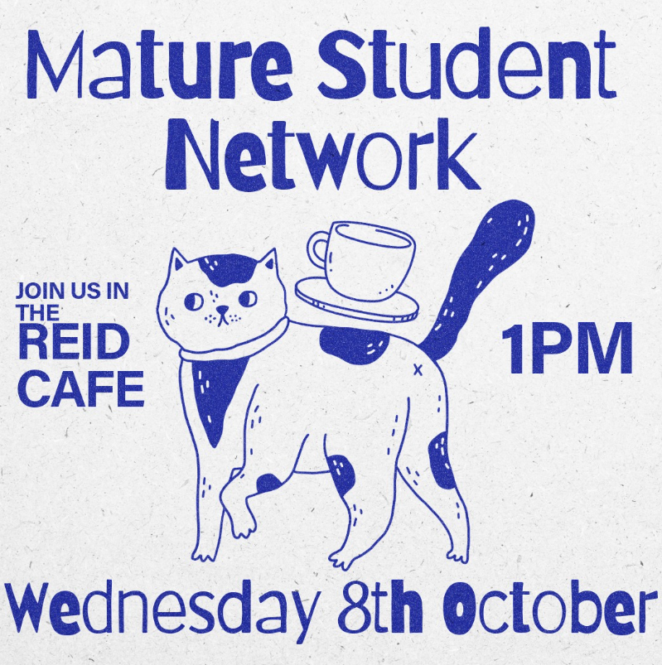
Image 6: A Mature Student Network promotional poster

Maryhill Integration Network – Oasis Women’s Group
GSA’s Archives and Collections team led a partnership project with Maryhill Integration Network’s Oasis Women’s Group. The initiative focused on exploring items from the GSA collections, which served as inspiration for a collaborative tapestry created by the group. The piece incorporates a range of techniques drawn from the GSA’s historic needlework collections and acts as a medium for participants to share personal narratives and establish connections with selected objects.

The final exhibition of this work is scheduled for March 2026, aligning with International Women’s Day and Gender Equality Month. This project was supported by a Sustainable Co-Production Fund, which aims to embed long-term change in how museums engage with communities, particularly those historically excluded from cultural spaces.

Men’s Mental Health Month
In November 2025, during Men’s Mental Health Month, Student Support launched a targeted campaign aimed at reducing stigma and encouraging male staff and students to access the mental health services available at GSA. The campaign featured Instagram posts and stories, as well as a dedicated section in the Equality Newsletter.

The newsletter reached 1,171 readers, and generated 25 direct clicks to key resources, including the Mental Health and Counselling booking portal and the Employee Assistance Programme. This engagement demonstrates the positive impact of focused awareness initiatives in promoting mental health support among men within the GSA community.

Mindfulness with Lego
The Library runs monthly Mindfulness with Lego sessions, which encourage students to practise mindfulness through the tactile nature of Lego.

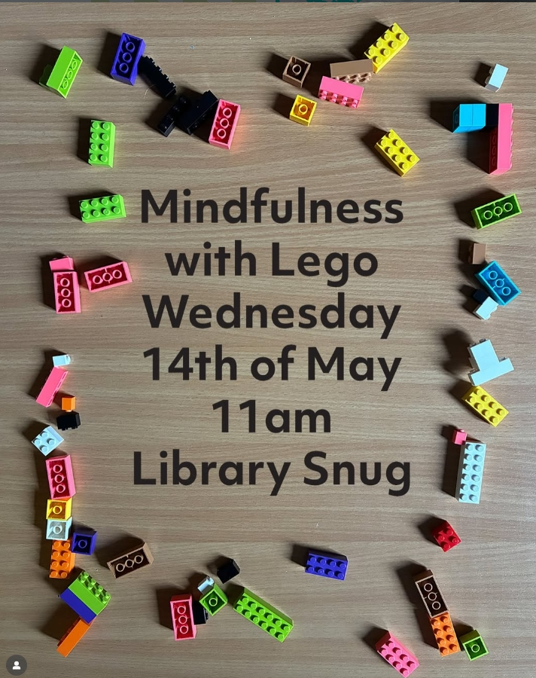
Image 7: Mindfulness with Lego promotional poster

Neurodiversity-Affirming Practice Workshop
Delivered by Daisy Abbott, a Research Developer from the School of Innovation and Technology, this workshop reframed neurodiversity as a strength. It explored neurodivergent experiences, introduced game-based learning, and identified practical steps to enhance inclusive teaching.

Personal Safety Training
In June 2025, a Personal Safety Training session was delivered to 25 members of staff, covering keep topics such as the legal framework surrounding self-defence, techniques for voice control and stance, and practical self-defence. As part of the 16 Days of Activism Against Gender Based Violence campaign in November, the training was also offered to students. Ten students registered for the session, with five attending. To ensure continued access to these important resources an additional session in January 2026 was held.

Reasonable Adjustment Policy
Analysis of sectoral recommendations in response to Bristol v Abrahart (2024) identified the need to enhance our practice and awareness of disability disclosure. Consequently, in 2025, the student Reasonable Adjustment Policy underwent a comprehensive review and update to strengthen accessibility and support for students with additional needs. Key improvements include simplifying the Reasonable Adjustment Report (RAR) process, making it easier for students to request and implement adjustments, and ensuring clearer communication between students, academic staff, and Student Support.

Souper Tuesdays and Thursdays
Building on the success of previous years, Souper Tuesdays and Thursdays were reintroduced in November 2025 to provide free hot meals for students during the winter months. Each Tuesday and Thursday, vegetarian soup and bread are served in GSA campus cafés, creating warm, welcoming spaces that support wellbeing and help alleviate financial pressures associated with the cost of living.

See Me – Empower Change Training
In October 2025, the GSA participated in the See Me Scotland pilot training focused on equipping staff, regardless of role or profession, with the confidence and skills to have supportive conversations about mental health. The sessions aimed to strengthen understanding of legal responsibilities under the Equality Act (2010) and the Public Sector Equality Duty, while building knowledge and practical strategies for supporting students and staff living with mental health conditions. A total of 30 participants from across the GSA engaged in scenario-based practice, action planning, and explored resources to challenge stigma and promote inclusion. The programme emphasised creating a culture where mental health conversations are normalised, leaving staff feeling empowered to provide support and advocate for change.

Speaking Your Mind
GSA continues to deliver Speaking Your Mind - weekly second-language support sessions designed to build students’ confidence in English, enhance engagement, and develop strategies for effectively communicating creative ideas. These sessions play a vital role in supporting international students and fostering inclusive learning environments.

Despite fewer sessions in 2024/25, attendance has increased, reflecting growing demand and engagement.

Table 33: Speaking Your Mind Participation Overview
Year | Number of sessions | Total attendance
2022/2023 | 39 | 261
2023/2024 | 42 | 281
2024/2025 | 21 | 288

Student Experience Survey 2025
Since the GSA’s last Mainstreaming Equality Report, the Student Experience Survey has been enhanced to include disaggregation by protected characteristics, enabling the GSA to better measure progress towards the NEOs. This approach allows for identification of trends and supports proactive, targeted action. Analysing data through the lens of protected characteristics, GSA can identify and address disparities, ensuring that equality and inclusion remain central to decision-making and continuous improvement.

In 2025, the survey received 1083 responses, representing a 43.2% response rate, with overall student satisfaction recorded at 78.1%.

Student Mental Health Agreement 2025 - 2027
In 2025, a new Student Mental Health Agreement was developed in collaboration with the GSA Students’ Association and is now being implemented as part of the GSA’s commitment to the NUS Think Positive initiative in alignment with the Scottish Government Student Mental Health action-plan. To support this, Student Support continues to strengthen external partnerships with the NHS and third-sector services, including ESTEEM, SAMH’s Compassionate Distress Response Service, Papyrus, local GPs, the Glasgow Council for Alcohol, and the new SAMH Glasgow drop-in hub. Workshop delivery aligns with the priorities of the agreement, addressing key areas such as creative wellbeing, meditation, journaling, mindful photography, and nature. Partnership initiatives include Mindful Creativity and Collections and Reflections workshops with Library and Archives, Art for Wellbeing peer groups co-facilitated by trained postgraduate students, and a library book club -promoting a holistic, institutional approach to wellbeing.

Student Support Drop in Sessions
Student Support is committed to improving the visibility and accessibility of its services, acknowledging that some students encounter barriers when seeking help. Strengthening collaboration with teaching staff remains a key priority, fostering earlier referrals and a deeper understanding of student needs. To support this, weekly, school-based lunchtime drop-in sessions (12:00–14:00) were introduced in late 2025. These sessions have been held across campus in locations such as the Reid, Stow, and Barnes buildings to ensure accessibility and visibility. They provide students with a convenient opportunity to learn about available support and register with the service, while also creating a space for staff to ask questions and enhance communication with our team.

Supporting Inclusive Wellbeing Toolkit
A Supporting Inclusive Wellbeing Toolkit has been launched and is available on the Staff Intranet. The resource was designed to be easily navigated and suitable for both managers looking to support their team and employees with a disability, health condition, or specific workplace needs. The Toolkit offers practical help by bringing together key tools, guidance, and support in once central location including:

- Key policy documents
- Guidance and resources on reasonable adjustments
- Personal Workplace Support Plan (template and step-by-step guidance)
- Independent Stress Risk Assessment (ISRA) form and guidance on managing work-related stress
- Discussion guides to support open and productive conversations
- Direct links to external support services, including Access to Work and our Employee Assistance Program (EAP)

World Mental Health Day
GSA Halls celebrated World Mental Health Day with activities in Blythswood House promoting wellbeing and awareness, including origami workshops, sustainability-themed sessions, and a visit from Therapet dogs. The Library offered relaxation spaces such as the snug with games and “Shelf Help” resources, and the Silent Sensory Room provided a calming environment for reflection.

These initiatives highlight GSA’s commitment to mental health and inclusion, ensuring staff and students know support is always available through Student Support services.

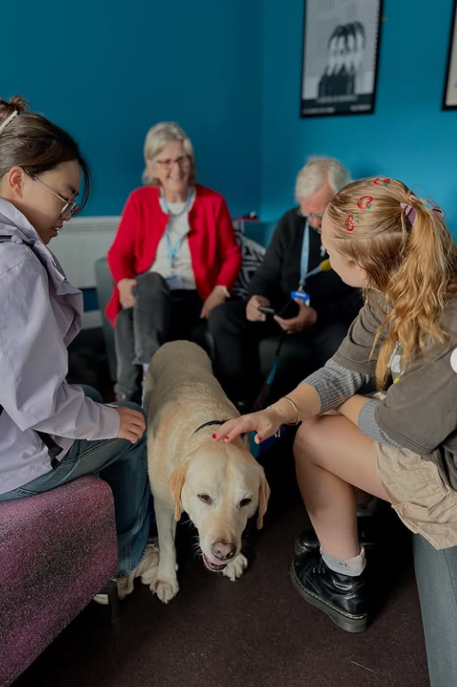
Image 8: “Therapets” at Blythswood House Halls of Residence

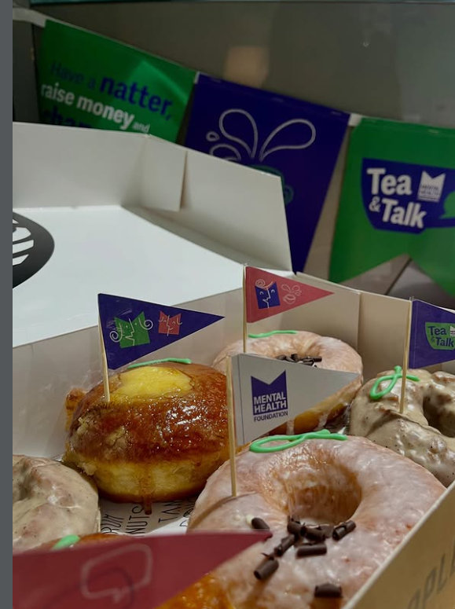
Image 9: GSA Halls World Mental Health Day Celebration

Foster good relations between persons who share a relevant protected characteristic and persons who do not share it

This section includes: Agency and Imagination Blow in the Winds of the Liberal State Exhibition, Black History Month, Book Club, Critical Studies in Sound for Moving Image, The Dance Short Film, Decolonising Research Workshop, Design for Care Project – BA (Hons) Interior Design, Empire Retold: Other Voices from the British Empire, Equality Newsletter, Garnethill Synagogue Tour, Inclusive Library Collections, Lunar New Year Card, Mother Curator, Migrant Garnethill Exhibition, The Maud Sulter Annual Lecture with Pratibha Parmar, Neurodiversity Forum, Race, Rights and Sovereignty Series, School EDI Leads, Student Consultants (EDI), Visual Language Glossary, Why We Ride – Film Screening and Panel Discussion

Agency and Imagination Blow in the Winds of the Liberal State Exhibition
This exhibition, held at the Glasgow School of Art’s Student Association, showcased the creative work of students of colour from across the institution, exploring themes of race, identity, and lived experience. The diverse collection included a standout piece by an Interior Design student, Jessie Orville, who conceptualised a beauty parlour designed specifically for mixed-race women, reimagining space as a site of empowerment and belonging.

The exhibition attracted approximately 60 visitors and provided a valuable platform for underrepresented voices in art and design. As a gesture of appreciation, participating students received vouchers in recognition of their contributions.

Complementing the visual work, a curated selection of books was displayed in a vitrine, including Women, Race and Class by Angela Davis, works by bell hooks, and (insert author/title). Free copies of Saidiya Hartman’s Venus in Two Acts were also made available to visitors, encouraging further engagement with critical Black feminist thought.


Image 10: Promotional poster for the “Agency and Imagination Blow in the Winds of the Liberal State” exhibition

Black History Month 2025
The GSA Students’ Association celebrated Black History Month in 2025 through partnerships with IMP!romptu and Woodlands Community Glasgow, delivering events that highlighted Black creativity and anti-racist dialogue. The Students’ Association hosted IMP!’s “Weird Eagle” music event, talk, and exhibition, showcasing work from creatives of Nigerian heritage living in Glasgow and across Scotland. The exhibition featured visual art, fashion, music, short film screenings, and live performances, celebrating artists who challenge norms through art and culture.

Additionally, the GSA Library curated a dedicated book display featuring a wide range of resources, including books, zines, and films. A comprehensive list of these materials was made available via a Padlet, accessible through the Library’s Linktree, alongside links to the Race and Rights subject guide and a Black History Month playlist on Planet Estream. The physical display was in the journal section of the reception area, encouraging staff and students to explore, engage, and deepen their understanding of Black history and culture.


Image 11: The Library’s Black History Month Display

Book Club
A monthly Book Club, hosted by Student Support, takes place in the Snug on the Library’s ground floor. The Library Snug is one of the GSA’s dedicated wellbeing spaces where students can relax and take some time for themselves. There is comfortable seating, plants, games, fidget toys, and our collection of books on health and wellbeing.

The Book Club is an informal gathering provides a welcoming space for students and staff to share and discuss the books they are currently reading, fostering community, conversation, and a love of reading in a relaxed environment.

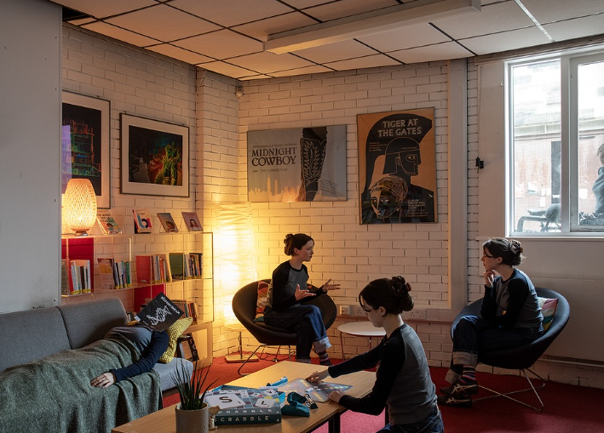
Image 12: The Library Snug

Critical Studies in Sound for Moving Image
In Year 3, the Critical Studies in Sound for Moving Image course in the School of Innovation and Technology engages students with contemporary issues surrounding representation, ethics, and equality in media. The curriculum addresses critical questions such as:
“Do AI machine learning models regurgitate and amplify human biases (gender, race, ethnicity), perpetuating hate speech and stereotyping?”

Recent sessions have explored themes including diasporic filmmaking and critiques of colonialism and cultural stereotyping in cinema. As part of this work, students are introduced to the Glasgow School of Art’s equality processes, with practical guidance on creating films that avoid harmful stereotypes and promote inclusive narratives. This approach supports the development of Creative Citizenship, encouraging students to consider the social impact of their work.

The Dance Short Film
The Dance is a short film by Anthony Coffield and Iona Taylor, created through the Student Partnership Project at The Glasgow School of Art. Blending art and advocacy, the film examines accessibility within the Reid Building, drawing from Iona’s lived experience as a wheelchair user.

Over the past three years, Iona has adapted to ongoing challenges in navigating the Reid Building, confronting barriers that remain despite accommodations. Through movement and dance, she expresses both the freedom her wheelchair can offer and the restrictions imposed by inaccessible spaces. The film highlights the unseen realities of navigating doors, lifts, and ramps, inviting viewers to reflect on what true accessibility means and to question whether our built environments genuinely serve everyone.

The impact of the project has extended beyond GSA. The Dance was showcased at the Glasgow Youth Film Festival at the Glasgow Film Theatre in September 2025 and has been selected for inclusion in the Little Venice Film Festival programme for Spring 2026, amplifying the conversation on accessibility in creative and public spaces.

The Estates department has met with students and created an action tracker listing all identified accessibility issues in the building for review and resolution. Actions include practical improvements such as replacing heavy steel doors with lighter aluminium doors to improve ease of access and engaging with the local authority to drop kerbs.

Decolonising Research Workshop
The Library continues to host Decolonising Research workshops, designed to support students preparing for dissertations. Delivered via Zoom and accessible through the Canvas course, these hour-long workshops aimed to empower students to approach research critically and inclusively.

Design for Care Project – BA (Hons) Interior Design
The Year 3 Design for Care project was co-delivered as part of the Studio course, with a focus on healthcare environments as a key typology within interior design. This initiative reflects a commitment to embedding inclusive design principles within the curriculum, ensuring students engage with real-world challenges that impact diverse user groups, including older adults and individuals living with dementia.
The project incorporated specialist input from the University of Stirling’s Dementia Design Research team. This collaboration provided students with access to expert knowledge on dementia-friendly design, including a dedicated lecture on design research and the application of Light Reflectance Values (LRVs) for material specification. Students also benefited from group tutorials and detailed feedback on their final proposals during the concluding review.
By embedding dementia design principles into the curriculum, the project promotes awareness of inclusive environments and the role of interior design in supporting health, wellbeing, and dignity. This approach equips students with the skills and understanding necessary to design spaces that meet the needs of diverse populations, contributing to the GSA’s broader equality objectives.

Empire Retold: Other Voices from the British Empire Exhibition
The 1938 Empire Exhibition in Bellahouston Park was a major international event intended to promote the achievements of the British Empire. Attracting around 13 million visitors, it played a significant role in shaping public perceptions of empire, yet little physical evidence remains today and its legacy is often overlooked.

Recognising the need to revisit this history through a postcolonial lens, Empire Retold, held in summer 2025, re‑examined the exhibition by centring voices excluded from official narratives. Presented in the Garnethill Gallery, the exhibition brought together perspectives from underrepresented communities and contemporary Glaswegians, exploring themes of colonialism, anti‑racism, identity and belonging, and encouraging critical reflection on Glasgow’s connections to empire.

Equality Newsletters
GSA publishes a quarterly Equality Newsletter, circulated to the Students’ Association, staff, and students, with an average readership of 1,102 per issue. The newsletter provides key updates and resources that support GSA’s commitment to creating an inclusive, welcoming learning and working environment. Recent content has included updates from EDIC, promotion of equality networks, recognition of religious holidays, acknowledgment of key EDI dates, and features on student projects with an equality focus.

As part of the 16 Days of Activism Against Gender-Based Violence campaign, a special edition newsletter was distributed to all staff and students, highlighting training opportunities, events, resources, and support related to GBV. This edition achieved 1,220 opens, exceeding the usual engagement rate, and generated 35 link clicks. Featured content included:

- GSA Students’ Association and BADFEM’s collaborative event - Solidari-Tea – A Day of Feminist Reading & Discussion
- Personal Safety Training for Students
- Information on the Report and Support Tool
- Where We Stop – short film on coercive control by Glasgow Girls Club
- Gender-Based Violence Training
- Guidance on staying safe for students


Image 13: Solidari-tea promotional poster

Garnethill Synagogue Tour
In April 2025, fourteen staff and students from the Glasgow School of Art participated in a two-hour tour of Garnethill Synagogue - Scotland’s first purpose-built synagogue. The visit included access to the synagogue's historic archives and collections, highlighting the work of prominent Jewish creatives such as Benno Schotz, Hilda Goldwag, and Marianne Grant (Hermann).


Image 14: Garnethill Synagogue photographed by Mahida Salam, PhD candidate, School of Architecture

GSA Degree Show 2025
The 2025 Degree Show featured a wide range of student projects that critically engaged with EDI themes, reflecting GSA’s commitment to embedding inclusive practice within creative education. Key thematic categories included:

- Gender, Identity and Representation
Projects explored intersecting aspects of gender, identity, and media representation, addressing questions of trans joy, gender fluidity, and Black feminism. These works challenged binary thinking and highlighted the inseparability of race, gender, and class in social contexts.
- Neurodiversity and Visibility
Creative responses celebrated neurological diversity, representing experiences of autism, ADHD, and other conditions. Projects interrogated stereotypes and advocated for inclusive narratives that reflect the complexity of human cognition and sociability.
- Race and Decolonisation
Students examined colonial legacies and the urgent need to decolonise creative practice and curricula. Works addressed cultural blind spots and called for critical engagement with histories of slavery, imperialism, and systemic inequality.
- Health and Wellbeing
Projects ranged from technology-driven innovations in healthcare to narratives of mental illness, questioning societal responses to psychological distress and imagining new models of care and community.
- Social Injustice
Projects tackled issues of race, class equity, isolation, disadvantage, migration, and bureaucracy, asking: “When equals are treated unequally and the unequal treated equally, what is our creative response?” These works often adopted political and philosophical perspectives to challenge systemic inequities and advocate for justice.

Several of these projects were featured in the Equality Newsletter and highlighted on the Student Intranet under “Student Spotlight,” amplifying student voices and sharing best practice across the institution.

GSA Student Association Societies
The GSA Student Association hosts a wide array of EDI orientated societies, offering welcoming platforms for social interaction, creative collaboration, and peer support.

- BADFEM
- Muslim Association
- Christian Union
- Jewish Society
- Palestine Solidarity Society
- Chinese Students and Scholars Association
- Sexual Reform Society
- Sunflower Society

Inclusive Library Collections
The Library’s Collection Management Policy commits to inclusive, sustainable, and equitable collections, shaped through co-curation to meet the needs of a diverse community of staff, students, and external members.

The library promotes representation through rotating displays linked to EDI events such as Black History Month, Pride Month, LGBTQ+ History Month, and International Women’s Day.

Ongoing reclassification and cataloguing work supports accuracy and inclusion, with recent projects including updates to the Library Snug health and wellbeing collection and improvements to the relevance and currency of the LGBTQ+ section.

Lunar New Year Card
Each year, GSA commissions a student or graduate to create a card that celebrates the New Year, providing an opportunity to highlight cultural traditions from around the world while promoting understanding and inclusivity.

Modest, Inclusive, Sustainable and Circular Considerations – Postgraduate Fashion
Postgraduate fashion students are encouraged to embed modesty, inclusivity, sustainability and circularity within their design process. This includes enhanced coverage, layering, opaque fabrics, and loose silhouettes; inclusive features such as adjustable sizing, age and sensory-friendly materials, and accessible fastenings; and sustainable practices including mono-materials, zero-waste techniques and biodegradable components.

Circularity is supported through product passports outlining materials, production ethics, care, repair, and end-of-life options. Students demonstrated mindful design in their Master’s projects, with the highest-achieving collection - gender-inclusive, adaptive, up-cycled and zero-waste - receiving the Chair’s medal for the School of Design and a commendation in the GSA Sustainability Graduate Degree Show Prize.

This approach promotes equality in relation to belief and disability while responding to the growing demand for modest and adaptive fashion and related employment opportunities.

Mother Curator Exhibition
Curated by fourth-year Fine Art student Emma Scarlett, Mother Curator was an exhibition hosted in the Reid Gallery in January 2026. It brought together both existing and newly commissioned works by GSA staff and students who are mothers. The exhibition seeks to reshape the narrative around motherhood, highlighting its complexity, creativity, challenges, and strengths - areas that are often undervalued in culture and society.

Image 15: Mother Curator Exhibition

The Maud Sulter Annual Lecture with Pratibha Parmar
In October 2025, SoFA, GSA Exhibitions, and RRS, in partnership with Glasgow Women’s Library and Street Level Photoworks, welcomed internationally acclaimed filmmaker, writer and activist Pratibha Parmar for the second Maud Sulter Annual Lecture.

This special event explored Parmar’s long-standing connection with the late artist, writer, and cultural historian Maud Sulter (1960–2008). The lecture series builds on Sulter’s legacy by providing a platform for Black and Women of Colour creatives to reflect on her work, its context, and its influence on contemporary practice. Through these conversations, the series ensures Sulter’s impact continues to inspire and inform future generations.

Migrant Garnethill Exhibition
In summer 2025, GSA hosted Migrant Garnethill, a community heritage exhibition created in partnership with St Aloysius Church’s ESOL class as part of Glasgow Life’s Uncovering Sauchiehall Street programme. The project celebrates Garnethill’s rich migrant histories and included film and artworks developed through community collaboration. Funded by the National Lottery Heritage Fund, the initiative highlights cultural diversity and fosters inclusion within Glasgow’s heritage landscape.

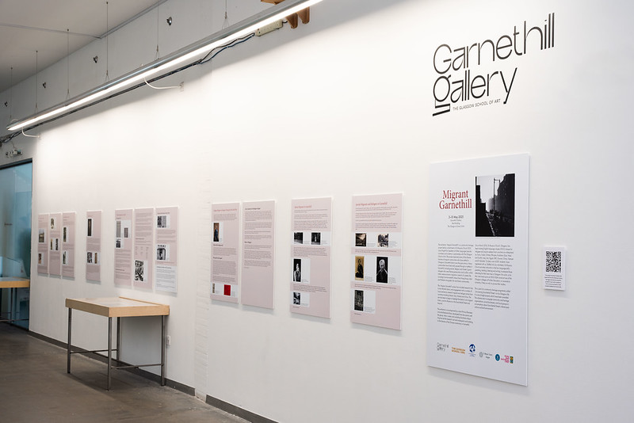
Image 16: Migrant Garnethill Exhibition

Neurodiversity Forum
In 2025, HR established a Neurodiversity Forum for neurodivergent colleagues and allies with the aim to shape a supportive community where experiences can be shared, workplace challenges discussed, and strategies for success exchanged. The forum also provides opportunities to raise awareness, advocate for meaningful adjustments, and collaborate on initiatives that promote inclusion and understanding.

Race, Rights and Sovereignty Series:
Race, Rights and Sovereignty (RRS) is a programme supported by the GSA Students’ Association in partnership with GSA Exhibitions. Now in its sixth year, the RRS programme continues to create inclusive spaces for dialogue and learning, supporting institutional commitments to advancing equality, fostering cultural understanding, and empowering the next generation of artists and designers.

Around Tropical Turns, Ways of Netting & Technologies of Relation: in May 2025, RRS hosted an online lecture with artists Juan Pablo García Sossa and Neema Githere. The discussion explored pluriversal approaches to technology, digital diasporas, and reindigenisation, challenging globalist narratives and centring perspectives from the Tropics and African diasporic thought.

Carried Across: Art, Memory, and Exile: In July 2025, U Belong Glasgow and RRS delivered a discussion and Q&A at The Glasgow School of Art with artists Malak Mattar and Sawsan Al-Areeqe, hosted by researcher Esraa Husain. The event examined how creative expression functions as resistance and documentation in contexts of forced displacement, while amplifying the voices of racialised groups, queer, and disabled communities.


Image 17: RRS promotional poster

Raindrops of Rani – Artist Talk and Screening: in September 2025, RRS presented an artist talk and screening with Scottish Pakistani interdisciplinary artist Aqsa Arif. The event showcased Arif’s immersive installation exploring displacement, generational trauma, and cultural memory, drawing on her family’s experience within the UK asylum system, and highlighting socio-economic inequalities in urban regeneration narratives.

School EDI Leads
The School EDI Leads continued to strengthen equality, diversity, and inclusion (EDI) activity across the institution, with new members joining from the School of Fine Art and the School of Innovation and Technology to enhance representation. Seven EDI Leads across four Schools play a key role in embedding inclusive practice, supporting the development and review of EDI policies, and acting as a point of contact for staff and students. Working with Heads of School and the central Equality, Diversity, and Inclusion Committee (EDIC), they align local initiatives with institutional priorities, convene area-specific committees, promote best practice, organise events, and encourage open dialogue on inclusivity.

Student Consultants (Equality, Diversity, and Inclusion)
Two Student Consultants (EDI) were recruited in 2025 to strengthen GSA’s work on race equality, anti-racism, and trans and non-binary inclusion. Working alongside the Equality Officer, they have conducted research into student experiences, identified barriers, and developed recommendations to inform institutional change. Reports will be presented to the Equality, Diversity, and Inclusion Committee, supporting progress toward the National Equality Outcomes. A budget has been allocated to recruit a third consultant in 2026.

Visual Language Glossary
The Visual Language Glossary (VLG) is a project, co-led by the Programme Leader Thomai Pnevmonidou and Learning Support Tutor Scott O’Regan McGowan, entered its second year, culminating in a publication archived in the GSA Library. The project encourages students to critically explore the language of interior design across cultures and languages, promoting inclusivity and awareness of linguistic diversity. The initiative was presented at the GSA Learning and Teaching Conference 2025 under the theme of Diverse Learner Journeys: Supporting Students to Succeed.

The VL/G project examines inclusivity in teaching, focusing on communication challenges within a diverse postgraduate cohort. Linguistic and cultural differences can hinder engagement, so we designed an initiative to enhance peer connections and foster meaningful learning experiences.

Through an open brief and guided discussions, students actively filled knowledge gaps and developed a shared understanding.

Rather than following a prescribed bibliography, participants curated their own, enriching the programme’s reading list with personally significant texts. The project sparked enthusiastic conversations on cultural pride, shaped by student ownership of the visualisation process, staff insights, and a well-defined purpose. It facilitated dialogue on values, identity, and global citizenship, reinforcing a sense of belonging.

By creating opportunities to recognise and integrate international students’ knowledge, the project encouraged deeper connections between first languages and English. “We were interested in the transition students make from the cultural reference points of value from their place of residence to the connections and values we communicate at GSA. Our early findings indicate meaningful linguistic and cultural associations, contributing to a more inclusive academic environment.”

Who’s Listening? Short Film
Who’s Listening? is a short film by Professor Ross Birrell (Contemporary Art Practice & Critical Theory, GSA), developed in collaboration with Palestinian musicians Ahmed Muin Abu Amsha and Fouad Khader of the Edward Said National Conservatory of Music in Gaza. Released to mark the UN International Day of Solidarity with the Palestinian People on 29 November, the film is dedicated to the more than 50,000 children killed or wounded during the Israeli attacks on Gaza. Drawing on Arabic lyrics composed by Abu Amsha and mobile phone footage filmed by Khader following an Israeli bombardment in Gaza City on 13 September 2025, the work bears witness to violence while foregrounding the role of artistic collaboration, testimony, and solidarity.

Why We Ride – Film Screening and Panel Discussion
In March 2025, a cycling-themed event further explored the intersection of sustainability, equality, and inclusion through film screenings and a panel discussion with local organisations including Dynamo (a queer-led, feminist cycling and maintenance project), Bikes for Refugees, and Women on Wheels. Films such as:

- After the Storm, which documents efforts to challenge racism and promote diversity in mountain biking
- Tour de Gaza, retracing the journey of cycling champion Alaa al-Dali and the creation of the Gaza Sunbirds, a para-cycling team supporting athletes with disabilities amid conflict.

These films reinforced the importance of representation and social justice within sustainable practices.

Definitions: Retention (Continue) = still enrolled at year end. Positive outcome = Continue + Left & awarded credit/qualification. Non-retained = Left without award + Transferred.

