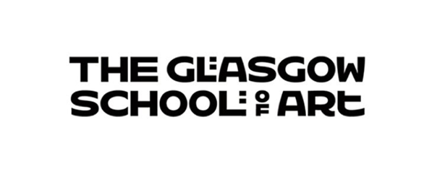

**Mainstreaming Equality Reports 2025**

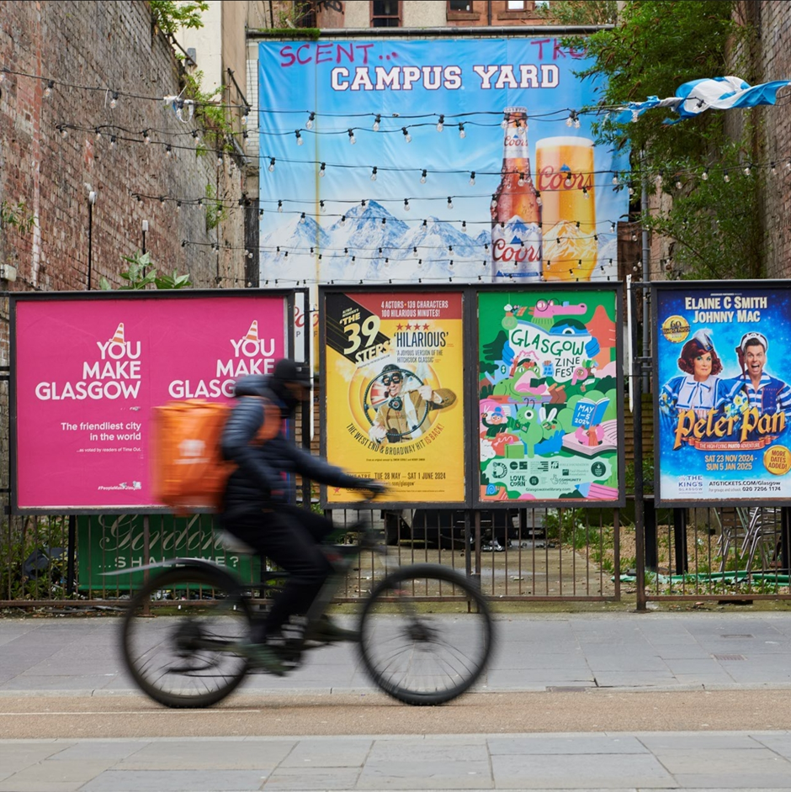

Image: Chao Zheng, *Cheers & Bye,* MDes Communication Design, 2024

**Foreword**

I am proud to present the Glasgow School of Art’s National Equality Outcomes (NEOs) and Mainstreaming Equality Report 2025.

At GSA, we are committed to fostering an inclusive and equitable environment where diversity is celebrated, and everyone has the opportunity to thrive. This report reflects the progress we have made in eliminating discrimination, advancing equality of opportunity, and fostering good relations across our GSA community. Over the past year, we have taken significant strides in embedding Equality, Diversity, and Inclusion (EDI) across our Institution, expanding both the breadth and impact of our efforts.

Guided by the Glasgow School of Art Strategic Plan 2022-2027, our Institution is committed to creating inclusive working and learning environments and celebrating the diversity of our staff and students, recognising the strengths this brings. Our Equality, Diversity and Inclusion Committee (EDIC) plays an important role in driving this work forward, helping to integrate EDI into our policies and practices and supporting progress towards the NEOs.

I am particularly proud of the development of our second Student Mental Health Agreement, reinforcing our dedication to supporting student wellbeing. While our staff and student surveys highlight ongoing concerns around mental health - aligning with the Scottish higher education sector - we recognise the urgency of these issues and are taking meaningful action to address them.

In the past year, we expanded our Digital Inclusion Scheme, developed an ethical Endowment Investment Policy, and broadened our staff and student EDI training. Our intersectional approach ensures that the lived experiences of our community remain central to our work, fostering a culture where every individual feels valued and empowered to reach their full potential.

Our People Strategy, launched in 2022, sets a clear roadmap building a diverse, engaged, and agile workforce equipped to deliver our strategic goals. We are committed to fair work practices and increasing workforce diversity, with clear actions and timelines in place. Additionally, we are enhancing our institutional oversight of key student data to inform policies that support fair access and address inequalities, as outlined in the GSA Education Strategy.

Looking ahead, we remain steadfast in our commitment to embedding EDI across all aspects of the GSA. By listening, learning, and working collaboratively with our community and beyond, we will continue to drive meaningful change and build an institution where everyone can flourish.

Professor Penny Macbeth

Director of the Glasgow School of Art

**Table of Contents**

Acronyms and Denotations5

Introduction7

Eliminating discrimination, harassment and victimisation9

Advancing equality of opportunity19

Fostering good relations24

National Equality Outcomes Progress Report34

Student Profile Data53

### **Table 1:** Acronyms and denotations

|  |  |
| --- | --- |
| **Acronym** | **Full title** |
| BSL | British Sign Language |
| CHP | Complaints Handling Procedure |
| DSA | Disabled Student Allowance |
| EDI | Equality, Diversity and Inclusion |
| EDIC | Equality, Diversity and Inclusion Committee |
| EEA | European Economic Area |
| EHRC | Equality and Human Rights Commission |
| EqIA | Equality Impact Assessment |
| FTE | Full Time Equivalent |
| GBV | Gender Based Violence |
| GSA | Glasgow School of Art |
| GSASA | Glasgow School of Art Student Association |
| HoS | Head of School |
| NEO | National Equality Outcome |
| PL | Programme Lead |
| pp | Percentage points |
| RAR | Reasonable Adjustments Report |
| SAAS | Student Awards Agency Scotland |
| SFPSR | Student-Facing Processional Services Review |
| SLG | Senior Leadership Group |
| SPSO | Scottish Public Services Ombudsman |
| WP | Widening Participation |

# 

# **Introduction**

The Glasgow School of Art is a small, specialist arts school with 2814 students and 671 staff members (excluding visiting workers). It is committed to high level, studio based, disciplinary creative visual arts’ education from pre-undergraduate through to doctoral study. The GSA provides this through four academic Schools: The Mackintosh School of Architecture, The School of Design, The School of Fine Art and The School of Innovation and Technology.

This report outlines the progress the Glasgow School of Art has made in mainstreaming equality, diversity and inclusion. Key examples of how this has been achieved, and ongoing actions are detailed under the three core objectives of the general duty of the Equality Act 2010 which are to:

* Eliminate discrimination, harassment, victimisation and any other conduct that is prohibited under the Equality Act 2010;
* Advance equality of opportunity between persons who share a relevant protected characteristic and persons who do not share it
* Foster good relations between persons who share a relevant protected characteristic and persons who do not share it.

The Mainstreaming Equality and National Equality Outcomes Report is an opportunity for the GSA to showcase its practice in relation to mainstreaming equality throughout its functions. Please note that this report will not repeat information contained within the GSA’s 2024 report which can be found here: <https://gsadocuments.net/category/equality-and-diversity/>.

Progress against the National Equality Outcomes (NEOs), which have replaced the GSA’s Equality Outcomes, is detailed within the report. These outcomes focus on improving equality across the protected characteristics under the Equality Act 2010, building on existing efforts at the GSA to foster more inclusive and diverse learning and working environments. A comprehensive mapping exercise was conducted to align priorities with the NEOs. This process identified key areas for advancing equality and highlighted gaps in current data. With support from the GSA’s central EDIC, work is underway to address these data gaps through the development of a National Equality Outcome Action Plan.

Going beyond legal requirements, the GSA publishes a Mainstreaming Equality and National Equality Outcomes Report annually, as well as reporting on our student profile. These are publicly available for all current and prospective staff and students, visitors and other interested groups and individuals. It will be publicised on the GSA’s staff and student intranet, the GSA’s public document store and will be shared via the GSA’s central communication channels.

Throughout this report, the term "ethnic minorities" will be used to refer to all ethnic groups except the White group. This is in line with gov.uk guidance. Additionally, the term "marginalised groups" will be used to describe communities at a higher risk of discrimination, including ethnic minorities, women, people with disabilities, and LGBTQ+ individuals.

# **Eliminate discrimination, harassment, victimisation and any other conduct that is prohibited under the Equality Act 2010**

Included in this section: *EDI Training (Corporate Parenting, Decolonising Resource Lists, Digital Accessibility, Dignity at Respect and Work, Mental Health Awareness, Scottish Refugee Council, Staff eLearning and Student eLearning) Endowment Investment Policy, Equality, Diversity and Inclusion Committee (EDIC), Report and Support, Widening Participation and Articulation*

## **Corporate Parenting Workshops**

In alignment with GSA’s Corporate Parenting Plan, Who Cares? Scotland facilitated a second Corporate Parenting workshops to 10 staff members in 2024. Prior to this, a top-down approach was taken with the first session targeted at SLG, Board members and Heads of Department. These sessions were fully-informed by the voices of Care Experienced individuals – children, young people and adults with lived experience of the care system. The workshops provided insights into what care experience is, clarified the responsibilities of Corporate Parenting, and outlined best practice for effective planning and reporting. A “Care Experience and Corporate Parenting” e-Learning module will be added to the GSA portfolio later in 2025, enabling all staff to understand and support those with care experience.

## **Decolonising Resource Lists Workshops**

Over the course of 17 months, 5 Decolonising Resource Lists workshops were delivered to 58 participants. The Library and Learning Resources also delivered 3 student workshops to 137 participants in this time period. These workshops aimed to promote critical engagement with colonial legacies in academic resources and explore strategies for creating more inclusive curricula. The sessions covered key themes, including the historical and current impacts of colonialism in academia, the importance of decolonisation in higher education, and practical steps for incorporating decolonising resource lists. The overarching purpose of these ongoing workshops is to foster more equitable and diverse learning environments.

## **Digital Accessibility Training**

The Library and Learning Resources has been delivering Digital Accessibility Workshops across the GSA to help staff create accessible content with the goal to ensure that both staff and students can fully engage and are not disadvantaged. 4 drop-in workshops were delivered to 7 members of staff from October - December 2024.  In addition to this, 1-to-1 consultations were made with staff from 2 departments on the process of improving the accessibility of forms. Guidance and support on digital accessibility is also available on the [Engaging with Digital page](https://canvas.gsa.ac.uk/courses/2491/pages/digital-accessibility?module_item_id=157534).

The GSA has integrated a new accessibility tool called “Ally” into our Canvas virtual learning environment. Ally is a tool that integrates with Canvas to automatically check the accessibility of course content. It performs two primary functions to improve the student experience and the accessibility of course content:

* **For instructors:** Ally provides feedback to instructors by assigning an accessibility score for each file. Instructors can click any score icon to launch a wizard that helps guide them through accessibility problems found with that file, and tips on how to fix them.
* **For students:** Ally automatically generates multiple alternative formats—such as tagged PDF, HTML, electronic braille, or audio—that students can download and use to support their learning. This means students can choose the format for all resources that best suits their learning style.

## **Enabling a Positive Culture - Dignity and Respect at Work Workshops**

To support the implementation of the recently refreshed staff Grievance Policy and Procedure and the Dignity at Work and Study Policy, 2.5-hour participative workshops were delivered to staff to explore the critical role of dignity and respect in fostering a positive workplace culture at the GSA. Participants delved into what dignity and respect truly mean and how everyone contributes to a supportive environment. The workshops covered key areas, including raising awareness of the GSA’s Report and Support tool, the legal principles and legislation underpinning dignity at work, recognising disrespectful behaviours, and addressing complaints of bullying and harassment. Practical tips and techniques were shared to help individuals and teams promote and uphold dignity and respect in their daily interactions. In total, two sessions were delivered to 14 staff members. More sessions are scheduled throughout 2025.

## **Endowment Investment Policy**

The GSA is dedicated to responsible and ethical investment practices. A new [Endowment Investment Policy](https://gsadocuments.net/wp-content/uploads/2024/11/Endowment-Investment-Policy-V2.0-October-2024.pdf) was publicly introduced in October 2024. This Policy was developed through extensive staff consultations and a thorough 12-month review of the School’s investment portfolio.

The Policy emphasises social justice and geopolitical considerations, explicitly excluding investments in entities that derive revenue from:

* Fossil fuels
* Armaments
* Using child labour
* High-interest rate lending

Or where there are controversies arising from or relating to:

* A firm’s supply chain
* The impact of a firm’s operations or human rights

There is also the continued commitment to avoid investments in companies which derive more than 5% of their revenue from:

* Tobacco
* Gambling
* Adult entertainment

Additionally, the Policy ensures that our investments observe internationally recognised sanctions. GSA investment managers play an active role in companies we invest in, exercising stewardship responsibilities through voting, engagement and public advocacy.

This enhanced approach will be implemented over the next year, allowing time for divesting from non-compliant investment and reallocating funds to compliant investments.

## **Equality, Diversity and Inclusion Committee (EDIC)**

EDIC was refreshed in 2024 after a gap in meetings between August 2023 and August 2024 due to staffing capacity. We consolidated progress and reaffirmed the GSA’s commitment to mainstreaming equality across the organisation. Chaired by the Secretary and Registrar, compromising membership across the GSA and reporting directly to the Senior Leadership Group, the committee has addressed a range of critical issues, including tackling religious-based discrimination, and supporting students with mental health challenges. Last year, the committee also advanced work on the National Equality Outcome Action Plan, aligning the GSA’s efforts with broader sectoral goals. Through initiatives such as targeted training, policy updates, and collaboration across departments, the EDI Committee continues to embed equality, diversity, and inclusion into the GSA’s practices, ensuring a culture of respect and belonging for all.

## **Mental Health Awareness Training**

The Mental Health and Counselling Service provides tailored mental health awareness training to frontline staff including studio assistants, library and halls of residence staff. The sessions cover what impacts student mental health, signs and symptoms, how to approach and support them and how and where to sign post. Additionally, the training explores how participants can look after their own wellbeing while supporting students. Throughout 2024, 5 sessions were delivered to 48 members of staff across the GSA.

In addition, St Andrews First Aid delivered two Mental Health Awareness workshops in 2024/25 to 30 members of staff. A Mental Health First Aid training course was also delivered to 15 frontline staff in January.

## **Scottish Refugee Council Training**

In October 2024, [the Scottish Refugee Council](https://scottishrefugeecouncil.org.uk/) delivered Access to Higher Education training to 17 staff across Widening Participation, Registry and Student Support. The three-hour session examined the barriers asylum seekers and refugees may encounter when pursuing higher education. Key topics included legal definitions, countries of origin, reasons for displacement, the asylum process, and associated rights and entitlements.

Participants also explored asylum support services, effective methods of providing assistance, and Sanctuary scholarships. The session also featured real-life case studies, discussions on trauma, and an in depth look at the refugee journey, equipping staff with valuable insights to better support displaced individuals within the GSA community.

Overwhelmingly positive feedback was received from participants, with all respondents stating that the session significantly enhanced their understanding of the area and boosted their confidence.

## **Staff eLearning**

To support the creation of inclusive and supportive working and learning environments, all staff are required to complete the following mandatory online training every three years:

* Equality and Diversity in the Workplace
* Identifying and Responding to Student Mental Health Problems
* Safeguarding

Beyond these mandatory modules, GSA provides a comprehensive suite of Equality, Diversity, and Inclusion (EDI) learning opportunities. In 2024, the offering was expanded to include additional modules aimed at deepening awareness and promoting inclusive practices. The courses now available include:

* Being an Active Bystander
* Bullying and Harassment for Managers
* Bullying and Harassment for Staff
* Disability Awareness
* Diversity in Learning and Teaching
* Gender-Based Violence
* Guidance for Managers on Having Wellbeing Conversations
* Inclusive Leadership
* Inclusive Manager’s Toolkit
* Inclusive Recruitment
* Insiders and Outsiders: How Micro-Behaviours Affect the Workplace
* Let’s Talk About Race in the Workplace
* Menopause at Work
* Neurodiversity at Work
* Overcoming Unconscious Bias

To further enhance engagement, targets have been established as part of the National Equality Outcomes Action Plan. These targets focus on increasing completion rates and ensuring widespread promotion of the courses to all staff members.

## **Student eLearning**

During the 2023/2024 period, the range of student training opportunities underwent a comprehensive review to ensure they continue to meet the diverse needs of learners. These eLearning courses, offered on a voluntary basis, are actively promoted through induction programs and during reading weeks to maximise accessibility and engagement. The available modules are:

* Bystander Intervention: Know How to Help Safely
* Gender-Based Violence Awareness
* Mental Health Training
* Sexual Consent Education
* Understanding Wellbeing

This proactive approach reinforces the GSA’s commitment to fostering an informed and inclusive learning environment for all.

## **Report and Support**

In 2025, the GSA opted to renew its [Report and Support tool](https://reportandsupport.gsa.ac.uk/) with Culture Shift. The online tool continues to be available for all staff, students and visitors to report bullying, harassment, abuse, assault or discrimination of any sort either anonymously or by including contact details so an adviser can provide support. Both internal and external support information can also be accessed via the Report and Support tool. 29 reports were made between September 2023 to September 2024 with incidents of bullying and harassment between students being the most prevalent.

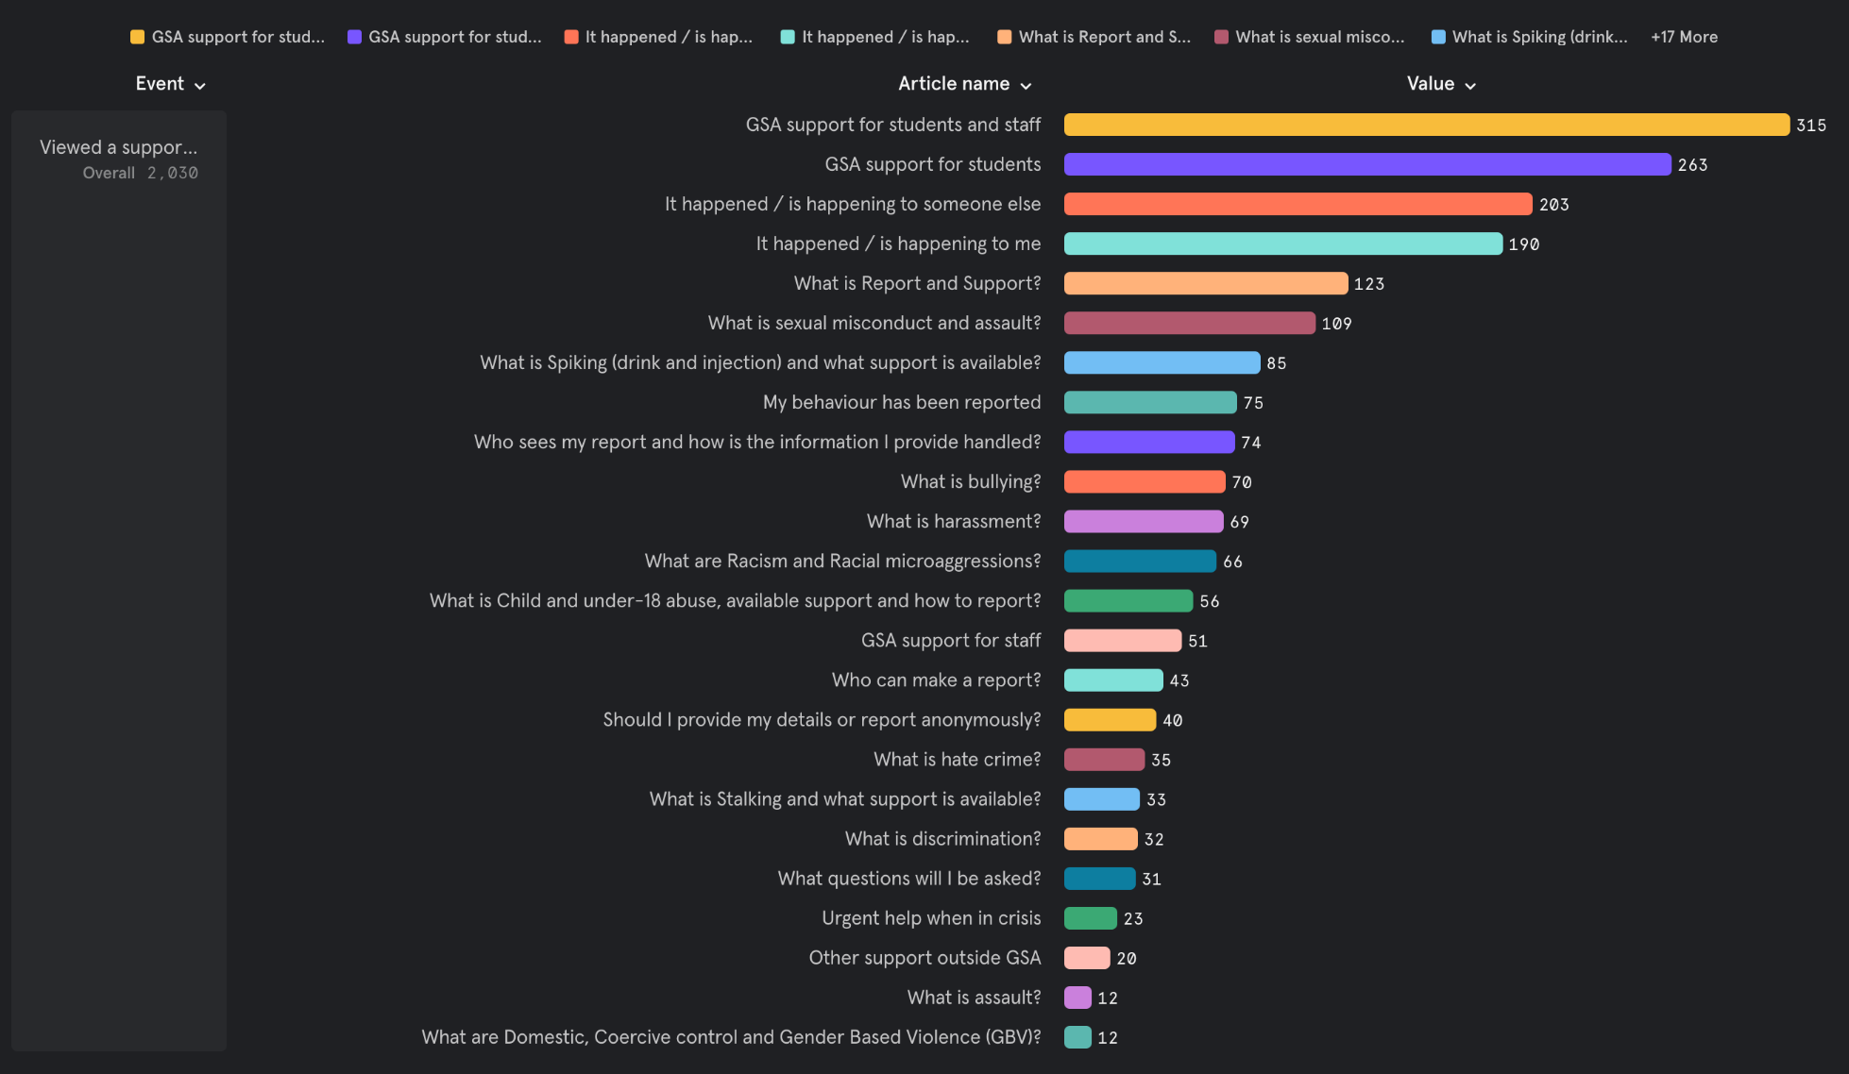

**Figure 1 –** Page hits on the GSA Support section of the Report and Support tool

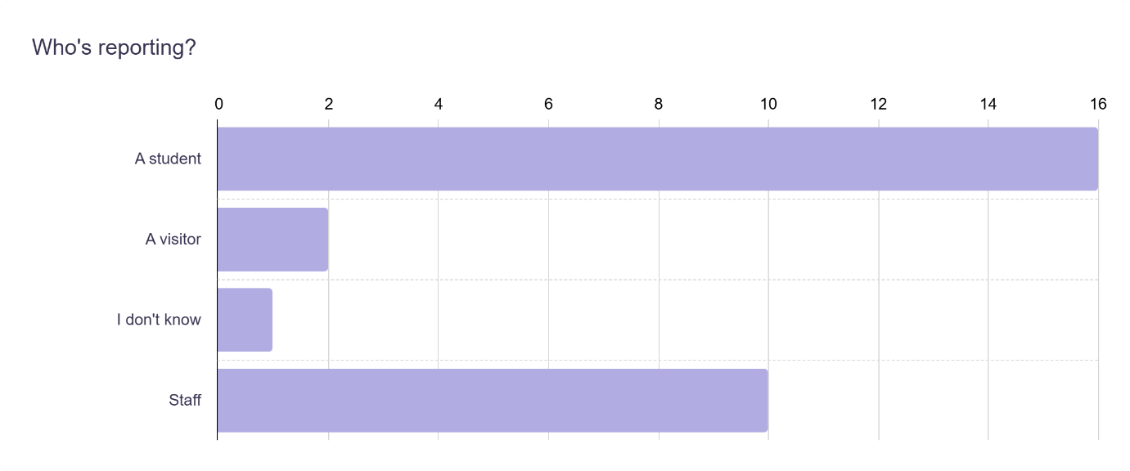

**Figure 2 -** Who reports have been made by

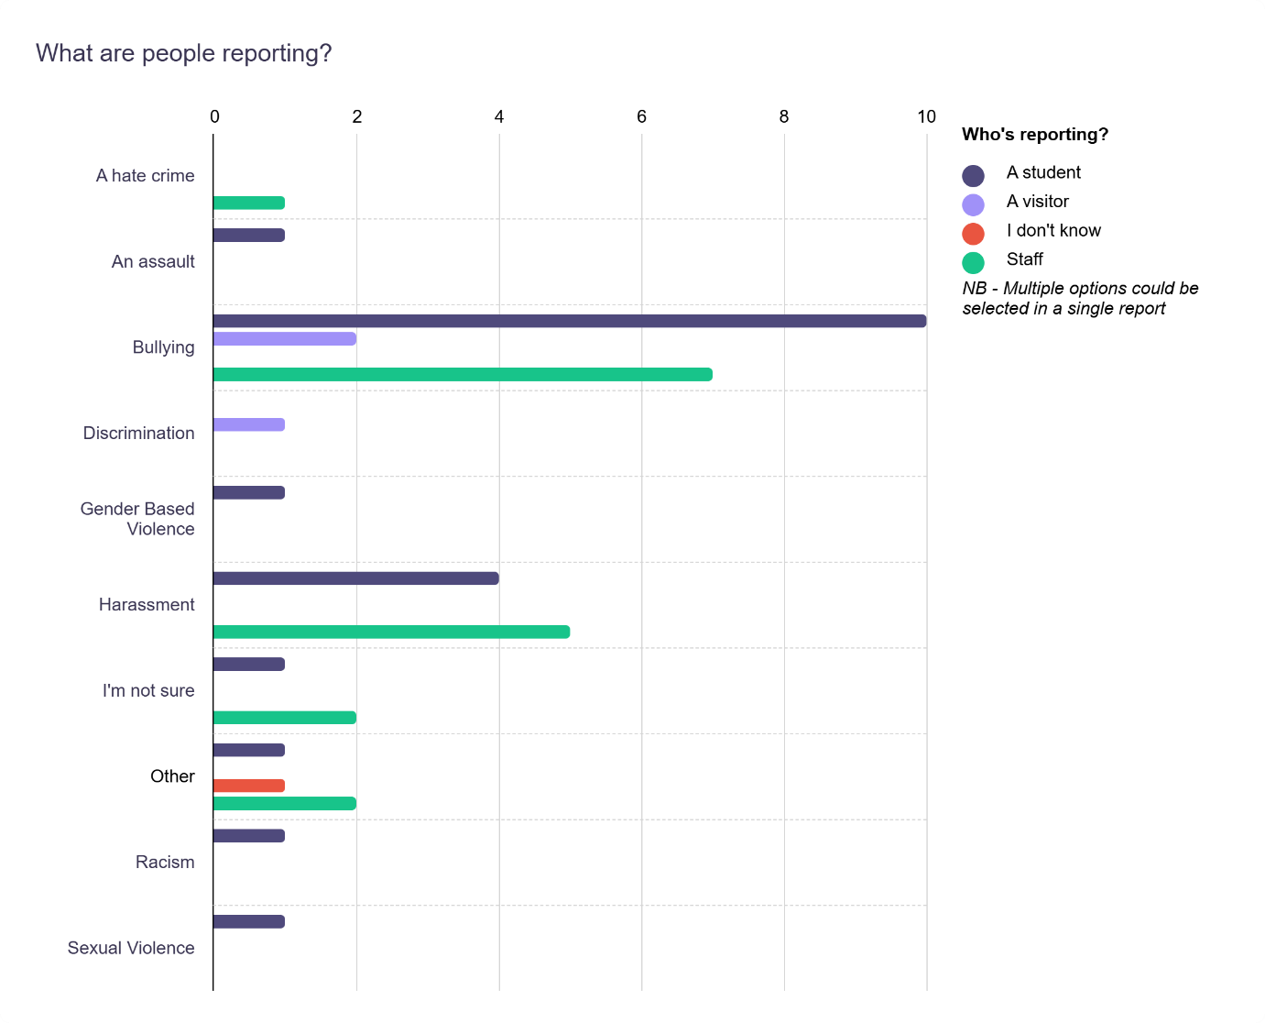

**Figure 3** – Types of reports made at the GSA

## **Widening Participation**

The Widening Participation (WP) initiative at the GSA is committed to fostering equality, diversity, and social inclusion. The primary aim of this government-funded work is to address historic socio-economic inequality in higher education by increasing the number of entrants from the most disadvantaged areas (SIMD 0-20 postcodes). By delivering activities as part of the National Schools Programme (NSP), the GSA WP Team supports senior phase pupils at state secondary schools in Scotland who meet our eligibility criteria. To ensure that educational opportunities at the GSA are accessible to a broader and more diverse range of students, the eligibility criteria set by the GSA WP team includes underrepresented groups at GSA as well as those meeting NSP objectives.

Eligibility criteria include:

* SIMD 0-20 postcode (those from the most disadvantaged areas)
* Those with care experience
* Carers
* Estranged students
* Refugees and asylum seekers in Scotland
* Ethnic Minorities
* Individuals living in very rural and island communities

The number of individuals worked with in 2023-24 is higher than ever, indicating strong outreach efforts and growing engagement. Pupils from 130 state secondary schools across 29 Local Authorities in Scotland participated in the Widening Participation programme in 2023/24.

While most categories saw an increase in participation from the previous year, there was a slight decrease in the number of care experienced participants, dropping from 19 to 15. The team are working with schools to identify barriers to participation so engagement from all eligible groups is maintained and improved.

Focusing on preparation for application to and study of creative subjects, the WP programme consists of studio-based and online learning for S4-S6 pupils. These activities introduce and develop art and design knowledge and skills beyond the SQA curriculum. A dedicated architecture portfolio course and one-day workshop are also offered. The curriculum takes a studio-based approach to teaching and learning reflective of art school. This helps participants to make informed decisions about future learning while supporting their transition to HE. Participants are also supported throughout the Admissions process. To further prepare students for study, eligible Year 1 entrants to the GSA are invited to a Transitions Week that runs prior to Freshers’ Week.

In 2023/24, all of the undergraduate programmes at the GSA received applications from WP programme participants with Painting and Printmaking and Communication Design receiving the most applications. Although many offers were received by this group, the conversion of offers to entrants isn’t consistently high.

Notably, acceptance rates for WP participants continue to exceed those of school leavers who did not engage with the programme. This indicates that efforts are effective in offering a sense of familiarity and belonging at the GSA.

Retention rates reflect the positive impact of the WP programme. Of the 47 students who joined the GSA through the WP initiative, 46 (98%) successfully completed their first year with 45 advancing into their second year of study.

## **Articulation**

A diverse group of students join the GSA each year following HE level study at college – also known as articulation. At least half of the entrants from MD20 postcodes each year enter via these routes. These learners include many mature students, parents, carers, refugees, and other underrepresented groups. Although Articulation work differs from the WP programme, it also aims to prepare participants for study at as well as application to art school. This is supported through two associate student schemes, a number of informal partnerships and related engagement activities, support during the admissions process, and transition workshops prior to entry. Most of these entrants join their programmes in second or third year. Articulation entrants graduate with firsts, win prizes and go on to study at Postgraduate and PhD level.

# **Advance equality of opportunity between persons who share a relevant protected characteristic and persons who do not share it**

Included in this section: *British Sign Language Plan 2024-2030, Board of Governors Diversity Monitoring, Building Connections, Diverse Student Voices Project, Digital Inclusion Scheme, Induction Loops, Menopause Experience Guide (MEG), Personal Tutor Scheme, Student Experience Survey, Student Mental Health Agreement, Supporting Trans, Non-Binary and Gender Non-Conforming Students*

## **British Sign Language Plan 2024-2030**

The [GSA’s British Sign Language (BSL) Plan 2024 – 2030](https://gsadocuments.net/wp-content/uploads/2024/06/GSA-British-Sign-Language-Plan-Update-2024-203024.pdf) was renewed and publicly published in May 2024. The Plan meets the requirements under the British Sign Language (Scotland) Act 2015 and promotes and raises awareness of the language. Closely aligned to the Scottish Government’s [British Sign Language (BSL): national plan 2023-2029](https://www.gov.scot/publications/bsl-national-plan-2023-2029/pages/1/), the GSA’s Plan includes key actions including ensuring BSL interpretation is available at core digital and on-campus GSA events and continuing to clearly signpost internal and external support available to current and prospective students who are BSL users.

## **Board of Governors Diversity Monitoring**

The GSA’s Board of Governors ensures compliance with the Equality Act 2010 and meets obligations under the Public Sector Equality Duty and Scottish Specific Duties, promoting equality and diversity. The Board actively monitors its composition, striving for a balance across all protected characteristics and adhering to the Scottish Code of Good Higher Education Governance. As of February 2024, the Board comprises 23 members, with a gender balance of 57% male, 39% female, and 4% other. Gender representation objective of 50% women non-executive members was not achieved in 2024.

However, last year, a recruitment exercise prioritised diversity and inclusion, leading to the appointment of three new independent governors, enhancing gender and ethnic minority representation. The Board’s current composition includes 13% from minority ethnic backgrounds and 4% declaring a disability, reflecting ongoing efforts to foster an inclusive governance structure.

To address current imbalances activity has been undertaken such as reviewing the [Board of Governors Equality and Diversity Statement](https://gsadocuments.net/wp-content/uploads/2024/07/Board-of-Governors-Statement-on-Equality-Diversity-and-Inclusion-2024.pdf) and undertaking a recruitment exercise with Aspen People. This has resulted in a split of 53% female and 47% male Independent Governors who will begin their roles in February 2025.

More information can be found within the Board of Governors Monitoring Report 2025: [equality – GSA Documents.](https://gsadocuments.kinsta.cloud/?s=equality)

## **Building Connections**

HR in collaboration with the staff mental health working group hosted a *Building Connections event* in Nov 2024 which provided an opportunity for colleagues across the GSA to connect with others over coffee and to explore some informative and interactive stalls focussed on wellbeing support and staff benefits. The event was well attended and received positive feedback and will be repeated in 2025.

## **Diverse Student Voices Project**

In 2024, a Student Consultant was appointed to lead the Diverse Student Voices Enhancement Project, aimed at advancing GSA's Education Strategy through meaningful partnerships with students. This initiative focused on enhancing students' learning and community experiences by exploring how they engage in feedback processes, build connections, and foster a sense of belonging. The project emphasised the critical importance of capturing diverse perspectives to improve learning, teaching, and institutional practices.

The findings revealed significant challenges, including barriers to engagement for marginalised groups and gaps in understanding the qualitative experiences of diverse students. In response, the GSA will implement the project's recommendations through its Student Partnership Agreement (SPA). The reconvened Student Partnership Working Group for 2024/25, comprising staff and students across GSA, will collaborate with the Student Association to drive these efforts. Key priorities include fostering inclusivity through accessible feedback mechanisms, integrating feedback opportunities into teaching, enhancing transparency in communication, and encouraging cross-program collaboration while respecting diverse backgrounds and perspectives. These actions aim to create a robust and inclusive student voice ecosystem, empowering all students to play an active role in shaping their educational journey.

## **The Digital Inclusion Scheme**

The Digital Inclusion Scheme aims to provide long-term laptop loans to students who may otherwise face challenges accessing necessary equipment due to financial hardship or digital exclusion. This initiative is specifically designed to support students who can demonstrate a clear need for such assistance, ensuring that those who will benefit the most are prioritised.

The scheme is available to both full-time and part-time undergraduate and postgraduate students enrolled at the GSA, provided they do not already have access to suitable IT equipment for their studies.

The scheme has been well received and widely utilised. The number of laptops issued to students has increased significantly, rising from 483 at the beginning of the 2023/24 academic year to 573 by the early stages of the 2024/25 academic year.

## **Induction Loops**

Following a review of existing induction loop provision within the GSA’s estate, a number of required improvements were identified. Throughout the 2024/2025 academic period, the following changes were made:

* Installation of a new fixed induction loop system in the Blythswood Large Seminar Room
* Procured 9 portable induction loop units
* Updated information on hearing systems on both staff and student intranets. This can be seen on the [Information Technology](https://gsofa.sharepoint.com/sites/intranet/ProfessionalSupport/Information-Technology/Pages/Hard-of-Hearing-Systems.aspx) page

## **Menopause Experience Guide (MEG)**

A research study, funded by the Rural Lab & Emerging Technology Department at Glasgow School of Art, underscores our commitment to integrating research and improving healthcare equity.

Menopause, occurring 12 months after the final menstrual period, and its transitional phase, perimenopause, can significantly impact quality of life through symptoms like sleep disturbances, anxiety, and weight changes. However, long wait times for specialist care—often up to six weeks—exacerbate health inequalities.

To address this, Digital Holistic Health Tools are being developed to enhance access and quality of menopause care. MEG, an AI-powered assistant, aims to improve the efficiency, empathy, and effectiveness of consultations. A pilot study will gather insights from individuals experiencing menopause to refine MEG, ensuring it meets diverse needs and helps reduce health disparities.

## **Personal Tutor Scheme**

The GSA Personal Tutor Schemeis embedded across of Schools in support of protected characteristics and barriers to learning. Updated resources are available on the [Learning and Teaching Hub Canvas](https://canvas.gsa.ac.uk/courses/293/pages/professional-development)  with a staff development schedule implemented to address the needs of academic staff. This included advice and guidance on roles, responsibilities and boundaries, identifying and responding to student mental health and awareness raising sessions on how to use Report and Support.

In 2022/23, a Programme Leader forum was set up by Learning and Teaching; addressing a variety of objectives in support of the student journey, raising staff awareness, improving consistency of message and promoting learning and teaching developments. Examples include supporting student continuation and retention, assessment and feedback methodologies and embedding graduate skills.

## **Student Experience Survey**

The annual GSA Student Experience Survey is conducted between January and March to evaluate undergraduate and postgraduate student satisfaction. In 2024, the survey had a response rate of 33.6%. Steps are being taken to improve engagement and increase the number of responses in 2025. The survey includes questions on EDI, such as awareness of Student Support services and the ability to feel safe and authentic at the GSA. In 2025, all survey questions will be disaggregated by protected characteristics to better understand of how students’ experiences may differ across marginalised groups. This data will be used to monitor the GSA’s progress towards NEOs.

## **Student Mental Health Agreement**

Co-created with the GSA and GSASA, the [Student Mental Health Agreement](https://gsofa.sharepoint.com/sites/StudentIntranet/ProfessionalSupport/StudentSupportServices/Pages/Mental-Health-Agreement.aspx), is underpinned by the GSA’s Strategic Plan 2022-2027 and supported by the NEOs. Established in 2022, the Agreement is currently undergoing a review with a new plan under development for 2025 – 27, guided by the Student Mental Health Agreement Working Group. Think Positive has recognised the GSA’s Agreement as a model of best practice. To develop the next Student Mental Health Agreement action plan, extensive consultation has been conducted. This upcoming plan will be closely aligned with the [Scottish Government’s Student Mental Health Action Plan](https://www.gov.scot/publications/student-mental-health-action-plan/).

Development has included:

* Introduction of Cognitive Behavioural Therapy (CBT) placement student in partnership with Glasgow Cognitive Therapy Centre, adding value to our mental health services by offering individual and group sessions.
* Increase in provision of Mental Health and Wellbeing Advisor; from 1 Full Time Equivalent (FTE) to 1,4 FTE
* For session 24/25, the GSA embedded mental health mentoring for SAAS Disabled Student Allowance (DSA) students rather than outsourcing, resulting in practitioners that are familiar with the learning environment and able to support in a holistic fashion.
* Joint working with other departments to increase awareness of wellbeing and support students with their mental health (archives monthly Collections & Reflections workshop and new book group with Library in process of commencing).
* The increase of incorporating outdoor space and nature into the wellbeing programme through mindful walks and mindful photography, promoting connection and reducing isolation.
* Increased partnership working between the Student Welfare, Learning Support and Mental Health & Wellbeing teams, to ensure consistent and multifaceted support provided to students whose studies have been impacted by a mental health condition.

In session 24/25, a non-mandatory trusted contact process in support of UUK and Papyrus Trusted-contacts guidance was implemented. Each year during enrolment, students are asked to provide the contact details for their Trusted Contact in addition to the mandatory emergency contact. A Trusted Contact may be contacted to support students prior to an emergency occurring if GSA believe their involvement could help reduce risk of harm for students. This will only happen when the School has serious concerns that students are at significant and imminent risk, and the School believe the student or others may be in danger of serious or lasting harm.

## **Supporting Trans, Non-Binary and Gender Non-Conforming Students**

At the GSA Learning and Teaching conference in June 2024, a member of staff from the School of Design presented their research on supporting trans, non-binary and gender non-conforming students in creative higher education. The session covered barriers and explored practical ways to create safe and inclusive learning environments for students. Within the National Equality Outcome Action Plan, the GSA is committing to spread this learning across the institution.

Additionally, it has become customary for Interior Design students to include gender-neutral and gendered toilet facilities as part of their Design practice and likewise for Fashion students to take account of gender-neutral and gendered clothing considerations as part of their practice.

# **Foster good relations between persons who share a relevant protected characteristic and persons who do not share it**

Included in this section: *Black History Month,* *Diversity and Inclusion Calendar, Diversifying Library Resources, EDI Newsletters, Equality Networks, Liberation Representatives, New Year Card, Queer Materialities, Race, Rights and Sovereignty Series, Resident Life at GSA Halls, School EDI Leads, Sonic Worlds – Emotion in Sound and Experimental Film, Sustainability, Visual Language Glossary, WËRAPARA*

## **Black History Month**

Black History Month (BHM) is an annual global reflection and celebration of Black history throughout the month of October. Observed across the world, Black History Month continues to educate, inspire and motivate millions of people, whilst acting as a catalyst for change. The School of Design has curated interactive Padlets that spotlight Black artists, events, and exhibitions both in Scotland and beyond, highlighting the richness of Black art while embracing the importance of intersectionality. These valuable resources remain accessible year-round, ensuring continued engagement and learning. Links to these can be seen below:

* Black History Month 2022 - [Black History Month:](https://padlet.com/jstephencran1/black-history-month-h0ivafy6mmzmz18r)
* Black History Month 2023 - [Black History Month 2023](https://glasgowschoolofart.padlet.org/jstephencran/black-history-month-2023-g5a3x8i4cqageywy)
* Serving Serious Style - [Serving Serious Style](https://padlet.com/jstephencran1/serving-serious-style-p7hilvyuk98dbnik)

## **Charter for Responsible Debate**

In 2024, EDIC and SLG endorsed and approved the adoption of the [Young Academy of Scotland’s Charter for Responsible Debate](https://www.youngacademyofscotland.org.uk/our-challenges/exchange/charter-for-responsible-debate/). The Charter consists of nine guiding principles which are rooted in the ideals of informed, respectful and inclusive collective decision making. The Charter serves as a framework to encourage discussion among those who initially disagree, but who listen well to each other in pursuit of common ground and common cause. Steps are currently being taken to support effective communication and successful implementation of the Charter across the GSA.

## **Diversity and Inclusion Calendar**

[The Diversity and Inclusion Calendar](https://gsofa.sharepoint.com/sites/intranet/ProfessionalSupport/Equality/Pages/Diversity-calendar-and-Events.aspx), provided by Culture Shift, sits on the Equality and Diversity Staff Intranet. The calendar has been promoted to staff to encourage a broader awareness across campus of religious events and key EDI dates with the aim to demonstrate institutional respect and appreciation for diversity.

## **Diversifying Library Resources**

The Library has made dedicated efforts to diversify their resources, inviting staff and students to make suggestions. [The Inclusive Library Collections Canvas page](https://canvas.gsa.ac.uk/courses/1572/pages/inclusive-lists?module_item_id=90237) contains a continually growing diverse reading list and alternative publishers and distributors. A section for teaching staff contains resources for staff seeking to promote inclusion and engage with decolonisation.

Encouraging the GSA community to engage with literature from different cultures and communities exposes readers to varied worldviews, histories, and narratives that challenge dominant or Eurocentric perspectives. This approach supports the GSA with creating a more equitable learning environment that values the contributions of all cultures and communities and highlights the intersectionality of protected characteristics, offering insight into the unique experiences of discrimination or privilege faced by individuals.

## **EDI Newsletters**

A quarterly EDI Newsletter is circulated to staff and students. They aim to provide key updates and valuable resources to support the GSA’s commitment to fostering inclusive and welcoming learning and working environments. In the last year content has included signposting to digital accessibility training, the Diversity and Inclusion Calendar and information on GSA equality networks. As part of the 16 Days of Activism Against Gender Based Violence campaign, a newsletter focusing on training opportunities, events, resources and support around GBV was circulated to all staff and students. The aim was to contribute to creating a safer, more supportive campus for everyone.

## **Equality Networks**

Established in 2024 and consisting of 95 members, the Women at GSAnetwork continues to provide a safe space for discussion, peer support and advocacy for women and non-binary staff. Established in 2023, Menospace is a support and advocacy group open to all staff and students experiencing menopause and those supporting someone experiencing menopause. Recently, the network has broadened its scope for peer support and advocacy related to all matters of menstrual health and wellbeing. In 2024, the Network welcomed the development of [a Menopause and Menstrual Health Policy and Toolkit](https://gsofa.sharepoint.com/sites/intranet/ProfessionalSupport/HR/Pages/Staff-Wellbeing---Menopause-and-Menstrual-Health.aspx). Additionally, activity is underway to establish a neurodiversity network in 2025.

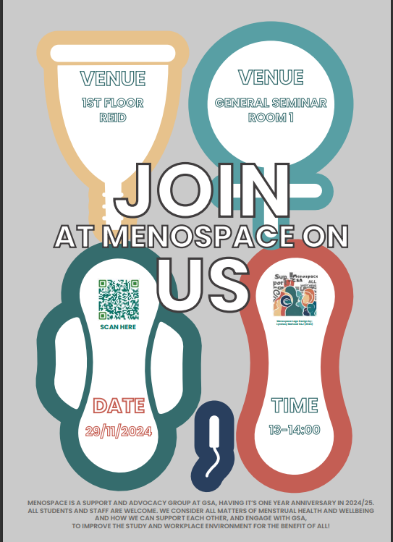

**Figure 4:** Menospace Poster

## **Liberation Representatives**

The GSASA has five Student Liberation Representatives, each advocating for:

* Disabled Students
* Gender Equality
* LGBTQ+ Students
* International Students
* Ethnic Minority Students

Three of these representatives sit on the GSA’s central EDI Committee (EDIC), serving as a direct link between students and GSA leadership. They play a crucial role in fostering inclusion by facilitating social connections, creating safe spaces, and building support networks for students who may face discrimination or exclusion.

Beyond community-building, they actively raise awareness of issues affecting marginalised students and hold the GSA accountable for meaningful action. They also push for policies that promote equity, diversity, and inclusion (EDI), addressing challenges such as accessibility, discrimination, and institutional bias.

## **Lunar New Year Card**

Each year, GSA commissions a student or graduate to create a card that celebrates the New Year, providing an opportunity to highlight cultural traditions from around the world while promoting understanding and inclusivity. In 2023, Yujie Wei, a graduate of the MDES Illustration program (2024), created a set of illustrations and accompanying texts that explored the New Year traditions of her home country, China, in recognition of the Year of the Snake. Her work served as a vibrant expression of Chinese heritage and offered an engaging way to share these traditions with the wider GSA community.

[For 2024, a New Year card celebrating the Year of the Dragon](https://www.linkedin.com/posts/the-glasgow-school-of-art_new-year-card-2024-activity-7160570913317339136-i2of) was created by artist and graduate Jiyoon Lee. Her artwork, titled “The blue dragon is awakening and preparing for the new year!”, draws on traditional Korean cultural elements to explore the symbolism of the Blue Dragon, which represents courage, hope, and good fortune. Through traditional Korean instrumental music and rhythmic dancing, Jiyoon’s work brings the movement of the dragon to life against the backdrop of Glasgow and Edinburgh.

Jiyoon, a South Korean artist based in Edinburgh and Glasgow, engages with diverse topics related to somatic experiences in the digital sphere. Her experimental approach to art, using video, installation, and performance, underscores the importance of creativity in building bridges between cultures.

The Lunar New Year Card initiative not only showcases the talents of GSA’s diverse student and graduate community but also serves as a meaningful way to promote intercultural dialogue and mutual respect. By celebrating the traditions of different cultures, the initiative reinforces the importance of courage, hope, and inclusivity for all in the coming year.

## **Queer Materialities**

The Queer Materialities conference, held in February 2024, built on the success of the *Queereal Secretions* publication from 2023. Proceeds from the book funded new student works for the conference, further integrating the network’s research into both staff and student experiences.

*Queereal Secretions* is the second exhibition at the GSA’s Annex Gallery, curated by the School of Fine Art’s Queer Materialities research group. The exhibition evolved from the June 2022 symposium, *What’s the Matter? Queer Materiality and Communities of Making,* at Glasgow School of Art, which marked the group’s inception.

Over the past two years, the group has explored concepts such as shapeshifting, the expansiveness of queerness, and its implications for artistic research. They examined themes like excess, the indescribable nature of creation, and the limits of language. This research culminated in the exhibition and its publication, *Queereal Secretions: Artistic Research as Exquisite Practice*, launched on November 30, 2023.

The exhibition showcases works by artists and researchers, featuring pieces inspired by visits to museums and galleries, including those of Felix Gonzalez-Torres and Yoko Ono. Both the exhibition and publication explore ‘exquisite’ possibilities—collaboration, dissemination, and the dynamic nature of artistic practices.

From *What’s the Matter?* to *Queereal Secretions*, the initiative presents compelling ‘exquisite fabulations’ that provoke critical thought and reflection.

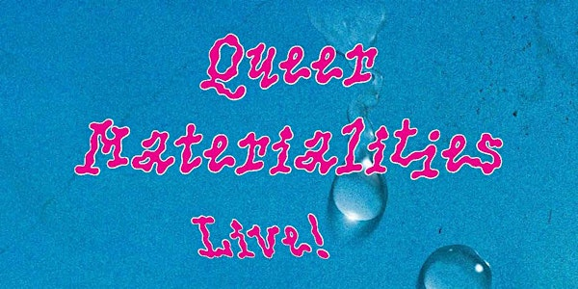

**Figure 5:** promotional poster for Queer Materialities

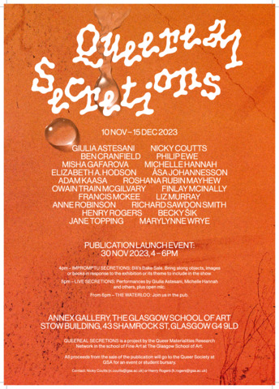

**Figure 6:** promotional poster for Queereal Secretions

## **Race, Rights and Sovereignty Series**

Established in 2016, the [Race, Rights and Sovereignty](https://www.racerightssovereignty.com/) series is a collaborative initiative between the Glasgow School of Art Students’ Association (GSASA) and GSA Exhibitions. Designed to foster meaningful dialogue, the programme aims to provide spaces to explore and engage with themes of race, rights and sovereignty, particularly within creative practice. The series aims to celebrate, challenge, inform and inspire the next generation of artists, designers and architects, empowering them express their creative voices.

The most recent programme strand, “What Will Be the Cure?” is geared towards artists and practitioners who wish to collectivise, experiment, and conspire towards transformative change. As part of this initiative, an online event titled “In Conversation with Marlene Smith and Camara Taylor” was held in December 2024. The artists reflected on their recent solo exhibitions, *Ah Sugar* and *(mouthfeel)*, discussing the materials central to their practices and the personal and social histories embedded within them.

Other events have included a workshop titled “Listening and Empathetic Witnessing as Writing Practices” with Nisha Ramanyya. The session adapted the deep listening practices of Pauline Oliveros and heard Blood and Moths, a sound work by Palestinian sound researcher, Bint Mbareh.



**Figure 7:** Race, Rights and Sovereignty Series – In Conversation with Marlene Smith and Camara Taylor

## **Resident Life at GSA Halls**

GSA Halls are managed by the Accommodation Team, which includes the Residence Life (ResLife) team. ResLife is dedicated to supporting the pastoral care and wellbeing of residents while fostering a strong, inclusive community. The team consists of three Accommodation Ambassadors who play a key role in delivering this support.

ResLife is committed to helping students settle into life at GSA by offering onsite assistance and organising a range of events and activities. Many of these initiatives are run in collaboration with other groups within the School, including GSA Sustainability, The Art School Student Association, and Student Support. These partnerships enhance the residential experience by celebrating diverse traditions and fostering community engagement. Examples of past events include Chinese New Year decorations, as well as Christmas and Halloween celebrations that highlight a variety of cultural customs.

More information on initiatives and updates can be seen on [ResLife Blog](https://gsa.starrezhousing.com/StarRezPortalX/57F24462/15/271/GSA_Halls_Blog-ResLife_Events) or on Instagram @GSAHalls where positivity, wellbeing and community spirit are promoted.

## **School EDI Leads**

In 2024, the School EDI Leads were reconvened with new members joining from the School of Fine Art and the School of Innovation and Technology, enhancing representation across disciplines. Eight EDI Leads across the four Schools play a pivotal role in fostering a supportive and inclusive environment for all staff and students.

The School EDI Lead role supports the development, implementation, and review of equality, diversity, and inclusion (EDI) policies and initiatives, acting as a key point of contact for staff and students on EDI matters. EDI Leads report to their Head of School/Department and the central EDIC, working to align local initiatives with the School of Art's institutional EDI goals. They convene area-specific EDI committees, promote best practices, organise EDI events, develop School level EDI initiatives and encourage open dialogue on inclusivity.

## **Sonic Worlds - Emotion in Sound and Experimental Film**

*Sonic Worlds: Emotion in Sound and Experimental Film* brought together Year 2 and Year 3 students from BDes Product Design, BSc Immersive Systems Design, and BDes Sound for Moving Image. The course emphasised collaborative approaches to interdisciplinary audio-visual creation, encouraging students to explore new techniques and software that expanded their creative practice while fostering a deeper understanding of diverse audiences.

Working in groups, students were assigned emotions expressed in languages other than English, including those rooted in diverse knowledge systems such as those of First Nations communities. Through the fusion of sound and imagery, they represented or evoked these emotions using a blend of analogue experimental filmmaking, innovative “noise-making” techniques, and digital tools.

A core aim of the course was to deepen students’ knowledge and sensitivity to global cultures and perspectives—highlighting how language shapes ways of being and relating to the world.

## **Sustainability**

The Sustainability team have promoted equality, diversity and inclusion through a range of initiatives. Diverse voices are amplified via Instagram, and the *Decolonising the Curriculum* initiative has been led to address issues of race and social justice in an art school setting. Funding and promotion have been provided for student research and workshops, including *Repeat Patterns: Colonialism in Textiles* by Christina Wong, a talk by peace activist Satish Kumar, and a lecture by Ama Josephine Budge. The department’s website highlights the links between racism and climate change, Black history, Race, Space and Architecture, menstrual activism, menopause support, and alternative reading lists. Additionally, the work of *Race, Rights and Sovereignty* is promoted, and support is given to *Missing in Architecture*, advocating for a feminist approach to architectural practice.

## **Visual Language Glossary**

As part of an MDes Interior Design project, students explored key terms at the intersection of language, visualisation, and artefact creation. Recognising language as a flexible, culturally shaped tool, the project investigated how words convey meaning beyond traditional linguistic structures through photography, collage, and digital design.

By experimenting with image-making, typography, and abstract concepts like memory, beauty, and emotion, students redefined communication and visualisation. Discussions highlighted how interior design terms hold multiple meanings depending on context, fostering cross-cultural dialogue and collaboration.

This initiative encouraged idea exchange over technical mastery, deepening cultural awareness and global citizenship. The Visual Language Glossary is available online or as a zine in the GSA Library.

## **WËRAPARA**

In 2024, the School of Design hosted Liliana Sanguino, a GSA part-time PhD student and Director of MFA Fashion at Parsons, New York. In October, she presented WËRAPARA (2019), a documentary highlighting the journey of trans women from the Colombian Embera community into the international fashion scene, blending artistic collaboration with the preservation of their spiritual and ancestral heritage. The event was open to all staff and students with approximately 150 people attending.

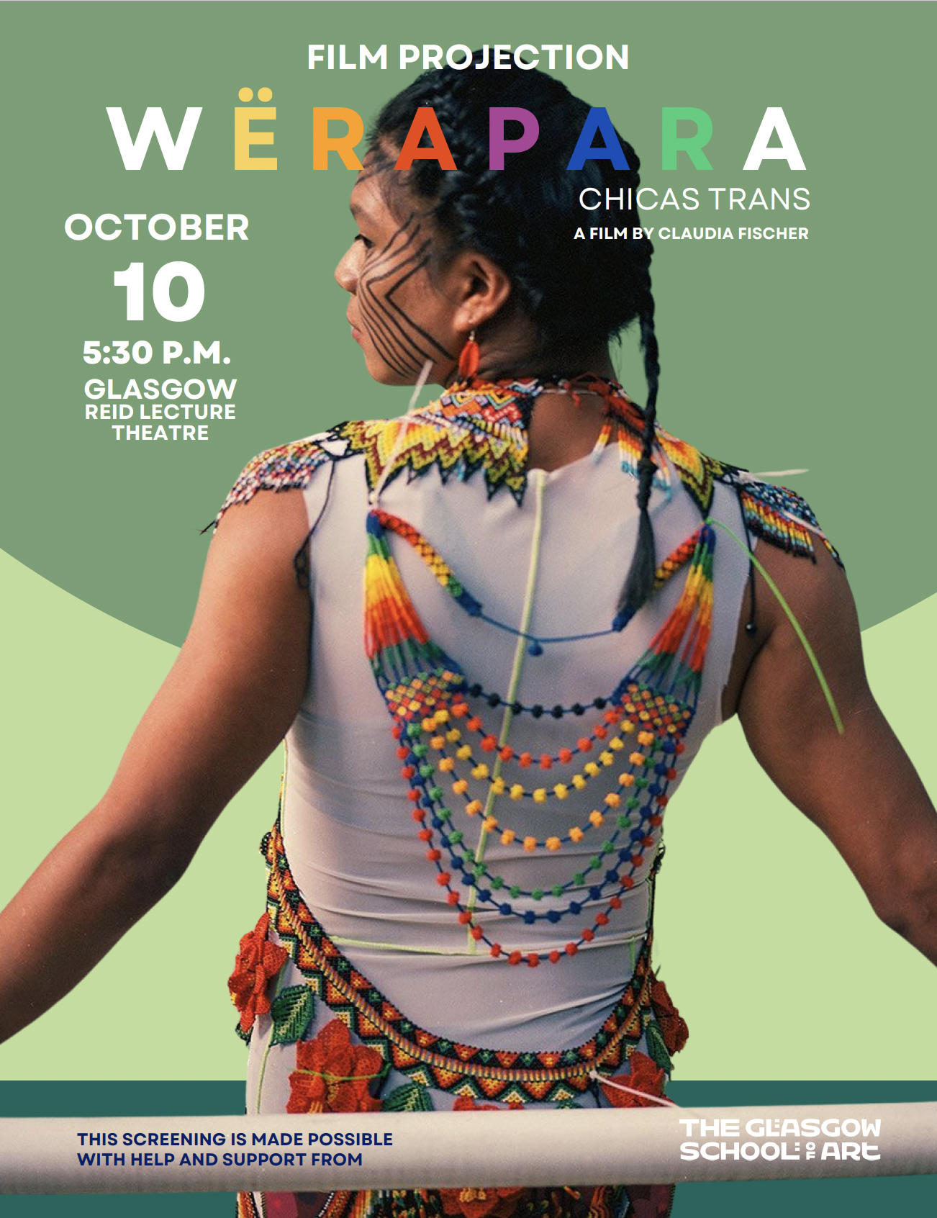

**Figure 8:** promotional poster for the screening of documentary, WËRAPARA

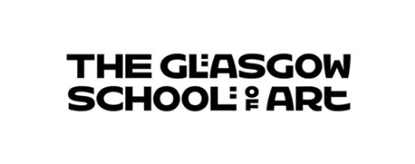

# **National Equality Outcomes Progress Report**

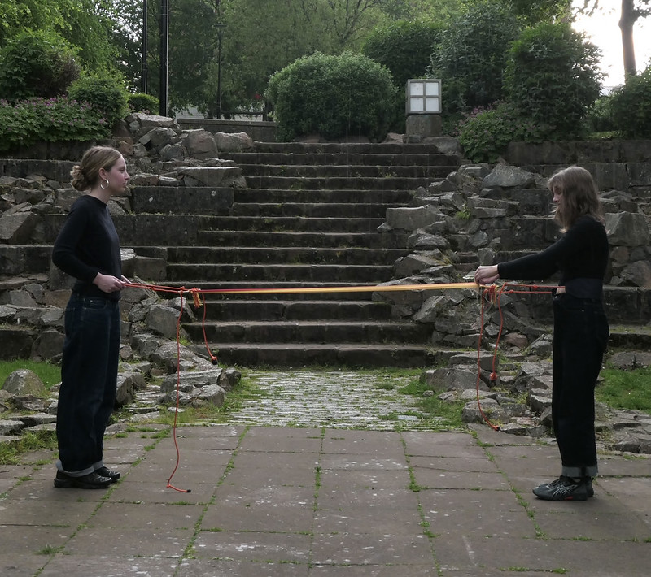Image: Tove Thomas, *two-person loom (*Product Design 2024)

## **National Equality Outcomes Introduction**

This section highlights the GSA’s progress towards achieving the [National Equality Outcomes (NEO).](https://www.sfc.ac.uk/wp-content/uploads/uploadedFiles/Tackling_persistent_inequalities_together.pdf) Comprehensive details on the activities supporting this progress are available in the Mainstreaming Equality Report above.

Due to a change in HESA data requirements, only data from the 2022/23 to 2023/24 period is available. Additionally, in order to preserve anonymity throughout the report, numbers under 10 have been presented as ‘*’.

## **Age**

1. **The retention outcomes for university students aged 25 and over will improve.**

The GSA’s retention rates will be utilised as a benchmark in future reports. Retention rates overall are low, with no evidence to suggest that students aged 25 and over are disadvantaged. Data will be monitored with future action instigated if required.

**Table 1:** Student Withdrawal by Age

|  |  |  |
| --- | --- | --- |
| **Metric** | **2022/23** | **2023/24** |
| Total Enrolment | 2842 | 2814 |
| Total Withdrawals (%) | 91 (3.2%) | 96 (3.4%) |
| Students Under 25 | 2164 | 2101 |
| Withdrawals Under 25 (%) | 68 (3.1%) | 64 (3.0%) |
| Students 25+ | 678 | 713 |
| Withdrawals 25+ (%) | 28 (4.1%) | 27 (3.8%) |

As part of GSA’s engagement with [Scotland's Tertiary Enhancement Programme (STEP)](https://www.step.ac.uk/en/what-is-step), we have committed to a discovery project exploring mature student’s learner journey and transition in, through and onwards. This project work will take place in session 2024/25 aligned to and reported through our Education Strategy project Supporting Student Success. The aim of the project will be to identify good practice case studies and feed into resources and guidance for staff and students.

Supported by Mental Health and Wellbeing Advisers, a Mature Student Network was established in February 2025. The Network is for those who started University that bit later, are making a career change or have returned to study after a break in education. It is a space where students can meet likeminded individuals and find community during their time at GSA.

## **Disability**

1. **The success and retention rates of college and university students who declare a mental health condition will improve.**

This has been identified as an area of concern both within the GSA and at sector and government level. Further information on activity to support students who have declared a mental health condition can be seen in the sections above such as [Mental Health Awareness Training](bookmark://_Mental_Health_Awareness) and [Student Mental Health Agreement.](bookmark://_Student_Mental_Health)

We can evidence an increase in presenting students and an increase in withdrawal rates however attainment data has fluctuated. The attainment and retention rates for students who declare a mental health condition will be utilised as a benchmark moving forward.

28.4% of students shared that they had a disability, including mental health conditions, in the 2023/24. This is an increase of 7.6% from the previous year. Table 2 below shows that in the 2022/23 period, 6.4% of students shared that they had a mental health condition. Concerningly, this figure increased to 268 9.5% in 2023/2024. The percentage of withdrawals from students with a disclosed mental health condition has also seen an increase; rising from 8.3% in 22/23 to 10.2%.

Table 3 below shows for the 2022/23 period a negative attainment gap of –3.4 percentage points, showing that students with a declared mental health condition outperformed students without a mental health condition. However, there was a slight disparity in 2023/24 where the attainment gap was 3.4 percentage points.

**Table 2:** Withdrawals by Mental Health Condition

|  |  |  |  |  |
| --- | --- | --- | --- | --- |
| **Academic Year** | **Total Students Enrolled** | **Total Students with Mental Health Conditions** | **Total Withdrawals** | **Withdrawals with Mental Health Conditions** |
| 2022/23 | 2842 | 183 (6.4%) | 96 (3.4%) | 8 (8.3%) |
| 2023/24 | 2814 | 268 (9.5%) | 187 (6.6%) | 19 (10.2%) |

**Table 3:** Attainment gap by mental health condition

|  |  |
| --- | --- |
| **Academic year** | **Attainment Gap** |
| 2022/2023 | 2.8pp |
| 2023/24 | -3.4pp |

The National Student Survey (NSS) ran February 2024 to May 2024 with GSA achieving an overall response rate of 73%. GSA NSS Results by Question Group note a slight decrease in positive response to Mental wellbeing.

**Table 4 –** 2024 NSS Results

|  |  |  |  |
| --- | --- | --- | --- |
| **Question Group** | **2023 (%)** | **2024 (%)** | **Variance (%)** |
| Teaching on my course | 85.59 | 78.20 | -7.39 |
| Learning Opportunities | 78.07 | 70.98 | -7.09 |
| Assessment and feedback | 79.23 | 79.23 | -3.57 |
| Academic support | 86.35 | 80.66 | -5.69 |
| Organisation and Management | 65.18 | 56.89 | -8.29 |
| Learning resources | 82.38 | 79.99 | -2.39 |
| Student Voice | 67.74 | 66.17 | -1.57 |
| Mental well-being services | 74.83 | 72.18 | -2.65 |
| Overall satisfaction | 73.31 | 58.10 | -15.21 |

This issue is being addressed within the GSA’s NEO Action Plan by investing in mental health resource, increasing staff capacity via training opportunities, developing strategies in support of the Scottish Government student mental health action plan and implementing sector guidance such as Universities UK’s suicide safer guidance and continuing to develop a whole university approach to wellbeing.

1. **Disabled students report feeling satisfied with the overall support and reasonable adjustments received, including from teaching staff, while on their course**

In session 23/24, 80.8% of students were satisfied or very satisfied with reasonable adjustments from Student Support maintaining a similar percentage to 22/23. 61.6% of students were satisfied or very satisfied with reasonable adjustments from teaching staff evidencing a 9% increase since 22/23.

As noted in NEO 4, 78.5% of students that completed the SES reported that the information and advice offered by Student Support services has been helpful.

Each student who discloses a disability, defined by the Equality Act 2010: “*a physical or mental impairment and the impairment has a substantial and long-term adverse effect on their ability to carry out normal day-to-day activities” is* offered the opportunity to complete the Reasonable Adjustment process. Evidence of disability is requested; however, we do not wait for this before needs are assessed and a Reasonable Adjustment Report (RAR) is agreed and communicated to relevant staff. This is followed up with a review of progress during session to check that adjustments are in place and working effectively. When issues are identified, Student Support work in partnership with academic teams, Estates, Technical Support Services and the Library and Learning team to resolve concerns where possible.

**Table 5 -** Overview of completed Reasonable Adjustment Reports (RARs) and Disabled Student Allowance Assessments (DSAs)

|  |  |  |  |  |  |
| --- | --- | --- | --- | --- | --- |
| **Academic Year** | **Presenting Students** | **RARs signed off** | **DSAs approved** | **New Students** | **Returning Students** |
| 19/20 | 349 | 135 | 41 | 217 | 132 |
| 20/21 | 367 | 158 | 68 | 240 | 127 |
| 21/22 | 352 | 172 | 65 | 203 | 127 |
| 22/23 | 421 | 280 | 68 | 249 | 172 |
| 23/24 | 475 | 256 | 68 | 312 | 163 |

In 2022/23, a Student Support Survey was launched. 78 responses were received, increasing to 106 in 2023/24. We recognise that this is not representative of the GSA student population however, the Survey yielded some helpful insights and identified areas that require further investigation. Responses can be seen in the tables below and will be used as a benchmark for progress.

**Table 6:** How satisfied were students with reasonable adjustments from Student Support?

|  |  |  |  |  |
| --- | --- | --- | --- | --- |
| **Academic Year** | **Very Satisfied** | **Satisfied** | **Neither** | **Dissatisfied** |
| 2022/23 | 65% | 15% | 3% | 18% |
| 2023/24 | 50% | 30.8% | 7.7% | 11% |

**Table 7:** How satisfied were students with the reasonable adjustments from teaching staff?

|  |  |  |  |  |
| --- | --- | --- | --- | --- |
| **Academic Year** | **Very Satisfied** | **Satisfied** | **Neither** | **Dissatisfied** |
| 2022/23 | 34.6% | 17.9% | 16.7% | 7.7% |
| 2023/24 | 30.8% | 30.8% | 23.1% | 15.4% |

Actions have been set to enhance awareness of services including investment in resource to facilitate improved partnership work with academic teams. This will support the GSA with increased awareness of service, early intervention where possible and promotion of an inclusive approach to reasonable adjustments in support of the Equality and Human Rights Commission (EHRC) [advice note for the higher education sector](https://eur01.safelinks.protection.outlook.com/?url=https%3A%2F%2Fwww.equalityhumanrights.com%2Fguidance%2Fadvice-note-higher-education-sector-legal-case-university-bristol-vs-abrahart&data=05%7C02%7CJu.Grant%40gsa.ac.uk%7C6015dd1272214e4acb9b08dd0fd45be8%7C67f9795821514513bd2170cde632768b%7C0%7C0%7C638684126948363523%7CUnknown%7CTWFpbGZsb3d8eyJFbXB0eU1hcGkiOnRydWUsIlYiOiIwLjAuMDAwMCIsIlAiOiJXaW4zMiIsIkFOIjoiTWFpbCIsIldUIjoyfQ%3D%3D%7C0%7C%7C%7C&sdata=9NPsnw6Gl9I%2Fud3ZlIHDK%2BBJufCfM2EttIGDV%2BMj9Gc%3D&reserved=0) after the legal case of University of Bristol vs Abrahart. Our aim is to achieve increased levels of satisfaction. Further information on actions to address this can be seen in the Eliminating Discrimination and Advancing Equality of Opportunity sections above.

1. **Disabled staff and students report feeling safe in the tertiary system**

A range of strategies have been employed to gather data and feedback including the SES, the recent staff survey, Report and Support, complaints reporting and increased consultation opportunities for students and staff.

A proposal to the Learning and Teaching Committee resulted in the inclusion of three additional questions in the GSA Student Experience Survey (SES) for the 2024 survey season.

In total, 801 responses were received from a population of 2,383, giving an overall response rate of 33.6%. A low negative response rate was recorded for all three questions. Full details can be seen in table 8 below.

**Table 8 – Student Experience Survey Results**

|  |  |  |  |
| --- | --- | --- | --- |
| **Student Experience Survey (SES) Question** | **Positive Response** | **Negative Response** | **N/A** |
| I am aware of Student Support services and how to access these | 90% | 2.9% | 7.1% |
| I feel safe to be myself at the Glasgow School of Art | 86.2% | 1.9% | 11.1% |
| When needed, the information and advice offered by Student Support services has been helpful. | 78.5% | 2.9% | 18.6% |

In the Staff Survey 2024, 72% of all staff expressed that they felt they can be themselves at work. 89% of undergraduate students and 90% of postgraduate respondents to the Student Experience Survey 2024 reported that they felt safe to be themselves at the GSA. This data will be utilised to benchmark progress.

Further detail of strategies in support of staff can be found in [People Strategy 2023-2](https://gsofa.sharepoint.com/sites/intranet/ProfessionalSupport/HR/PublishingImages/Pages/People-Strategy/People%20Strategy%202023-2027.pdf#search=people%20strategy)027 detailing investment in inclusive and accessible working environments with a focus on staff wellbeing.

At present, the GSA does not disaggregate this data by protected characteristic, although plans are underway to do so.

We have seen a noteworthy rise in both student and staff disability disclosure potentially indicating more confidence in the culture and ethos of the GSA. Support for students is clearly defined, effective and well utilised however, there is opportunity to increase awareness of service. Specific staff support is under development and will be addressed in the NEO action plan.

1. **Where representation is not proportionate to the relevant population, increase the representation of disabled staff in the workforce and on college Boards and university Courts**

For staff, the figure of people sharing they were disabled rose from 10% to 25%. This increase could be a result of the [GSA People Strategy](https://gsofa.sharepoint.com/sites/intranet/ProfessionalSupport/HR/PublishingImages/Pages/People-Strategy/People%20Strategy%202023-2027.pdf#search=people%20strategy) which focussed on improved diversity of the GSA workforce, a review of policy and extensive activity to encourage an increase of staff sharing protected characteristic and wider equality information for equality monitoring purposes.

28% of students shared that they had a disability. Census data shows that 20% of the Scottish population aged 16 – 64 has a disability. HESA data tells us 15.3% of HE students in Scotland identify as disabled, placing the GSA at the higher end of the scale.

Despite targeted positive recruitment strategies in 2023/24, 4.4% of GSA’s Board of Governors shared that they had a disability, 87% did not have a disability and the remainder is unknown. This is consistent with 2022/23 board data and acknowledged as an area for development. Steps are being taken within the NEO Action Plan to increase the number of disabled people on the Board of Governors.

**Table 9** -Staff Disability Figures

|  |  |  |  |
| --- | --- | --- | --- |
| **Disability** | **2023/2024** | **2022/2023** | **2021/2022** |
| No / Not known | 75% | 90% | 92.5% |
| Disabled | 25% | 10% | 7.5% |

**Table 10 -** Student Disability Figures

|  |  |  |  |
| --- | --- | --- | --- |
| **Disability** | **2023/2024** | **2022/2023** | **2021/2022** |
| No / Not known | 72% | 79% | 77% |
| Disabled | 28% | 21% | 23% |

**Table 11 –** Board of Governors Disability Figures

|  |  |  |  |
| --- | --- | --- | --- |
| **Disability** | **2023/2024** | **2022/2023** | **2021/2022** |
| No / Not known | 95.6% | 96% | 89.5% |
| Disabled | 4.4% | 4% | 10.5% |

## **Gender Reassignment**

1. **Trans staff and students report feeling safe to be themselves in the tertiary system**

A significant improvement has been seen in the number of students sharing information about their transgender status or history, increasing from 78% in 2022/23 to 93% in 2023/24 potentially indicating greater trust in the GSA. However, there has been a 1.5% increase in students responding “prefer not to say” when asked if they are transgender or have a trans history. It is hoped that the training opportunities offered throughout 2022/23 have increased awareness of understanding, language, and potential barriers. Project examples to promote understanding include Queermaterialities and a session on supporting Trans, Non-Binary and Gender Non-Conforming students.

In the Staff Survey 2024, 72% of all staff expressed that they felt they can be themselves at work. 89% of undergraduate students and 90% of postgraduate respondents to the Student Experience Survey 2024 reported that they felt safe to be themselves at the GSA. This data will be tracked to monitor progress.

At present, the GSA does not disaggregate this data by protected characteristic, although plans are underway to do so. In addition, an institutional equality survey will be developed and launched in 2025 to gather additional data.

## **Race**

1. **Staff and students feel supported and safe and are confident that complaints of harassment or bias on the grounds of race will be dealt with appropriately because complaints procedures are fit for purpose and offer effective redress.**

In the Staff Survey 2024, 72% of all staff expressed that they felt can be themselves at work. 89% of undergraduate students and 90% of postgraduate respondents to the Student Experience Survey 2024 reported that they felt safe to be themselves at the GSA.

At present, the GSA does not collect disaggregated data on feelings of safety, although plans are underway to do so.

Complaints are categorised according to the themes outlined in the National Student Survey (NSS). A recent review was undertaken to better align with the GSA’s NEO reporting responsibilities and to enhance the collection and analysis of data. In September 2024, a new theme was introduced to address race-related harassment and bias. Since its implementation, no complaints have been reported under this category.

Prior to this change, race related incidents were collected under the theme of “Dignity and Respect” which also included GBV, misogyny, staff misconduct and staff sensitivity. Table 12 below details the number of complaints.

**Table 12 –** Scottish Public Services Ombudsman (SPSO) Stage 1 and Stage 2 Complaints

|  |  |
| --- | --- |
| **Academic Year** | **Complaint Theme - Dignity and Respect** |
| Session 22/23 | 9 |
| Session 21/22 | 11 |
| Session 20/21 | 3 |

To support timely and effective responses to complaints, all staff must complete Complaints Handling e-Learning at three yearly intervals.

To facilitate the submission of complaints, multiple channels are available from HR to Student Support to the central complaints team. Staff and students can also utilise the GSA’s Report and Support tool, which also allows for anonymous and named reporting. The availability of multiple reporting channels for race-related harassment and bias enables the GSA to provide quicker and more efficient resolutions. This approach also improves reporting rates and supports more comprehensive data analysis.

Since the introduction of Report and Support there have been 62 reports; 48 named and 14 anonymous:

* 39 student reports
* 16 staff reports
* 3 visitor reports
* 3 prefer not to say
* 1 I don’t know

In session 22/23, there were 17 student reports and 4 staff reports. Of these reports:

* 5 reports selected racism as the incident type
* 3 reports selected hate crime as the incident type
* 8 reports selected as harassment the incident type

*NB - Multiple options could be selected in a single report*

In session 23/24, there were 17 student reports in addition to 10 staff reports. Of these reports:

* 1 selected racism as the incident type
* 2 selected hate crime as the incident type
* 9 selected as harassment the incident type

When asked: “Do you feel as though any of the following factors played a role in what you've experienced?” 5 reports selected ethnicity or race in comparison to 3 in 22/23.

It should be noted that 19 reports selected bullying and harassment as the incident type in 23/24. In response, we revised and relaunched the [Dignity and Respect at Work and Study](https://eur01.safelinks.protection.outlook.com/?url=https%3A%2F%2Fglasgowschoolofart.cmail19.com%2Ft%2Fr-l-tiiuxyk-botiwhut-j%2F&data=05%7C02%7Cju.grant%40gsa.ac.uk%7C25e2bab993834aeac4b108dc2330d400%7C67f9795821514513bd2170cde632768b%7C0%7C0%7C638423939825902666%7CUnknown%7CTWFpbGZsb3d8eyJWIjoiMC4wLjAwMDAiLCJQIjoiV2luMzIiLCJBTiI6Ik1haWwiLCJXVCI6Mn0%3D%7C0%7C%7C%7C&sdata=LVT7hrjhY%2FjhJ%2F7VtdoSkWHdK3BWBksIiOGJW4la%2BAE%3D&reserved=0) policy and procedure 2024; designed to enable and encourage students and staff in understanding acceptable and unacceptable standards of behaviour that underpin dignity and respect at the GSA, and what to do where there is a perceived breach of these standards.

This year, as part of the Student-Facing Processional Services Review (SFPSR) process, the Complaints Handling Procedure (CHP) will undergo a full review including gathering student and staff feedback. All feedback will be incorporated Self-Evaluation with a series of recommendations agreed in 2025 after process in complete.

1. **Institutions should also have regard to attainment levels by racial group and ensure that their curriculum is diverse and anti-racist**

The attainment gaps are the percentage difference between first and second class, upper degrees awarded to students from the particular racial group and first and second-class upper degrees awarded to students from any white background. A minus (-) percentage indicates that students from the particular racial group have received a proportionately higher percentage of first and upper second-class degrees than students from any white background. Yearly attainment by racial group will be monitored with positive action identified and tracked via the NEO action plan.

**Table 13 –** Attainment gap by UK-domiciled ethnic minority

|  |  |
| --- | --- |
| **Academic Year** | **Attainment Gap GSA** |
| 2023/2024 | 5.7% |
| 2022/2023 | 8.1% |

**Table 14 –** Attainment gap of ethnic minority groups regardless of domicile

|  |  |
| --- | --- |
| **Academic Year** | **GSA Attainment Gap** |
| 2023/2024 | 6.3% |
| 2022/2023 | 2.9% |

The preparatory work required in advance of the implementation of the Common academic framework in session 24/25 required each programme to complete a comprehensive EqIA developed specifically for academic programmes. Part of this process required each programme leader to consider the curriculum through the lens of diversification and decolonisation. For example, the most recent EqIA for Sound and Moving Image details that the Ethics of Documentary module currently includes a film is shared from the perspective of a theologian who loses his sight, critiques on colonialism and cultural stereotyping in mainstream Hollywood cinema; to the colonial settler biases of early acoustic ecology practices in Canada. While students become aware of cultural exclusion in the past, they discover constructive methods to amplify marginalised voices in theory, cinema, and sonic practices in the present.

Objective 3 of the Education Strategy committed to supporting all students to achieve their potential and make positive contributions. An action was set to ensure our admissions, pedagogies and curricula are inclusive and intercultural, decolonising our curriculum and strengthening our commitment to anti-racism and social justice.

In 2024, we reviewed strategies for decolonising resource lists, cognisant of compassionate pedagogies and developed and delivered co-creative workshops focussing on student/staff partnership approaches to decolonising resource lists. We will develop future evaluation plans for inclusive curriculum with consideration for graduate destinations. Further detail can be found in the GSA Education Strategy.

1. **Where representation is not proportionate to the relevant population, increase the racial diversity of Court members and address any racial diversity issues in college Boards.**

As of February 2024, 13% of the Board of Governors identified as belonging to an Ethnic Minority group, maintaining the same percentage as February 2023. The figure is 6% for staff and 34% for students. However, the figure of UK domiciled ethnic minority students is 8.4%. For the whole of Scotland, it’s nearly 13% and 17% for Glasgow. Full details on activity that is being undertaken to increase the racial diversity of the GSA’s Board can be found in the [Board of Governors Diversity Monitoring section](#_Board_of_Governors Diversity) above.

**Table 15 –** Board of Governors by Ethnicity

|  |  |
| --- | --- |
| **Ethnicity** | **Percentage** |
| Ethnic Minority Background | 13% |
| White | 74% |
| Unknown/prefer not to say | 13% |

1. **Where representation is not proportionate to the relevant population, increase the racial diversity of teaching and non-teaching staff to align with student representation in the sector.**

In 2024, 24% of applicants were made by ethnic minorities. However, the percentage of GSA staff who identify with an ethnic minority group has remained at 6% for the 2023/24 period. In 2024, the proportion of staff belonging to an ethnic minority group in Scottish universities was 5.5%. The 2022 census data shows that 12.9% of people in Scotland belong to a minority ethnic background. In Glasgow, the figure is 17.3%.

In the 2023/24 period, 8.4% of UK domiciled students at GSA belonged to an ethnic minority group. All ethnic minority groups at the GSA in 2023/24 accounted for 34.3% of the population. 10.9% of UK domiciled students in Scotland belong to an ethnic minority group. Please note this is based on 2023 data due to delays in HESA providing data. This data shows that the GSA have a notably lower percentage of UK domiciled students from ethnic minority background.

Increasing the ethnic diversity within the GSA staff population has been identified as a core outcome of the [People Strategy](https://gsofa.sharepoint.com/sites/intranet/ProfessionalSupport/HR/PublishingImages/Pages/People-Strategy/People%20Strategy%202023-2027.pdf#search=people%20strategy)  including gathering more comprehensive data and working with hiring managers and staff to develop and implement a Recruitment Strategy for the GSA that is focussed on widening reach of recruitment campaigns and positive impact. , More information on this can be found in the HR Equality Monitoring Report.

This highlights that our staff population does not reflect the diversity of our student cohort and despite acknowledging this within our recruitment processes and actively encouraging applications from underrepresented areas, further positive action is required. Action to increase the number of UK domiciled students from ethnic minority groups will be captured in the GSA’s NEO Action Plan. Action to increase the diversity of staff is outlined in the GSA People Strategy

## **Religion or Belief**

1. **Students and staff report that they have confidence in institutional report and support mechanisms because they are fit for purpose.**

During the 2022/23 academic year, a total of 21 reports were submitted through GSA’s Report and Support tool, none of which pertained to religion or belief-related incidents. In the 2023/24 academic year, the number of reports increased to 27, with one case indicating religion or belief as a factor. This rise in reporting could suggest a greater awareness and trust among staff and students in the effectiveness of the GSA’s Report and Support system. However, it must be noted that there has been a 2.6% increase in students from 2022/23 to 2023/24 choosing the “prefer not to say” option when asked what their religious belief is.

Over the past year, heightened tensions stemming from the Israel-Palestine conflict have had a direct impact on university campuses across the UK, including the GSA. Alongside these tensions, there has been a documented rise in hate crimes targeting both Jewish and Muslim communities. These incidents reflect a concerning increase in anti-Semitism and Islamophobia, often fuelled by misinformation, prejudice, and the polarisation of complex issues. To address this, the GSA has developed a comprehensive plan that includes enhanced training, the adoption of the Charter for Responsible Debate, and collaboration with local faith-based organisations.

Looking ahead, an Equality, Diversity, and Inclusion Staff and Student Survey is scheduled for 2025. This survey will include questions about the Report and Support tool, with data disaggregated to determine whether religion or belief impacts confidence in the mechanism.

## **Sex**

1. **Staff and students know how to access support about violence, harassment and abuse, report their experience and feel properly supported in doing so because the services are fit for purpose.**

The GSA have well-publicised reporting pathways for those experiencing or wishing to report any form of violence, harassment or abuse.

GBV was identified as a common theme in 2022/23 although, it should be noted that over 50% of reports related to incidents out with and unrelated to GSA, which enabled us to offer support but not always an outcome. There has been a reduction in GBV related reports for session 23/24.

In session 22/23, there were 17 student reports and 4 staff reports in comparison with 17 student and 10 staff reports in 23/24. Of these reports:

* 3 selected assault as the incident type in comparison to 1 in 23/24
* 2 selected domestic abuse as the incident type in comparison to 0 in 23/24
* 9 selected GBV as the incident type in comparison to 1 in 23/24
* 4 selected sexual harassment in comparison to 0 in 23/24
* 4 selected sexual violence in comparison to 1 in 23/24
* 14 noted their gender as a suspected factor in comparison to 8 in 23/24.

*NB - Multiple options could be selected in a single report*

In response, we revised and relaunched the [Dignity and Respect at Work and Study](https://eur01.safelinks.protection.outlook.com/?url=https%3A%2F%2Fglasgowschoolofart.cmail19.com%2Ft%2Fr-l-tiiuxyk-botiwhut-j%2F&data=05%7C02%7Cju.grant%40gsa.ac.uk%7C25e2bab993834aeac4b108dc2330d400%7C67f9795821514513bd2170cde632768b%7C0%7C0%7C638423939825902666%7CUnknown%7CTWFpbGZsb3d8eyJWIjoiMC4wLjAwMDAiLCJQIjoiV2luMzIiLCJBTiI6Ik1haWwiLCJXVCI6Mn0%3D%7C0%7C%7C%7C&sdata=LVT7hrjhY%2FjhJ%2F7VtdoSkWHdK3BWBksIiOGJW4la%2BAE%3D&reserved=0) policy and procedure 2024; designed to enable and encourage students and staff in understanding acceptable and unacceptable standards of behaviour that underpin dignity and respect at the GSA, and what to do where there is a perceived breach of these standards. The relaunch includes supporting documents that can all be accessed on our dedicated [Dignity and Respect at Work and Study Toolkit](https://eur01.safelinks.protection.outlook.com/?url=https%3A%2F%2Fglasgowschoolofart.cmail19.com%2Ft%2Fr-l-tiiuxyk-botiwhut-i%2F&data=05%7C02%7Cju.grant%40gsa.ac.uk%7C25e2bab993834aeac4b108dc2330d400%7C67f9795821514513bd2170cde632768b%7C0%7C0%7C638423939825915126%7CUnknown%7CTWFpbGZsb3d8eyJWIjoiMC4wLjAwMDAiLCJQIjoiV2luMzIiLCJBTiI6Ik1haWwiLCJXVCI6Mn0%3D%7C0%7C%7C%7C&sdata=79hc79sA4mkrwihjBDJHFAGDikqIiwtimm2wunLf8O8%3D&reserved=0) intranet pages.

**Key changes include:**

* Outlining the roles and responsibilities of staff and students in the application of the policy and directing the appropriate channels to report concerns including the use of the [Report and Support tool](https://eur01.safelinks.protection.outlook.com/?url=https%3A%2F%2Fglasgowschoolofart.cmail19.com%2Ft%2Fr-l-tiiuxyk-botiwhut-t%2F&data=05%7C02%7Cju.grant%40gsa.ac.uk%7C25e2bab993834aeac4b108dc2330d400%7C67f9795821514513bd2170cde632768b%7C0%7C0%7C638423939825908893%7CUnknown%7CTWFpbGZsb3d8eyJWIjoiMC4wLjAwMDAiLCJQIjoiV2luMzIiLCJBTiI6Ik1haWwiLCJXVCI6Mn0%3D%7C0%7C%7C%7C&sdata=ziGWXJKVXk5Xj%2BU1fBBG7WAx23%2BUR1M530gX7P3ajHc%3D&reserved=0);
* An expanded FAQ document covering both staff and student queries and signposting of appropriate routes to discuss questions or concerns;
* A (non-exhaustive) list of unacceptable behaviours and misconduct; listing many behaviours that fall into the GBV category.

Additionally, the GSA promotes the #erasethegrey campaign developed by Glasgow Caledonian University as part of the 16 Days of International Activism for the Elimination of Violence Against Women Campaigns and International Women’s Day. A dedicated student resource containing advice and guidance on issues related to gender-based violence including how to access support internally and externally was published and promoted in support of the GSASA participation in the annual *Fight for the Night* march.

An Equality, Diversity, and Inclusion Staff and Student Survey is scheduled for 2025. This survey will include questions related to this outcome.

1. **Institutions can evidence approaches that prevent and respond to violence, harassment and abuse.**

**Prevention**

* Gender Based Violence e-Learning modules are available to all staff and students. Through the GSA’s NEO Action Plan, measures will be taken to increase uptake of these.
* As part of the global 16 Days of Activism Against Gender Based Violence campaign, a staff and student newsletter in collaboration with the GSASA was released in November 2025 detailing a plethora of resources, events and support dedicated to combating Gender Based Violence.
* [The Dignity and Respect at Work and Study Procedure](https://gsofa.sharepoint.com/sites/intranet/ProfessionalSupport/HR/PublishingImages/Pages/Dignity-at-Work---Policy-and-Toolkit/GSA%20Dignity%20and%20Respect%20at%20Work%20and%20Study%20Procedure.pdf) and [Student Conduct Policy and Misconduct Procedure](https://gsadocuments.net/wp-content/uploads/2024/01/Student-Conduct-Policy-and-Misconduct-Procedure.pdf) both outline unacceptable conduct which include Gender Based Violence and Sexual Harassment.

**Response**

* The Report and Support tool can be used by any student, member of staff or visitor to report and seek support for incidents of GBV, harassment and abuse. Support information and frequently asked questions are available for victims of gender-based incidents as well as the people who support them.

1. **Men (staff and students) know how to access mental health support (recognising intersectionality within that group).**

The GSA does not currently collect the data required to ascertain levels of awareness of mental health support from male staff and students. However, steps are being taken to measure this in 2025 through a staff and student EDI survey and the disaggregation of the Student Experience survey (SES).

The 2024 Student Support Survey (106 respondents) found that 64% of students knew how to access our counselling and mental health service which is a significant drop from the previous year of 80%. This contradicts the larger institutional Student Experience survey (801 respondents) where 90% of students reported they were aware of our services and knew how to access them.

Data in tables 16 and 17 below show access to student Mental Health and Counselling services by sex; demonstrating a 2% increase in males accessing counselling and a 3% decrease in males accessing mental health services. Please note that 32% of GSA students were male in the 2022/23 academic year. The figure dropped to 29% in 2023/2024.

**Table 16:** Student access to Counselling by sex

|  |  |  |  |
| --- | --- | --- | --- |
| **Year** | **Female** | **Male** | **Other** |
| 2022/23 | 78% | 21% | 1% |
| 2023/24 | 76% | 23% | 1% |

**Table 17:** Student access to Mental Health support by sex

|  |  |  |  |
| --- | --- | --- | --- |
| **Year** | **Female** | **Male** | **Other** |
| 2022/23 | 77% | 23% | - |
| 2023/24 | 79% | 20% | 1% |

To help break the stigma around men seeking support, [information on accessing mental health service for men](https://gsofa.sharepoint.com/sites/StudentIntranet/ProfessionalSupport/StudentSupportServices/Pages/Student-Counselling-Service.aspx) is available on the Counselling webpage of the student intranet.

1. **Institutions will have regard to significant imbalances on courses and take action to address it.**

In the 2023/24 period, there was a greater decrease in the number of males students across all of the GSA’s Schools. The Schools of Fine Art and School of Design have the greatest imbalances with majority female students.

Enhanced institutional oversight, analysis and use of key student journey data (e.g., admissions, attainment, progression, retention) has been set as an action for 2025 in the [GSA Education Strategy](https://gsofa.sharepoint.com/sites/intranet/Schools/EducationStrategy/Pages/Education-Strategy-2023-2027.aspx). This will be supported by a clear implementation plan to deliver recommendations and enhance admissions processes, supporting institutional fair access ambitions.

Some developments have been made in the analysis and reporting of data on admissions, progression, retention and attainment however further work is required. This will be a priority within the year 2 action plan.

Action to address this will be captured within the NEO Action Plan.

**Table 18 -** 2022/23sex imbalances by School

|  |  |  |  |
| --- | --- | --- | --- |
| **School** | **Male** | **Female** | **Other & prefer not to say** |
| Architecture | 43% | 56% | 1% |
| Design | 27% | 72% | 1% |
| Fine Art | 23% | 74% | 4% |
| Innovation and Technology | 43% | 54% | 3% |
| Continuing Education | 23% | 77% | 0% |
| GSA Total | 32% | 66% | 2% |

**Table 19:** 2023/24sex imbalances by School

|  |  |  |  |
| --- | --- | --- | --- |
| **School** | **Male** | **Female** | **Other & prefer not to say** |
| Architecture | 43.5% | 55% | 1.5% |
| Design | 20% | 78% | 2% |
| Fine Art | 22% | 72% | 6% |
| Innovation and Technology | 38% | 59% | 3% |
| Continuing Education | 15% | 85% | 0% |
| GSA Total | 29% | 68% | 3% |

## **Sexual Orientation**

1. **Lesbian, Gay and Bisexual staff and students report that they feel safe being ‘out’ at university and college.**

At present, the GSA does not collect this data, although plans are underway to do so in 2025. In the Staff Survey 2024, 72% of all staff expressed that they felt can be themselves at work. 89% of undergraduate students and 90% of postgraduate respondents to the Student Experience Survey 2024 reported that they felt safe to be themselves at the GSA. Data in the student profile section below shows 21.9% of GSA students identify as lesbian, gay or bisexual. For staff, the figure is 15.8%, only 5% lower than the student demographic. 5.2% of staff 7.7% of students in UK HEIs identify as lesbian, gay or bisexual.

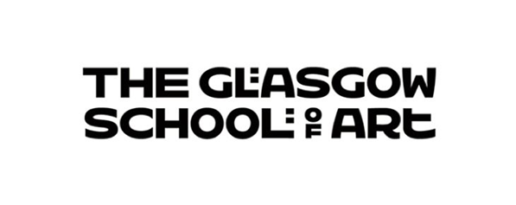

# **Student Profile Data**



Image: Ke Wang, *Black Box Theatre | Ground Floor* (Interior Design 2024)

## **Student Profile Data Introduction**

This report presents an overview of GSA’s student body profile by protected characteristics for 2023/24. This is based on HESA guidelines. Please note that there have been changes implemented to [HESA’s Data Futures](https://www.hesa.ac.uk/innovation/records/reviews/data-futures-2022-23) as of 2022/23 which affect the way certain data relating to the protected characteristics can be presented. This, in turn, has impacted on drawing comparisons with previous years.

Student profile data is collected to help the GSA identify areas of inequality, inform policies and support initiatives, and evaluate the effectiveness of current efforts to promote diversity and reduce inequality. All data is stored and used in compliance the Data Protection Act 2010.

In order to preserve anonymity throughout the report numbers under 10 have been presented as ‘*’. Data on pregnancy and maternity is not included in this report to protect the identity of the individuals.

## **Key findings:**

* There has been a rise in students selecting “prefer not to say” regarding disability (+3.3%), religion and belief (+1.7%), sexual orientation (+2.4%), and gender identity (+1.5%) between the 2022/23 and 2023/24 periods.
* There has been a 7.6% increase in the number of students sharing that they have a disability.
* Male students now comprise 29% of the student body, representing a decline across all Schools.
* The percentage of students sharing information about their transgender status or history has increased significantly, rising from 78.3% in 2022/23 to 91.4% in 2023/24.
* There has been a 4.9% increase in students disclosing their ethnicity, with only 3.4% of students' ethnicities now classified as unknown.
* Encouragingly, the GSA has observed an increase from 30.5% to 34.4% of students from Ethnic Minority backgrounds. However, just 8.4% of GSA’s ethnic minority students are UK domiciled. The average in Scottish HEIs is 10.9%.

## **Age**

|  |  |  |
| --- | --- | --- |
| **Age Group** | **2022/23** | **2023/24** |
| Under 25 | 2164 (76.2%) | 2101 (74.7%) |
| Over 25 | 678 (23.8%) | 713 (25.3%) |
| **Total** | **2842** | **2814** |

## **Disability**

|  |  |  |
| --- | --- | --- |
| **Disability Status** | **2022/23** | **2023/24** |
| Known Disability | 591 (20.8%) | 800 (28.4%) |
| No Known Disability | 2170 (76.4%) | 1847 (65.7%) |
| Prefer not to say | 69 (2.4%) | 161 (5.7%) |
| Unknown | 12 (0.4%) | 6 (0.2%) |
| **Grand Total** | **2842** | **2814** |

## **Ethnicity**

|  |  |  |
| --- | --- | --- |
| **Ethnicity** | **2022/23** | **2023/24** |
| Ethnic Minority EEA & International | 631 (22.2%) | 722 (25.7%) |
| Ethnic Minority UK Domiciled | 224 (7.9%) | 238 (8.5%) |
| Ethnic Minority Unknown Domicile | 13 (0.5%) | 8 (0.3%) |
| Ethnic Minority Total | 868 (30.5%) | 968 (34.4%) |
| White | 1737 (61.1%) | 1750 (62.2%) |
| Unknown Ethnicity | 237 (8.3%) | 96 (3.4%) |
| **Total** | **2842** | **2814** |

## **Religion and Belief**

|  |  |  |
| --- | --- | --- |
| **Religious belief** | **2022/23** | **2023/24** |
| Any other religion or belief | 109 (3.8%) | 116 (4.1%) |
| Buddhist | 45 (1.6%) | 41 (1.5%) |
| Christian – Church of Scotland | 59 (2.1%) | 50 (1.8%) |
| Christian – Roman Catholic | 189 (6.6%) | 177 (6.3%) |
| Christian – other denomination | 136 (4.8%) | 136 (4.8%) |
| Hindu | 44 (1.5%) | 40 (1.4%) |
| Jewish | 10 (0.4%) | 17 (0.6%) |
| Muslim | 63 (2.2%) | 70 (2.5%) |
| No Religion | 1940 (68.3%) | 1871 (66.5%) |
| Prefer not to say | 213 (7.5%) | 260 (9.2%) |
| Sikh | * | * |
| Unknown | 32 (1.1%) | 19 (0.7%) |
| **Total** | **2842** | **2814** |

## **Sex**

|  |  |  |
| --- | --- | --- |
| **Sex** | **2022/23** | **2023/24** |
| Female | 1889 (66.5%) | 1909 (67.9%) |
| Male | 897 (31.6%) | 815 (29%) |
| Other | 37 (1.3%) | 54 (1.9%) |
| Unknown | 19 (0.7%) | 36 (1.3%) |
| **Total** | **2842** | **2814** |

## **Sexual Orientation**

|  |  |  |
| --- | --- | --- |
| **Sexual Orientation** | **2022/23** | **2023/24** |
| Bisexual | 413 (14.5%) | 438 (15.6%) |
| Gay or lesbian | 163 (5.7%) | 178 (6.3%) |
| Heterosexual or straight | 1602 (56.4%) | 1514 (53.7%) |
| Other sexual orientation | 78 (2.7%) | 91 (3.2%) |
| Prefer not to say | 511 (18%) | 574 (20.4%) |
| Not available | 75 (2.6%) | 19 (0.7%) |
| **Total** | **2842** | **2814** |

## **Transgender or Transgender History**

|  |  |  |
| --- | --- | --- |
| **Gender Identity** | **2022/23** | **2023/24** |
| Yes | 37 (1.3%) | 47 (1.7%) |
| No | 2186 (77%) | 2527 (89.7%) |
| Prefer not to say | 135 (4.7%) | 174 (6.2%) |
| Unknown | 484 (17%) | 66 (2.3%) |
| **Total** | **2842** | **2814** |